Wizdom Releases ProcessWorks!® V.6
Newest Release for the Worlds Best Process Modeling Suite
Superior Features and Functionality

For Immediate Release

NAPERVILLE, IL, December 2, 2003 -- Wizdom Systems, Inc.®, celebrating its 17th year as a leader in providing Business Process Reengineering (BPR) software, training, and solutions, today announced the release of ProcessWorks! V.6 software. ProcessWorks! is a seamless suite of BPR software tools for creating, analyzing, and editing process flows. This new version significantly enhances user friendliness and provides flexibility in terms of the ability to support IDEF and UML methodologies. This means customers can reap the benefits of improved processes incorporating the latest advances in process modeling.

“ProcessWorks! V.6 and the professionals at Wizdom Systems, Inc. fully met our process modeling needs,” said Paul Ricciuti, CEO, LogConGroup, Inc.; a successful logistics consulting company. “Our clients require rigorous structured and analytical modeling tools. No other Business Process Re- engineering course of instruction could satisfy our company and meet our clients' needs. With the integration of ProcessWorks!, and with the newest features such as HTML output and instant IDEF to UML conversion, our clients realize immediate value and ROI from our work.”

Benefits of ProcessWorks!

- Provides an understanding of the way you do business today.
- Reveals redundant and non-value added activities.
- Establishes a forum and a structure for process analysis.
- Identifies opportunities for improvement.

ProcessWorks! V.6
ProcessWorks! supports IDEF standards. This is process modeling in a hierarchical manner, by decomposition. ProcessWorks! contains the ability to generate graphical models using textual lists, embedded analysis tools and reports, an integrated Glossary with import and export of Glossary terms.

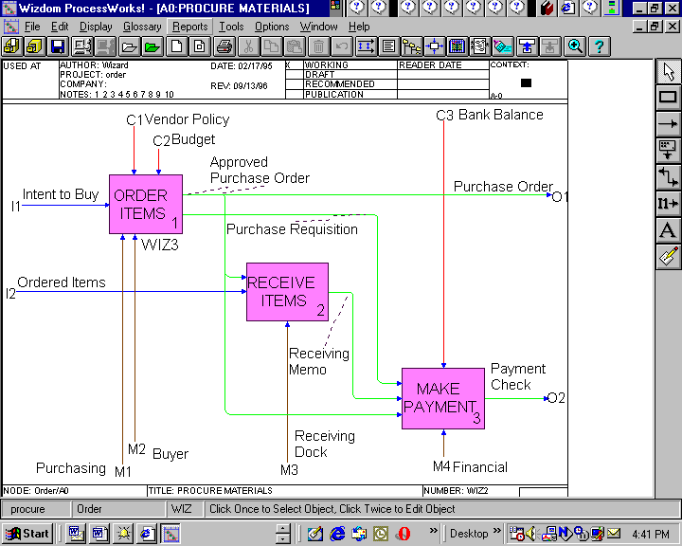
Figure Error! No text of specified style in document.-1

Newest ProcessWorks! V.6 features

1. Create UML USE CASE models directly from your IDEF models, instantly at the click of a button!
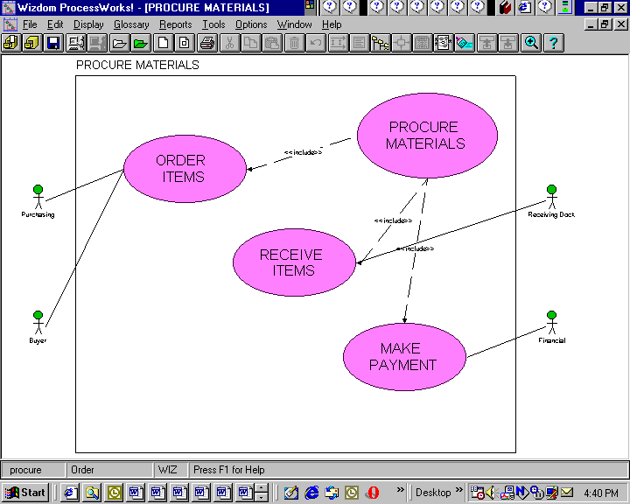

2. Document Manager: Link to legacy documents that support processes:

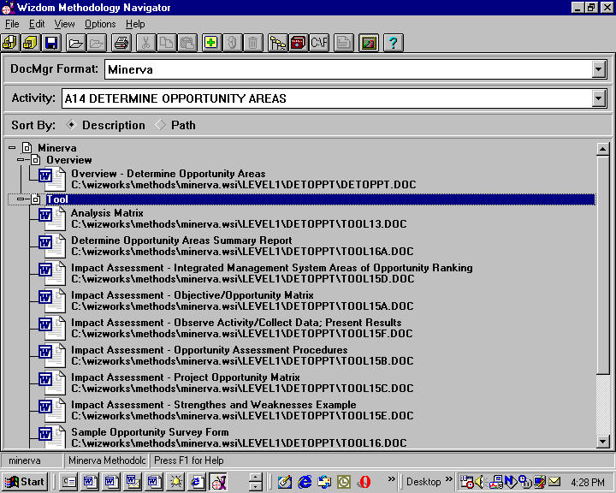
Figure Error! No text of specified style in document.-2

3. HTML Page Generation for your Models
This feature enables your team to review and collaborate on models or you can post them to your web server for your team to access process documentation. Whole models and their attached documents can be exported to HTML and then viewed on the web via your favorite web browser.

4. Business Case Analyzer

The Wizdom ProcessWorks ! BCA compatible with the US Government OMB Business Case Analysis requirements.

5. Other Great ProcessWorks! Functions:

- Attach URL (web address) to individual activities
- Creation of Detailed reports
- Import/Export Glossary Terms
- Integrated Glossary
- Embedded IDEF0 Standards
- Model generation from Indented Activity List
- Activity/Arrow Properties
- Branch Copy & Paste
- Copy Diagram to Clipboard
- Embedded Analysis Tools (MS Excel and MS Project) with 2 way OLE links
- What-if Analysis
- Master Project with automatic links
- Link to Wizdom Repository
- Converts IDEF models from other tools into ProcessWorks!

“Wizdom listened to our clients”, said Stephen Kroll, Wizdom V.P. of Product Development. “ProcessWorks! V.6 has more hours of real use than any other product of its kind.” “Our move to UML from IDEF is unique and will be of immense value in the practical world of IT and business process implementation.”

Wizdom supports all of its products and services with intensive world class out of the box and customized training.

Pricing and Availability
ProcessWorks! V.6 is available in three editions that differ in capabilities, features and prices. ProcessWorks! V.6 is available directly through Wizdom or from any of our VARs around the world.

About Wizdom

Since 1986, Wizdom has been a recognized leader in providing clients with innovative process-based business and software solutions. Wizdom’s integrated software, training and consulting enables industry and government clients to communicate, plan and execute a unified strategy. Wizdom helps both the public and private sector to meet its objectives by aggressively pursuing new opportunities and employing the best business practices. Wizdom’s corporate headquarters is located in Naperville, IL, a western suburb of Chicago.

For information on Wizdom’s complete range of products and services, contact Robin Davies at (630) 357-3000 ext. 3084, robind@wizdom.com, or visit Wizdom’s website at http://www.wizdom.com

