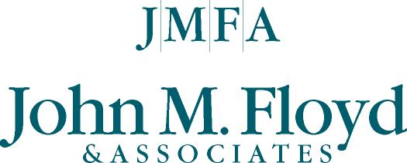
ELEVEN QUESTIONS . . .
Consumers should ask about a check overdraft program.

Whether dealing with a bank, S&L, thrift or credit union, savvy consumers should ask these questions before active involvement in a check (or share draft) overdraft program. Sometimes known as “bounce protection” or overdraft privilege, such programs cover non-sufficient funds (NSF) checks that accountholders or members may write inadvertently or by choice.

- Is the program mandatory or optional to maintain a checking account at the financial institution?

- Would it be less expensive and/or more convenient to cover overdrafts automatically with funds from a savings account, credit card or through a small personal line of credit?

- Fees charged on NSF checks range from $17 to $35 (average $22.50). What fee will I pay?

- Is the program offered widely to all customers or members, or is it discriminatory and available only to large account holders and high-income individuals?

- Is my overdraft limit a set amount, that is unchanging, or is it determined by a “matrix” of checking activity and monthly account balances unknown to the customer or member (me)?

- Is my available overdraft amount shown separately and distinguishable from my own account funds when I use an ATM machine, or is it “disguised” as part of available funds?

- Does the financial institution offer any education or guidelines to wisely using or relying on overdraft protection?

- Is the program formally communicated on a frequent enough basis so the consumer has a complete understanding on how the program works?

- Does the institution pay the largest NSF check first so that multiple NSF fees accumulate on smaller checks, or does it pay NSF checks in the order they were written?

- How long do I have to make the check “good” or bring my account back to a positive balance before the NSF check will incur a second penalty fee or additional charges?

- If I begin to use the overdraft feature too often, as opposed to routinely living within my income, will I be alerted by the institution or receive any personal financial counseling?

John M. Floyd & Associates, Inc. of Houston, Texas, a leading provider of such programs, including JMFA’s Overdraft PrivilegeSM (www.jmfa.com), prepared these questions for the Consumer Federation of America’s Annual Issues Conference in Washington, DC, Dec. 4, 2003.

