Char Roasted Eggplant and Almond Spread

Yield: approximately 2 cups

1 large eggplant (1 ½ pounds)
1 tablespoon olive oil
2 cloves garlic, peeled and chopped
½ cup American Almond ™ Roasted Almond Butter
4 tablespoons lemon juice
1 teaspoon cumin
¼ cup plain yogurt
salt and pepper to taste
2 tablespoons fresh cilantro, chopped
2 scallions, cleaned and chopped

- Wash and dry the eggplant and remove the stem. Rub it with the olive oil. Place the eggplant on a tray under a preheated broiler and cook until well browned, approximately 5 minutes on each side. Remove from the oven and let cool.
- Remove the charred skin from the eggplant. Place the flesh in the bowl of a food processor fitted with metal blade. Add the garlic and American Almond ™ Roasted Almond Butter. Process until smooth and creamy. Add the lemon juice, cumin, yogurt and salt and pepper. Process to blend. Adjust seasonings.
- Garnish with the chopped cilantro and scallions and serve with toasted pita crisps or flatbread. Covered and refrigerated, this spread will keep 4 to 5 days.
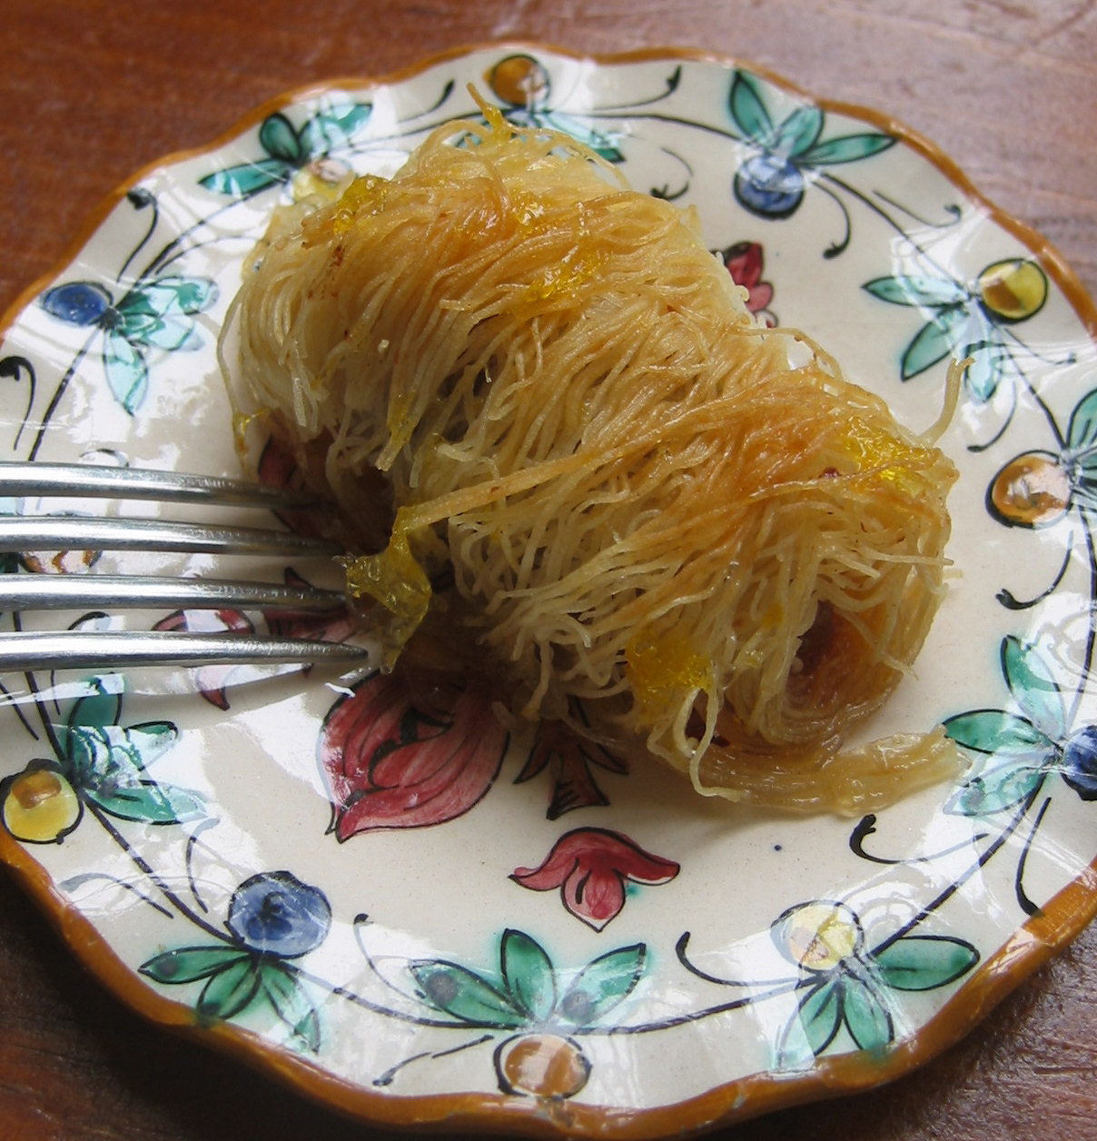
Sweet and Crunchy Almond Kataifi Pastries
Yield: 24 to 32 pastries
For the syrup:
2 ½ cups granulated sugar
2 cups water
2 tablespoon orange juice
2 tablespoons lemon juice

For the pastry:
1 cup (6 oz.) whole almonds, chopped
½ cup (3 oz.) walnuts, chopped
½ cup (5 oz.) American Almond™ Traditional Almond Paste
1 teaspoon cinnamon
1 pound Kataifi*(shredded filo dough), thawed in the refrigerator if necessary
½ to ¾ pound unsalted butter, melted Image Copyright 2004 American Almond Products Co.
- Preheat the oven to 375ºF.
- Combine the sugar, water and orange and lemon juices in a small saucepan over high heat. Bring to a boil stirring to dissolve the sugar. Let the mixture boil for 5 minutes. Remove from the heat and keep warm.
- Combine the almonds and walnuts in a small bowl. Grate the American Almond ™ Traditional Almond Paste with a cheese grater into the mixture. Add the cinnamon and stir with a fork to combine the ingredients. Add two or three tablespoons of the sugar syrup to make a soft paste. Set aside.
- Spread the Kataifi out on a flat worktable. Divide the pastry into 4 long sections. Working with one section at a time, cut bunches of the pastry into 4-inch pieces. (One pound of Kataifi will produce approximately 24 to 32 rolls.)
- To make the pastry rolls, flatten a cut portion of the Kataifi. Brush it with melted butter and spoon a heaping teaspoon of the reserved nut paste into the center of the dough. Roll the dough into a tight cylinder measuring approximately 3 inches long and 1 inch wide. Place the rolled pastry, seam side down, onto an ungreased 15 x 10-inch baking sheet. Repeat with the remaining Kataifi dough placing each roll on the baking sheet with sides touching. Brush the tops of each roll with more melted butter.
- Bake until the rolls are evenly browned, approximately 45 to 50 minutes.
- Remove the pastry from the oven and immediately ladle the warm sugar syrup over the rolls. Cover with foil and allow the pastries to sit and absorb the syrup for at least 30 minutes. Serve warm or at room temperature. When tightly covered, these pastries will keep for one week.


*Note: Kataifi is also called shredded filo dough. It is sold at Middle Eastern or other international grocery stores. It is refrigerated or frozen. Athens and Lilas are two popular brands.

