beauty BUZZ
THE LATEST AND GREATEST IN THE WORLD OF BEAUTY

How to make the skin you’re in look like the skin you dream of. Dr Low Chai Ling from The Sloane Clinic gives you the scoop on the dream treatments you can undergo to achieve a more youthful complexion. Skip the nip, tuck and needle for these breakthrough skin treatments. You’re how old? Don’t let your skin age you. These skin savers will keep them guessing.

all about SKIN
The best form of make-up is great looking skin

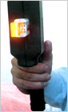
Hey, lighten up
We know age is only a number, but why should your skin celebrate another birthday? Thanks to IPL Photofacial, aging need not be inevitable. From sun damage, freckles to age spots, we've got a pigment-erasing remedy. They say that a true lady never reveals her age and now your skin will also be able to keep the secret. Let IPL photofacial lighten, brighten and even out your complexion.

Line erasers
We're living in an extreme makeover world, where there's a surgical remedy for everything from expression lines to sagging skin and cellulite. But if the thought of being poked and prodded by needles makes you shudder, there is a non-surgical alternative that can give you a little lift. Breakthrough technologies have created a way for even the most scalpel-phobic among us to get some results without those painfully expensive invasive procedures. Aramis Laser enhances collagen and promises smoother, plumper, firmer skin in no time. Together with our 20% Vitamin C & E cream, time will be firmly on your side.

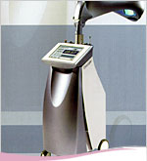
Achieve Clarity
You’re not alone. Nearly 17 million people suffer from acne. Acne is most often a result of clogged pores, which are unable to properly shed themselves. Oil and dead skin become clogged, leading to inflammation (a.k.a. zits). Acne sufferers swear by I-Clear, a blue light therapy which reduces the bacterial count of the skin without oral medication or expensive topical products. Gently shine your way to clearer skin with a series of I-Clear treatments or add it to your regular facial treats to maintain total skin clarity.

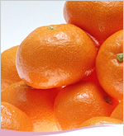
Get up and glow
Yes, you can reclaim your youthful glow! Slough off the rough stuff (dull, dry surface cells) and watch your skin go from smooth to radiant. From Pumpkin Peels to Crystal Microdermabrasion, these top-selling skin treatments will get you glowing. Top it off with our Multivitamin Booster Gel and you can glow with confidence again.

See the light
You can thank your parents for this one: darkness under the eyes is most often the result of hereditary thinning of skin, which makes blood vessels more visible. Lack of sleep is the other culprit. Concealer may be your best friend when it comes to disguising darkness, but we’ve got a number of remedies that can shed some long term light on the situation, from our LED photomodulation red light therapy to our IPL photofacial for undereye circles. Top it off with our Power K Rescue eye cream and you can throw those dark shades away.
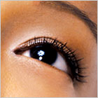
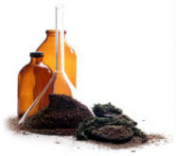
“Beautiful skin- we know you want it. It’s no secret that shopping for skincare treatments can be confusing. At The Sloane Clinic, we help you take the guesswork out of skincare by simplifying the process. We identify the most common skin problems (acne, wrinkles, dryness to name a few) and offer the best possible solution. We’re committed to providing you with the most innovative treatments from the finest brands to give you the best possible results: Beautiful skin.” Dr. Low Chai Ling, The Sloane Clinic.

The Sloane Clinic is a medical aesthetic clinic, located at 30 Raffles Place, #03-01 Caltex House.You may call them for an appointment at 6533 2522 or explore www.sloaneclinic.com for details.

