For Immediate Release
September 20, 2004

Press Contact: Robin Davies
630-357-3000 robind@wizdom.com

Wizdom Offers DoDAF Symposium on Modeling and Simulation Tools

Naperville, IL, September 20, 2004 – Wizdom Systems, Inc. in cooperation with PIKOS GmBH recently completed the first in a series of symposia developed to introduce the user community to its family of integrated DoDAF products and service.
Held on August 31, 2004 in the Wizdom Alexandria office, an invited group of enthusiastic DoDAF practitioners were witness to live demonstrations of the new WizdomWorks! Release 6.1 showing:
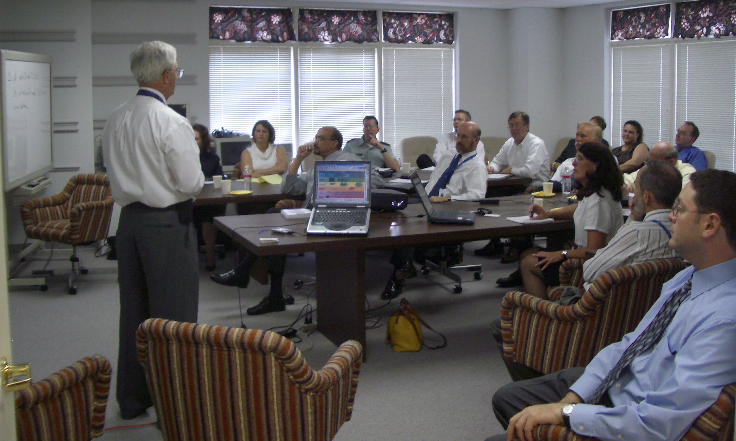

Development of OV-2, OV-4, OV-5, OV-6A, OV-7, SV-4, AV-2 and SV-1,

Truman Parmele CISA Program Manager, DARS Program Manager

PIKOS GmBH showed their Bonapart software which builds simulation models for SV-7 and SV-10C.

In addition, the attendees were the first ever to see
Data integration and exchange between Wizdom and PIKOS
”Wizdom and PIKOS have combined to offer the best combination of features in both ease of use and thoroughness in tools to build DoDAF products”, said Steven Kroll, Wizdom Vice President of Product Development.

Highlights of the morning and afternoon sessions were presentations by Truman Parmele, CISA Program Manager, DARS Program Manager in the morning and Martin Johnson, CISA Deputy Program Manager in the afternoon. Both Mr. Parmele and Mr. Johnson presented the DoDAF roadmap outlining near and long term plans for DoDAF as well as the current standing of the DARS in terms of vendor support.

“We know that we are the best in terms of DoDAF training and the breath and depth of our product offerings, said Wizdom founder President, Dennis E. Wisnosky. “So that we can maintain this reputation, it is important to know exactly where the Government DoDAF Team is now and where they are headed. We re extremely pleased with the support of vendor community provided by Mr. Parmele and Mr. Johnson.
Work Product | Tool(s)  Recommended | Project Management Tool  Recommended
AV-1 | ProcessWorks!, MS WORD | DoDAFLive!  Features Include:  - 100% web based  - Manages the DoDAF work product life cycle.  - Built-in Gantt charts for work product development  - Templates for each work product  - MS OUTLOOK Compatible  - MS PROJECT Compatible  - WAP Compatible  - Document Management  - Calendaring and Resource Management  - Collaboration and Instant Messaging
AV-2 | ProcessWorks!
OV-1 | ProcessWorks!
OV-2 | ProcessWorks!
OV-3 | Bonapart!
OV-4 | ProcessWorks!
OV-5 | ProcessWorks!, MS VISIO
OV-6a | DataWorks!
OV-6b | Bonapart!
OV-6c | Bonapart!
OV-7 | DataWorks!
SV-1 | Bonapart!
SV-4 | ProcessWorks!
SV-5 | MS EXCEL
SV-6 | MS EXCEL
SV-10b | Bonapart!
SV-10c | Bonapart!
SV-11 | DataWorks!
TV-1 | MS EXCEL

In addition to a live demonstraton of the WizdomWorks! and Bonapart capabilities by Wizdom, and PIKOS in building DoDAF products, attendees were treated to presentation of an actual users experience in simulating a complex US Army situation by Mitre. Mitre has been a leader in the application of executable architectures

And, Wizdom demonstrated DoDAFLive!, its exclusive web based tool for planning and managing DoDAF project and DoDAF project teams over the Internet. With DoDAFLive!, team members, no matter where they are, have instant access to every tool needed to build and analyze DoDAF products. The project file within DoDAFLive!, is compatible with MS Project.
DoDAF products Produced by Wizdom and PIKOS


About Wizdom
Since 1986, Wizdom has been a recognized leader in providing clients with innovative process-based business and software solutions for improving performance. Wizdom’s integrated software, training and consulting enables our clients to communicate, plan and execute a unified corporate strategy. Wizdom helps businesses grow by aggressively pursuing new opportunities and employing the best business practices. Wizdom’s corporate headquarters is located in Naperville, IL, a western suburb of Chicago.

About PIKOS GmBH
PIKOS GmbH specializes in the development and retail of software solutions for Business Process Management (BPM). PIKOS BPM Solutions enable companies to structure, analyze, simulate, monitor internal and external applications.

For information contact Robin Davies at (630) 357-3000 ext. 3084, robind@wizdom.com, or visit Wizdom’s website at http://www.wizdom.com.
###

