
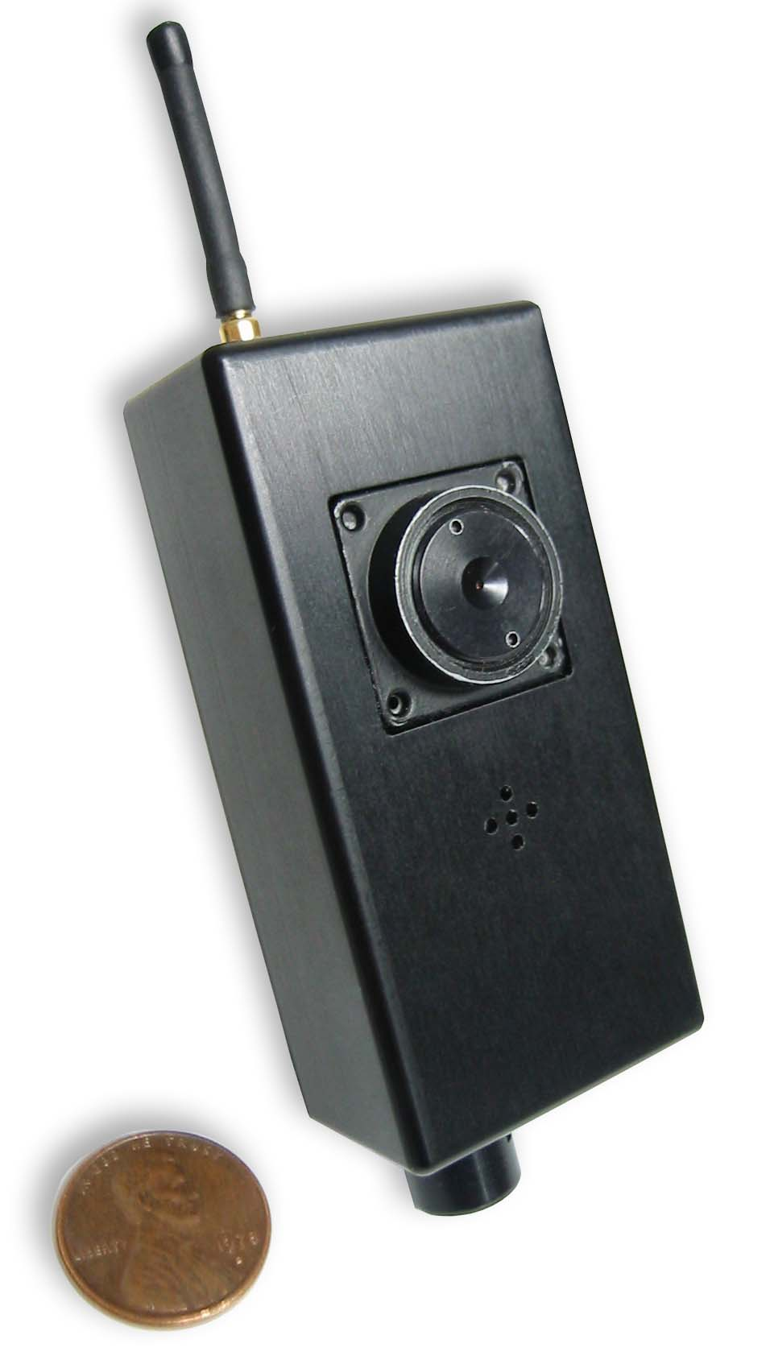
LC518M / LC618M
Short Range Wireless Lapel Camera

Applications

- Public safety: Police, Fire, EMV, Swat Teams & Community Watch systems
- Combat in caves and urban areas
- Inspections
- Training 

DESCRIPTION
The LC518M and LC618M wireless lapel camera transmit FM modulated broadcast quality video and audio with no latency. They are miniature, lightweight and low power.

Operating frequency: LC518M from 900MHz to 2.15GHz. LC618M from 2.15GHz to 2.5GHz. The units have 16 factory preset channels.

The LC518M and LC618M have a built-in video camera and an electret microphone.

KISS design: Only manual control is an On/Off switch.

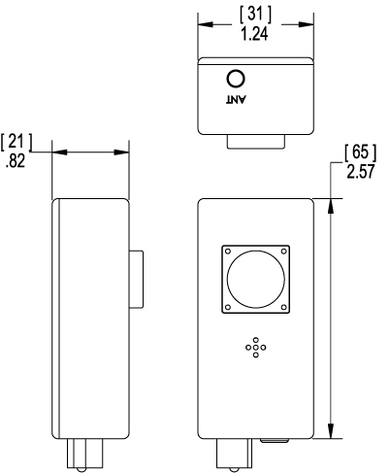

LC518M/LC618M FEATURES
⬧ A low light camera with a resolution of 470 lines.
- An Electret microphone.
- Sixteen preset frequencies
⬧ Range: urban area - 500 feet
open space - 1500 feet line-of-sight
- Operates off 12V@300mA
- Weight is under 8 oz.
- Optional: Solar panel and charger for fast “hand-and-go” deployment

344 Coogan Way, El Cajon, CA 92020, PH 619-401-1967 Fax 619-401-1971 www.avalonrf.com

