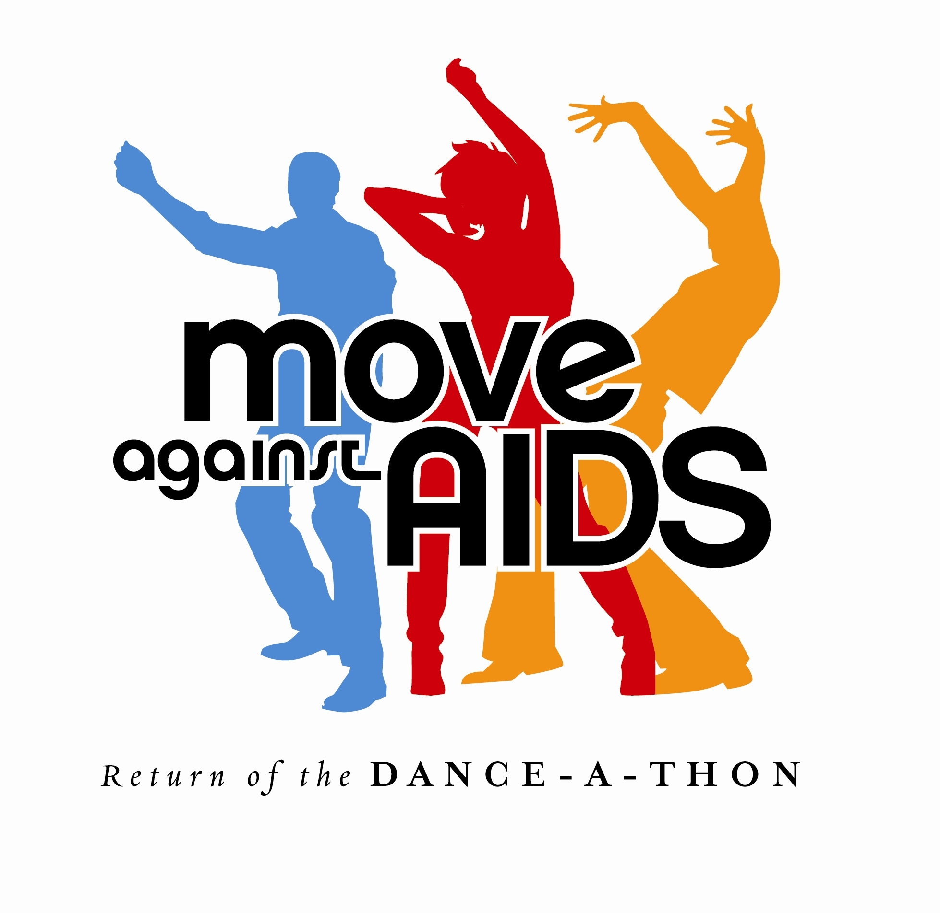
Press Release

For Immediate Release
November 10, 2004

Internationally Renowned Club Legends Unite to Move Against AIDS

New York, NY – Legends of the New York club scene and internationally renowned producers and DJ’s Beverly Bond, Peter Rauhofer, Danny Tenaglia, Tony Touch, and Junior Vasquez have united to perform for thousands at Move Against AIDS on December 11, 2004, at the Jacob Javits Convention Center in Manhattan.

The celebrity-hosted dance-a-thon will benefit Gay Men’s Health Crisis (GMHC), the nation’s oldest AIDS service and advocacy organization, and its HIV/AIDS programs and direct services to over 15,000 men, women and children living with HIV in New York City.

“This event will engage those young men and women most at risk for contracting HIV,” said Ana Oliveira, executive director of GMHC. “The participation of youth in HIV prevention is a vital part of the solution in reducing HIV transmission. Our goal is to reprise the successes of past dance-a-thons in raising awareness about HIV and AIDS, and raising the funds needed to continue our fight against the Pandemic.”

There are one million people living with HIV/AIDS in the United States, and 40,000 more people are infected each year. African Americans and Latinos have experienced the greatest increases in HIV diagnoses, especially among young people and women. Half of all new HIV infections are among people under the age of 25, and the number of women living with HIV has tripled in the last two decades.

“The HIV epidemic in the United States is a rapidly changing public health emergency, and we must address the exploding rates of HIV infections among young people,” said Move Against AIDS Producer Craig R. Miller of MZA Events. “Move Against AIDS is an innovative way to raise awareness and re-invigorate our response to the HIV/AIDS epidemic. We are honored that these world-class DJ’s have united to reach out and inspire a new generation of AIDS activists.”

Move Against AIDS: Return of the Dance-a-thon is produced by MZA Events and is one of many events in its long legacy of successful AIDS fundraisers, including AIDS Walk. New York City’s first AIDS Dance-a-thon, launched by Miller and MZA Events in 1990, was an all-star show and dance party that immediately appealed to a wide and diverse base of participants. Move Against AIDS: Return of the Dance-a-thon is sponsored in part by Delta Airlines, NBC, KTU 103.5 FM, Metro Newspaper, HX Magazine, and Next Magazine.

GMHC is a not-for-profit, volunteer-supported and community-based organization committed to national leadership in the fight against AIDS. Its mission is to reduce the spread of HIV disease, help people with HIV maintain and improve their health and independence, and keep the prevention, treatment and cure of HIV an urgent national and local priority. GMHC provides services and programs to over 15,000 men, women and families that are living with or affected by HIV/AIDS in New York City.

# More #

World Renowned DJ’s Move Against AIDS

DJ BEVERLY BOND continues to make waves both in the commercial and underground music worlds, as well as in the fashion world. She is widely known and respected for her music knowledge, unabashed versatility, skill, and unique style. Whether she's spinning in the Hamptons or holding down the club circuit, she never fails to keep her crowd coming back for more.

"Move Against AIDS is a great way for people to have fun while really taking steps to eradicate HIV/AIDS," says Bond. "I am excited to be part of this creative event and to do my part to help change the course of the epidemic."

PETER RAUHOFER has few equals when it comes to achievements within the worldwide Dance music scene. A lauded producer, Grammy Award Winning remixer and Star 69 Records label owner he has spent the last 20 years establishing himself as a force to be reckoned with in a fickle industry where most merely come and go. Thanks to his Midas touch in all departments and his hugely successful residency at Roxy in NYC he currently represents a solid part of the city's electronic establishment.

“I'm glad that the event is back again this year and that I am involved,” says Rauhofer. “People need to be reminded that the crisis is definitely not over.”

DANNY TENAGLIA is an internationally renowned DJ, remixer and producer who has performed for audiences around the world since the release of his debut album Hard & Soul in 1995. Tenaglia has remixed and produced over 200 songs, including collaborations with Madonna, Janet Jackson, Grace Jones, Kim Mazelle, Bette Midler, Cher, Pet Shop Boys, and Blondie. Danny can now be found in New York playing his monthly gig at Vinyl and also some of the most popular spots in the city.

TONY TOUCH is a Hip Hop icon. Some may know him as the Piece Maker, others recognize him as one of the Diaz Brothers, and many call him TONY TOCA. All will attest to his superior skills on the turntables, his ability to rock the microphone with the best and his knack for releasing some of the greatest Hip Hop mix-tapes. You can now also catch TOCA Saturday nights on Power 105.1 in NYC from 11PM to 2AM.

JUNIOR VASQUEZ has been at the forefront of the dance music scene for over twenty years and has been described as a pioneer, a luminary, and an icon. The secret to Junior’s long and distinguished career is his keen awareness of music’s ever changing landscape and his uncanny ability to remain two steps ahead of music’s cutting edge. Through his own record label, JVM, Junior continues to work with big name talent, but remains focused on fostering relationships with new artists and producers, giving them a direct outlet to the dance world’s biggest DJs and underground devotees the world over.

“Events like these are opportunities to celebrate the tremendous advances we have made in our struggle against AIDS,” says Vasquez. “But these events are also reminders that the battle is not won yet - we still have more to do. We must continue to stand together and fight for a cure.”

###

Contacts:

Andrew Sousa
Move Against AIDS: (213) 201-9255

Noel Alicea
GMHC: (212) 367-1216

