Sports Media, Inc.
Advertising in Sports Venues has just gotten easier. Sports Media provides Advertising Agencies as well as Independent Advertisers a media buying and planning service. Sports Media places advertising in Stadium and Arenas throughout the United States.
Sports Media produces concession products such as, CD Cup Lids, 3D Lenticular Cups, Photo Cups, Plastic Cups, Cup Holders and Concession Trays. These products are available for distribution at sports and entertainment events worldwide.
Sports Media product distribution covers over 1500 Stadium and Arenas including MLB, NFL, NBA, WNBA, and MLS, Minor Leagues, Universities, NASCAR, 500 Ski Resorts, IMAX Theaters and Fairs.
Let Sports Media put your brand in the game. Come and explore the possibilities!
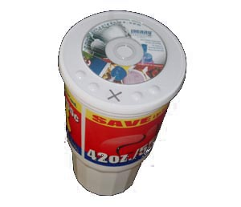 | CD-ROMs on Cup Lids!  Creative and innovative method for advertisers to deliver a targeted message to thousands of like minded, enthusiastic prospects. Enhance customer loyalty by delivering an interactive fan appreciation commemorative Track and produce reports on CD behavior, web activity and gather accurate e-mail database information. CD’s can be co-branded with Team or Event licensing.  Available in 32oz, 44oz & 64oz. cup sizes.
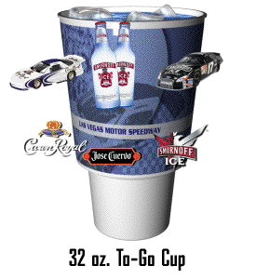 | They take it home and keep it forever!  3D Lenticular Plastic Cups by Sports Media are excellent promotional products and high impact collectibles. These dishwasher safe cups offer 360° viewing with high quality lenticular 3D imaging. Consumers keep these collectibles forever giving our advertisers and sponsors long lasting brand impressions. Available in 22 oz, 32 oz.
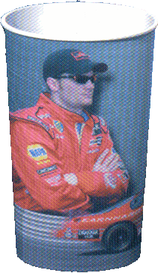 | Photographic Cups!  Turn beverages into works of art with custom photo cups. These dishwasher safe cups come with full color photo graphics, more colorful, more resilient, and more fun. Photo cups will add value to any fountain program and provide increased profits. Available in 16, 22, 32, 44oz. sizes, which fit our CD lid.
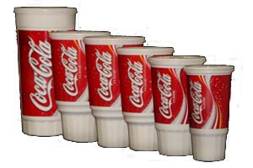 | Plastic Cups!  Everyday use of plastic cup sill has a major impact on advertising; these cups can be printed in a full color range and offer an economical means to delivering your message. Available in 20, 22, 32 traveler, 32 stadium, 44 traveler, 44 stadium and 64 oz. sizes. CD lid available in all sizes.
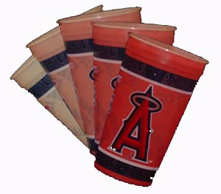 | Color Change Cups!  Add an interaction experience with your audience, here’s how they work, when the beverage is poured it changes the temperature of the cup causing a color change, when the beverage is gone the cup reverts back to its original state. Your advertisement is always in the customer view with a twist. Available in 20, 22, 32 traveler, 32 stadium, 44 traveler, 44 stadium and 64 oz. sizes. CD lid available in all sizes.
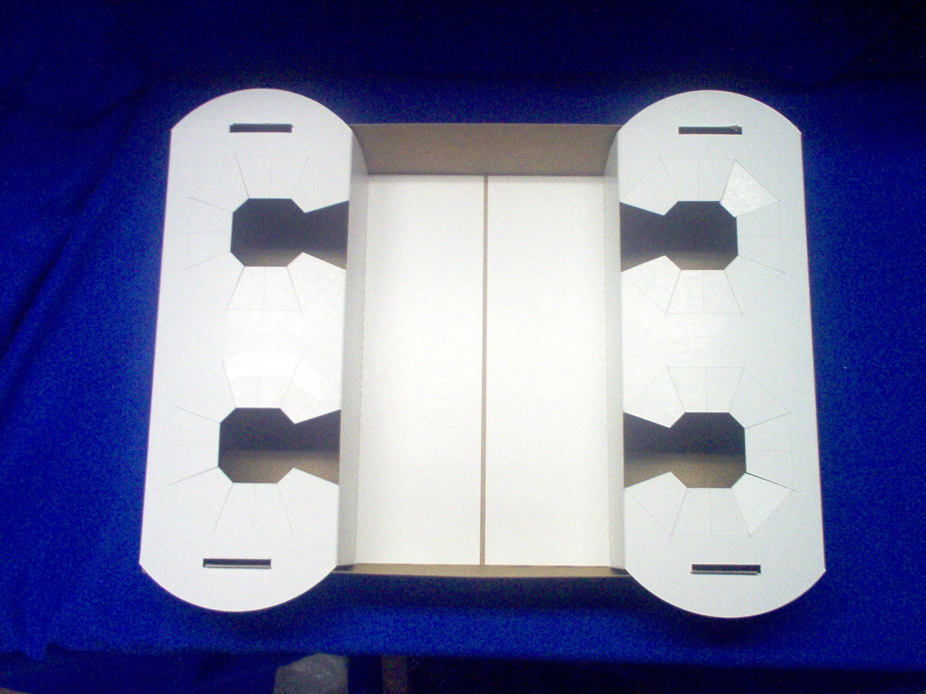 | Sports Media Stadium Concession Trays!  These unique food and drink trays can be distributed throughout the country in MLB, NFL, NASCAR, NHL, NBA stadiums and arenas. Concession Trays are just the thing to give the advertisers’ message a refreshing boost. The Sports Media Tray can be used for branding, couponing, and even for sampling!
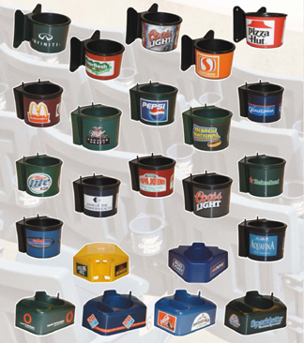 | Cup holders, a Great Branding Opportunity!  The Cup holder based place media and advertising branding medium has proven to be one of the most appealing and effective ways to reach new customers and build your brand. Cup holders offer high visibility and exposure; you have a captive audience for a minimum of 2 to 4 hours per event. Cupholders build relationships directly with consumers, teams, facilities advertisers and other sponsors. Consumer Experience Marketing is a great way to build brand loyalty. Sports Media places Cup holders in sports venues nationwide.

Sports Media, Inc. ● 520 Eighth Street Silvis, IL. 61282 ● (877) 266-0042 ● info@SportsMedia.net ● www.SportsMedia.net

