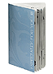 | 700242
 | Gift Album A -- $20

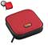  TDKCD Storage/Speaker Case -- Red | 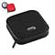  TDK CD Storage/Speaker Case -- Black | 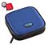  TDK(R) CD Storage/Speaker Case -- Blue | 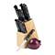  14-piece Block Cutlery Set | 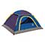  Expedition Trails Authority Tent | 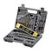  66-piece Power Bit Set
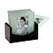  Five-piece Photo Coaster Set | 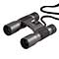  MeadeCompact Binoculars | 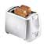  ToastmasterTwo-slice Toaster | 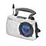  EmersonPortable Radio | 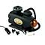  300-PSI Air Compressor | 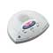  GEDigital Answering System
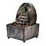  Cordless Tranquility Fountain | 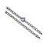  Women’s Bracelet/Watch Set | 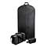  Three-piece Travel Set -- Black | 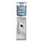  Desktop Beverage Dispenser | 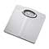  ThinnerBath Scale | 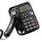  Speakerphone with Caller ID -- Black
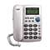  Speakerphone with Caller ID -- White | 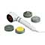  Handheld Infrared Massager | 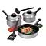  Seven-piece Cookware Set | 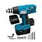  Cordless Drill Set | 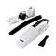  Rechargeable Hand Vac | 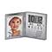  Talking Picture Clock
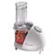  Toastmaster Food Processor | 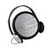  EmersonPersonal CD Player | 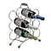  Chrome Wine Rack | 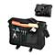  Flapover Brief Bag | 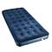  Velour Twin Air Bed | 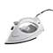  Toastmaster Steam & Dry Iron
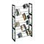  Stackable Storage System | 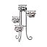  Four-tier Tealight Holder | 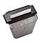  Royal Stripcut Paper Shredder | 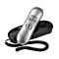  GESlimline Caller ID Phone | 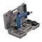  40-piece Screwdriver Set | 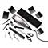  Remington 15-piece Haircut Kit
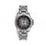  Men’s Sport Watch | 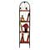  Four-tier Wicker Baker’s Rack | 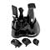  Cordless Grooming Kit | 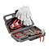  30-piece Auto Emergency Kit | 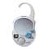  EmersonShower Radio | 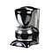  10-cup Coffeemaker
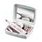  Nail Care System | 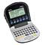  Royal Flip-case Data Organizer | 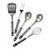  InnovaFive-piece Utensil Set | 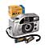  Bell & Howell Camera Kit | 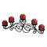  Metal Wire Candleholder | 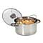  Three-piece Multicooker

700248
Gift Album B -- $30

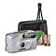  35mm Camera Kit | 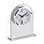  Howard MillerAlarm Clock | 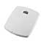  ThinnerLithium Scale | 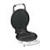  ToastmasterCool Touch Waffle Baker | 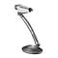  Swing-arm Desk Lamp | 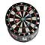  Sportcraft Electronic Dartboard
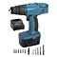  Cordless Drill Set | 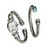  Ladies Bangle Watch/Bracelet Set | 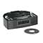  CD Dual Alarm Clock Radio | 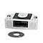  CD Dual Alarm Clock Radio | 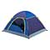  Expedition Trails Authority Dome Tent | 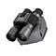  MeadeCompact Binoculars
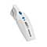  EurekaThe Boss Cordless Hand Vac | 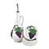  5-piece Oil Dipping Set | 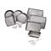  22-piece EZ-Baker Bakeware Set | 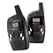  Bell South Two-way Radios | 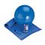  Bally Total Fitness Pilates/Yoga Kit | 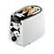  Toastmaster Cool Touch Two-slice Bagel Toaster
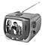  Memorex Portable TV with AM/FM Radio | 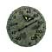  Decorative Outdoor Thermometer | 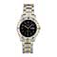  Embassy by Gruen Men’s Watch | 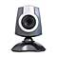  Micro Web Cam PC Internet Video Camera | 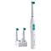  InterplakCordless Rechargeable Toothbrush | 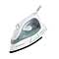  Steam Storm Nonstick Iron
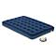  Full-size Airbed with Pump | 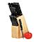  15-piece Cutlery Block Set | 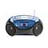  Portable CD Player --Blue | 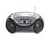  Portable CD Player --Silvertone | 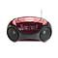  Portable CD Player -- Red | 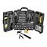  135-piece Tool Set
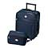  Two-piece Luggage Set | 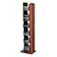  CD Storage Tower | 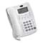  AT&T Speakerphone | 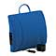  Massaging Lumbar Cushion | 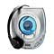  Personal CD Player | 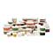  100-piece Food Storage Set
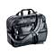  Expandable Briefcase | 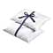  Pair of White Goose Feather Pillows | 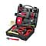  Auto Emergency Kit | 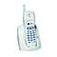  GE 900 MHz Cordless Phone -- White | 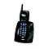  GE 900 MHz Cordless Phone -- Black | 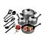  Nonstick Cookware Set
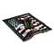  Allegiance Throw | 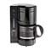  Melitta 5-cup Automatic Drip Coffeemaker | 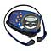  Emerson Water-resistant Personal Stereo | 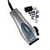  ConairDeluxe Haircutting Kit | 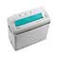  Royal Stripcut Shredder | 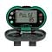  Pedometer with Pulse Meter

700249
Gift Album D -- $40

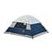  Expedition Trails Dome Tent | 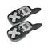  Bell South Two-way Radios | 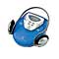  NO LONGER AVAILABLEPersonal CD Player with Radio | 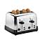  Toastmaster Four-slice Toaster | 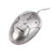  Compaq Wireless Mouse | 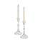  Set of Crystal Candlesticks
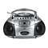  Portable CD/Cassette Stereo -- Silver | 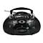  Portable CD/Cassette Stereo -- Black | 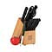  Tramontina 14-piece Cutlery Set | 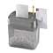  Royal Crosscut Shredder | 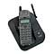  Coby 2.4GHz Cordless Phone - Black | 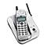  Coby 2.4GHz Cordless Phone - Silver
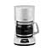  Betty Crocker 12-cup Coffeemaker | 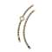  Embassy by Gruen Embassy Ladies Watch Set | 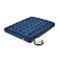  Queen Air Bed with Pump | 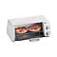  Toastmaster Toaster Oven | 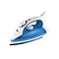  Rival Full-size Steam Iron | 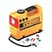  Rechargeable Air Compressor
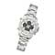  Men’s Analog Digital Watch | 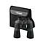  Meade Full-size Binoculars | 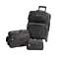  Three-piece Luggage Set | 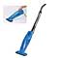  Eureka Corded Stick Vac | 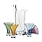  Six-piece Martini Glass Set | 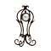  Scroll Easel Clock
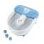  Conair Foot Spa | 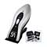  Vidal Sassoon Haircutting Kit | 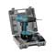  Rechargeable Cordless Drill | 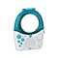  Emerson CD Shower Radio | 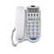  Phone with Digital Answering Machine, Caller ID, and Speakerphone - White | 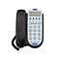  Phone with Digital Answering Machine, Caller ID, and Speakerphone - Black
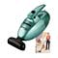  Eureka Copperhead Hand Vac | 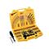  160-piece Drill/Driver Set | 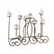  Fireplace Candelabra | 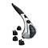  Relaxor Percussion Massager | 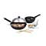  18-piece Wok Set | 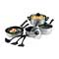  11-piece Cookware Set
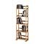  Multimedia Storage Tower | 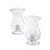  Set of Two Hurricane Candles | 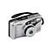  Vivitar 35mm Zoom Camera | 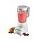  Hamilton Beach 14-speed Blender | 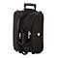  20-in. Two-section Rolling Duffel - Black | 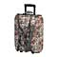  20-in. Two-section Rolling Duffel - Tapestry
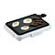  Toastmaster Cool-touch Griddle | 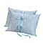  Jumbo Feather and Down Pillows | 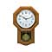  Oak Schoolhouse Regulator Clock | 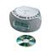  Emerson CD Clock Radio | 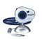  Cool-iCam™ 3-in-1 Digital Camera | 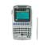  Royal Data Organizer

700265
Gift Album G -- $50

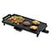  ToastmasterGriddle | 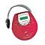  Personal CD/MP3 Player | 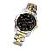  Chronograph Watch | 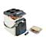  Travel Cooler and Warmer | 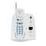  Cordless Phone with Answering System | 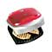  George Foreman Grill
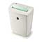  Crosscut Shredder | 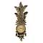  Palm Leaf Clock | 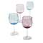  Marquis Glassware Set | 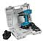  Cordless Drill Set | 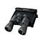  Zoom Binoculars | 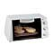  Toaster Oven/Broiler
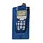  Cordless Phone with Caller ID-Blue | 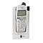  Cordless Phone with Caller ID-Gray | 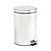  Trash Can | 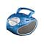  Portable CD Player with Cassette Recorder and Stereo | 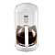  Digital Coffeemaker | 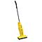  The Boss Stick Vac
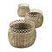  Wicker Basket Trio | 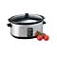  Slow Cooker | 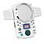  Shower CD Player/ Radio | 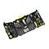  Home/Auto Tool Set | 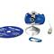  Digital Camera | 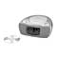  CD/Dual-Alarm Clock Radio
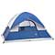  Dome Tent | 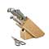  Cutlery Block Set | 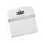  Body Fat Analyzer/ Bath Scale | 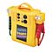  Jumpstart Power Station | 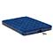  Queen Air Bed with Pump | 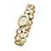  Ladies Watch
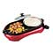  Fajitas & More Buffet | 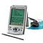  Data Organizer | 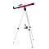  Telescope | 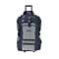  Rolling Duffel | 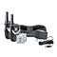  Two-way Radios | 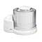  Ice Cream Maker
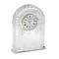  Lead Crystal Clock |   Jumbo Pillows | 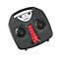  Massage Spa | 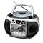  Portable CD with TV | 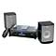  Micro Stereo System | 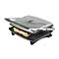  Panini Maker
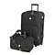  Luggage Set | 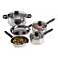  8-piece Stainless Steel Cookware Set | 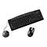  Wireless Keyboard | 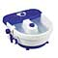  Foot Spa | 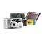  35mm Camera Kit | 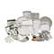  35-piece Bakeware Set

700263
Gift Album Q $25.00

Coffee, Sweets & Treats

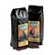  Flavorful Ground Coffees | Flavorful Whole Bean Coffees | 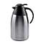  Stainless Steel Carafe | 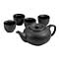  Five-piece Oriental Tea Set | 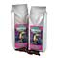  Costa Rican Ground Coffee | Costa Rican Coffee -- Whole Bean
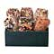  Gourmet Snack Mixes | 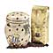  Coffee Storage Canister with Coffee | 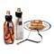  NO LONGER AVAILABLEPancake and Syrup Set | 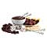  Deluxe Fondue Dessert Set | 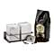  Sugar and Creamer Set with Coffee | 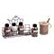  Coffee Flavor Set
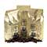  African Coffee Selection | 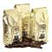  Fair Trade Organic Whole Bean Coffee | 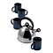  Teakettle and Mug Set | 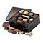  Belgian Chocolate Biscuit Assortment | 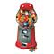  The Jelly Belly Bean Machine | 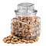  Large Whole Cashews
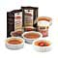  Crème Brulée Gift Set | 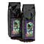  Kona Blend Ground Coffee | Kona Blend Whole Bean Coffee | 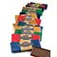  Ghirardelli Premier Bar Assortment | 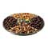  Deluxe Party Tray | 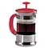  8-cup French Press Coffee Maker
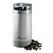  Toastmaster(R) Coffee Grinder | 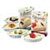  Cheesecake Tart Kit | 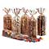  Peanuts! Peanuts! Peanuts! | 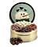  Almond Delight Tin | 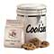  Big Cookie Jar | 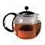  Bodum 8-cup Tea Press
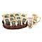  Coffee Variety with Mugs | 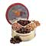  Cashew Delight Tin | 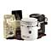  Coffee Storage Jars with Coffee | 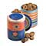  Aunt Beth’s Cookie Jars | 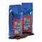  Jamaican Blue Mountain Blend Ground Coffee | Jamaican Blue Mountain Blend Whole Bean Coffee

Gift album R $50.00
Gourmet Gifts
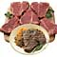  USDA Choice T-bone Steaks | 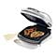  George Foreman Champ Grill | 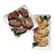  Steak and Chicken Sampler | 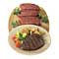  Top Sirloin Steaks | 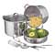  Professional Multipurpose Cooker Set | 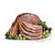  Spiral-sliced Ham
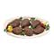  Sirloin Sizzlers | 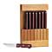  Tramontina9-piece Steak Knife Set | 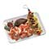  Land and Sea Combination | 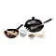  Wok Set | 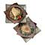  Swordfish and Tuna Steak Combination | 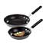  Commercial NSF Sauté Pan Set
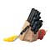  Farberware20-piece Knife Set | 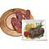  USDA Choice New York Strip Steaks | 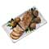  Pork Sampler | ToastmasterGriddle | 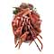  Snow Crab Clusters | 8-piece Stainless Steel Cookware Set
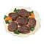  Bacon-wrapped Top Sirloin | 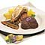  Surf and Turf | 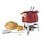  ChantalCeramic Fondue Set | 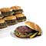  Black Angus Burger Patties | 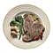  Porterhouse Steaks | 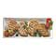  Chicken Breast Variety
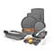  15-piece Proweight Bakeware Set | 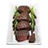  Filet Mignon

Here’s how it works!

Selections from the gift catalogs can be redeemed on line. It’s easy and fast!

- The recipient locates the multi-character redemption number on the reply card that’s inserted in the album.
- He or she visits www.ordermygift.com, types the redemption number, and makes the selection. We’ll ship the gift postpaid, directly to the recipient. Most gifts arrive in 1-2 weeks-that’s up to 3 weeks faster than redeeming by sending in the redemption card by mail.

To order: Fill in the following information

Company Name________________________________________
Contact Name__________________________________________
Street Address__________________________________________
City___________________________________________________
State_____________________Zip Code______________________

Catalog code Quantity Unit Price Total price
____________________________________________________
____________________________________________________
____________________________________________________
____________________________________________________
____________________________________________________
Shipping & Handling
Total Quantity X $3.95 __________
Fl State tax 6% __________
Total __________

Payment due upon ordering
All major credit cards accepted
Card #_________________________ Expiry Date___________
Signature_________________________

