

AValon RF product suite for future police force
Applications:

- Police
- Fire Fighters
- Emergency Medical Vehicles
- ITS
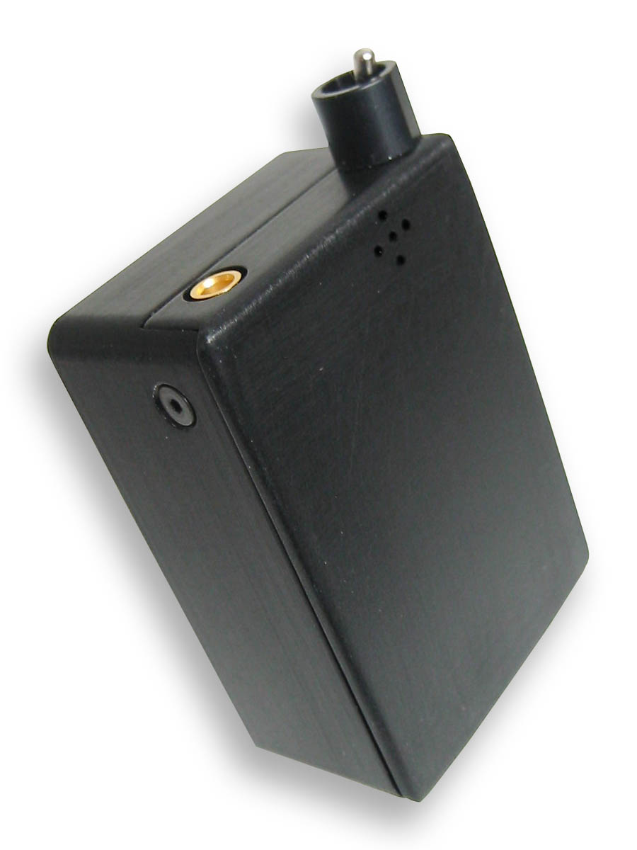
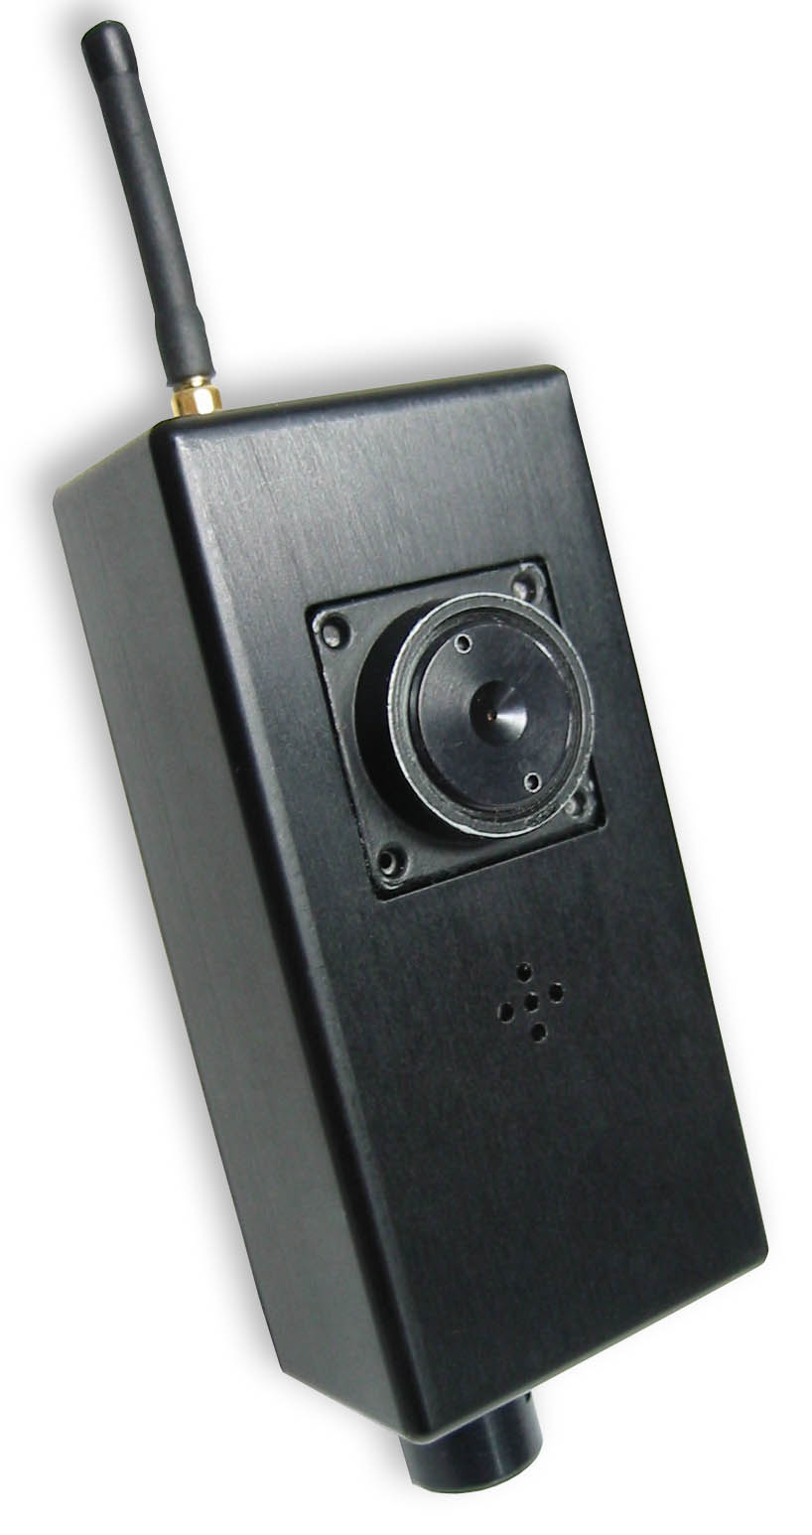
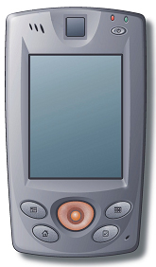


MX416A
microphone
LC618D
camera
V38R PDA

1000ft
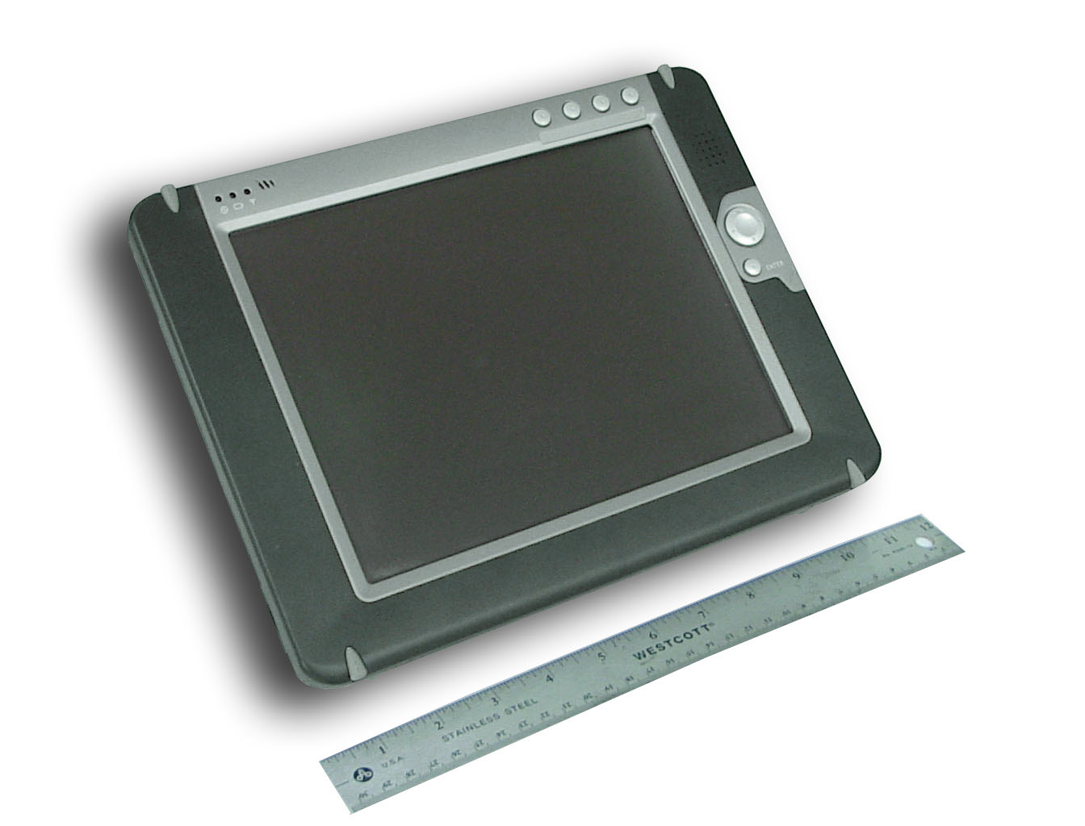

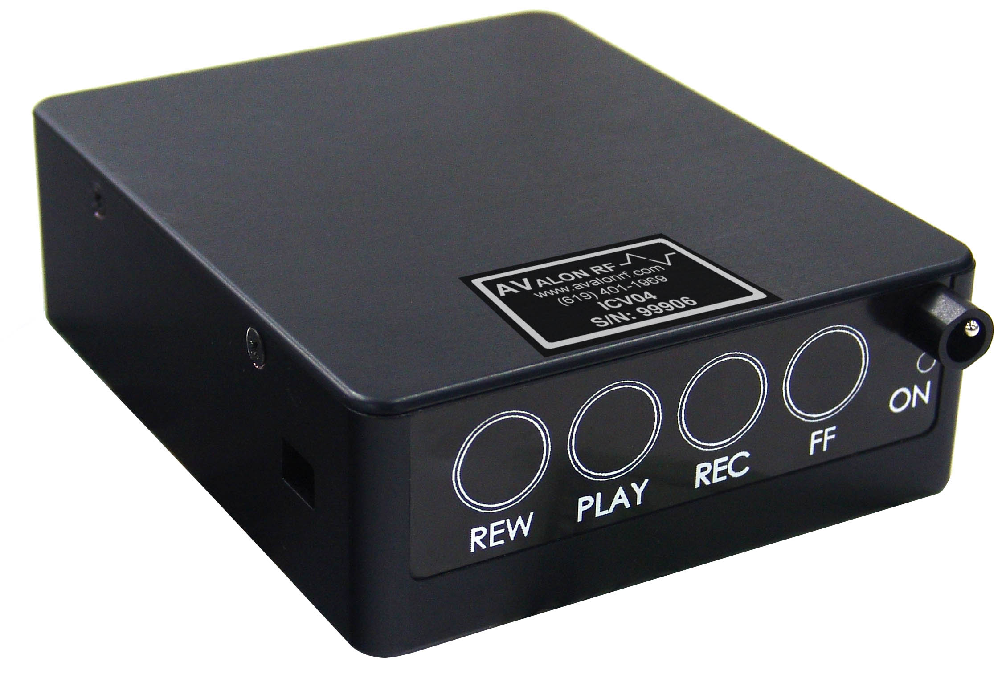
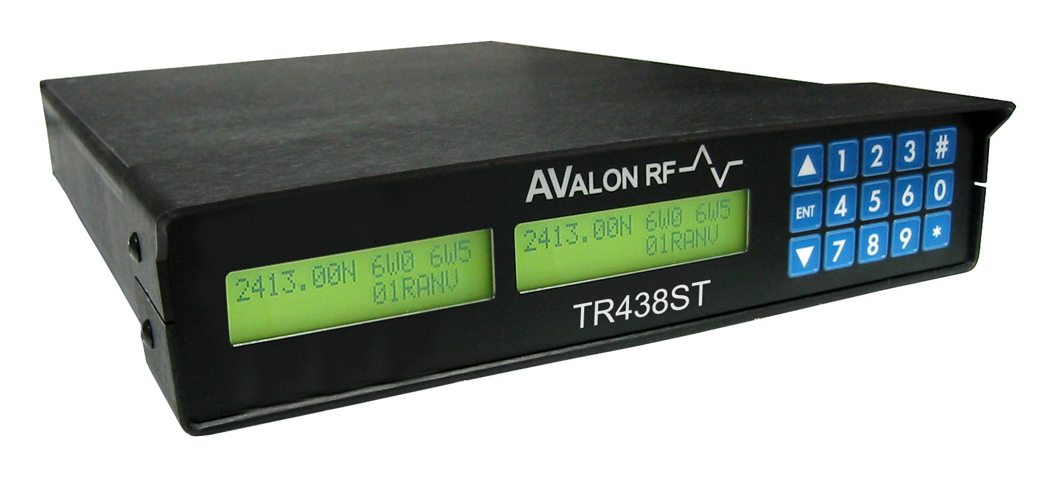

TR438ST
ICVS04
V211R
Police car
30 Miles



TR438ST
Police Station

Officer components:
MX416 Wireless Encrypted Digital Microphone/speakerphone
LC618 Wireless Encrypted Digital Camera
V38R Public Safety PDA with biometrics, DUI, Speeding and parking ticket generation capability
Patrol Vehicle Components:
V211R Rugged Tablet PC with 10.4” LCD and Windows® XP Embedded
ICV04 Four camera In-Car-Video-Recorder-System
Cisco 3200 mobile router with seamless connectivity to Cell, Wifi and Apco25 networks
TR438ST Long range 1Mbit/sec video/audio/data connectivity to headquarters
Headquarters Components:
TR438ST Long range 1Mbit/sec video/audio/data connectivity to patrol vehicles

344 Coogan Way, El Cajon, CA 92020, PH 619-401-1967 Fax 619-401-1971 www.avalonrf.com

