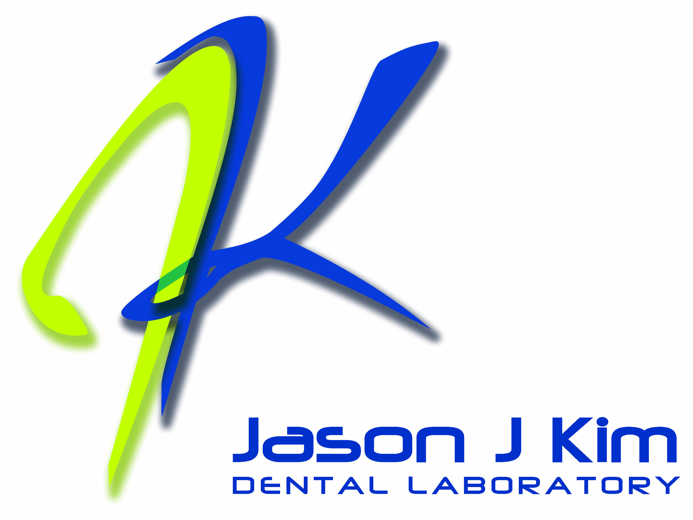

255 Great Neck Road

Great Neck, NY 11021

P: 516.829.4933

F: 516.829.2068

T: 800.547.4532

PRESS RELEASE FOR IMMEDIATE RELEASE

Contact: Randy Savicky
President & CEO
Strategy + Communications Worldwide, Inc.
(516) 467-4122
randy@StrategyPlusCommunications.com

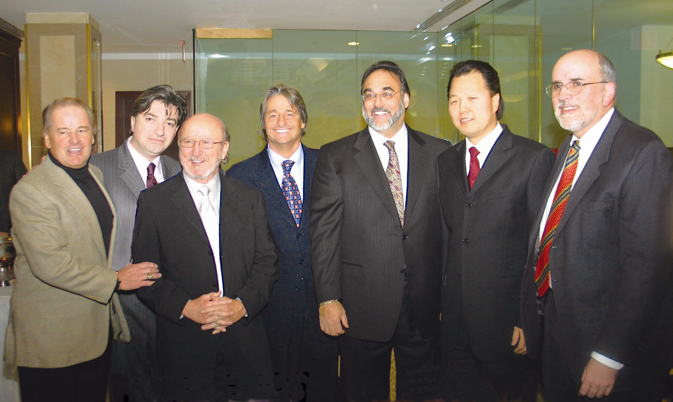

JASON J. KIM DENTAL LABORATORY HONORED BY NEW YORK UNIVERSITY COLLEGE OF DENTISTRY -- Underscoring the importance of the technical aspects of aesthetic dentistry, the internationally acclaimed New York University College of Dentistry (NYUCD) recently honored Jason J. Kim Dental Laboratory, Great Neck, NY, as one of the founders of the College’s Rosenthal Institute of Aesthetic Dentistry by naming the laboratory in the Institute the Jason J. Kim Laboratory. Pictured at the ceremony at the Rosenthal Institute in Manhattan are (left to right): Rod Gilbert, former New York Ranger and member of the Hockey Hall of Fame; Peter Kouvaris, Oral Design member, Vice President and Partner of Jason J. Kim Dental Laboratory; Robert Campbell, Chairman and CEO, BBC International; Dr. Larry Rosenthal of the Rosenthal Institute of Aesthetic Dentistry; Jack Manno, Executive Vice President and Partner of Jason J. Kim Dental Laboratory; Jason J. Kim, Founder and President of Jason J. Kim Dental Laboratory, Oral Design Member and President of Oral Design New York; and Michael Alfano, Dean of the New York University College of Dentistry.
(Photograph by Stan Zlotnick)

###

