2005 ESSENCE MUSIC FEST TOUR PACKAGE
TO
NEW ORLEANS, LA JUNE 30 – JULY 4, 2005
LAND PACKAGE – 5 DAYS, 4 NIGHTS
(Transportation to New Orleans from your location is not included in this package.)

SINGLE OCCUPANCY $899 DOUBLE OCCUPANCY $599
TRIPLE OCCUPANCY $549 QUAD OCCUPANCY $499

DELUXE TOUR PACKAGE INCLUDES

*Four (4) Hotel Nights at the Luxurious Wingate Inn Airport!
*Lunch at the World Famous RALPH & KACOO’S in the French Quarters!
*Lunch, New Orleans Jazz and a two (2) hour cruise down the Mighty Mississippi
River on the Authentic Steamboat Natchez!
*Chartered ride on the Original New Orleans Streetcar sipping frozen Daiquiris
(Daiquiris included) through the historic Garden District to World Famous Canal and
Bourbon Streets!
*Chartered Bus Shuttle Transportation from the hotel and downtown New Orleans All
Day to All Scheduled Music Fest Concerts at the Superdome, Seminars and the French
Quarters!
*All Hotel Taxes and Gratuities!
**DEPOSIT: $200.00 (Due at time of Booking. You can pay online @ www.dottiemarketingroup.com or via MoneyGram Express Pay @ $6.50 (Go To Walmart) for Any Amount, from Anywhere in the USA)
**BALANCE DUE: June 17, 2005 Be sure to call the Reservations Department @ 1-866-418-0133
or 1-866-747-9831 to Confirm Availability. When your deposit is received, a confirmation email or
confirmation fax will be sent to you.

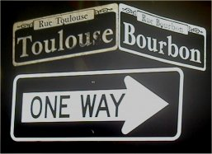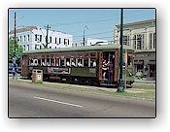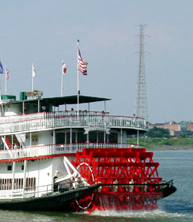

"Historic Bourbon Street & Toulouse in the French Quarters"

"The Original New Orleans Streetcar, the oldest continuously operating street railway system in existence!"

"The authentic Steamboat Natchez, a truly classic expression of the best of America's great steamboat tradition!"


For Reservations Call: 1-866-418-0133 or 1-866-747-9831
www.dottiemarketingroup.com * dottiemarketinggrouptravel@yahoo.com
*Airfare Reservations not included in this Land Package.

