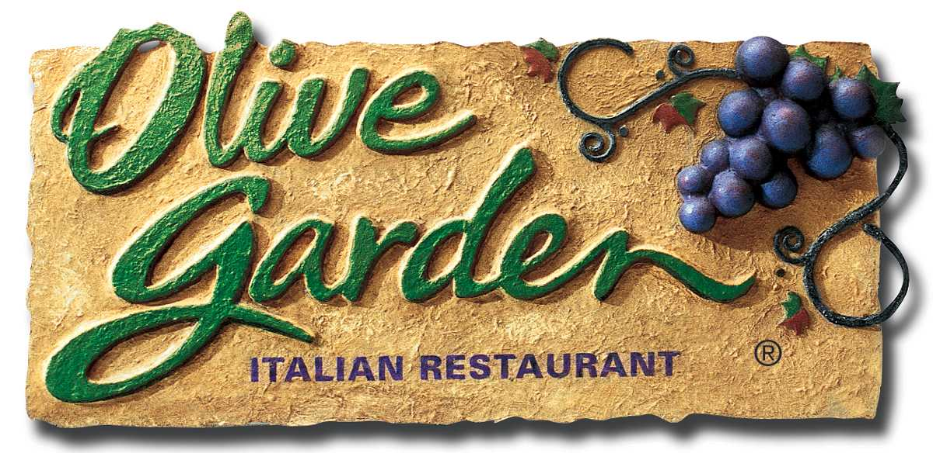

AT-HOME RECIPE FOR
OLIVE GARDEN’S SMOKED MOZZARELLA FONDUTA
Serves Eight

Wine Pairing Recommendation: Beringer PVS White Zinfandel

Ingredients:

1 loaf Italian bread, such as ciabatta or semolina, sliced into ¼ inch slices
1 cup sour cream
1 teaspoon thyme
½ teaspoon crushed red pepper
¼ teaspoon cayenne pepper
3 cups shredded mozzarella or smoked mozzarella cheese*
3 cups shredded smoked provolone or provolone cheese*
(*This recipe calls for one of these two cheeses to be smoked and one to be
regular)
3 tablespoons grated Parmesan cheese
3 tablespoons grated Romano cheese
8 teaspoons fresh diced tomatoes
Fresh chopped parsley

Preparation:

- Arrange sliced Italian bread flat on a baking sheet and cover with foil. Set aside until ready to use.
- Preheat oven to 450 degrees F.
- Combine sour cream, thyme, red pepper, cayenne pepper and four cheeses in a large bowl and blend thoroughly.
- If serving family-style, spray an 8” x 10” casserole dish with pan spray, then use a spatula to transfer the mixture. For individual servings, spray eight individual heat-resistant serving bowls, such as soufflé cups, with pan spray and fill each with ½ cup of mixture. Place individual bowls on a baking sheet.
- Using a large spoon, spread cheese mixture to create an even surface.
- Place casserole dish or baking sheet with individual bowls on center rack in oven.
- After five minutes, place baking sheet with bread, still covered, on top rack in oven. Bake for an additional five minutes.
- Remove bread and fonduta from oven.
- Garnish casserole dish with diced tomatoes and parsley in center of fonduta or divide evenly among smaller bowls.
- Arrange bread slices around bowl(s) and serve immediately.

