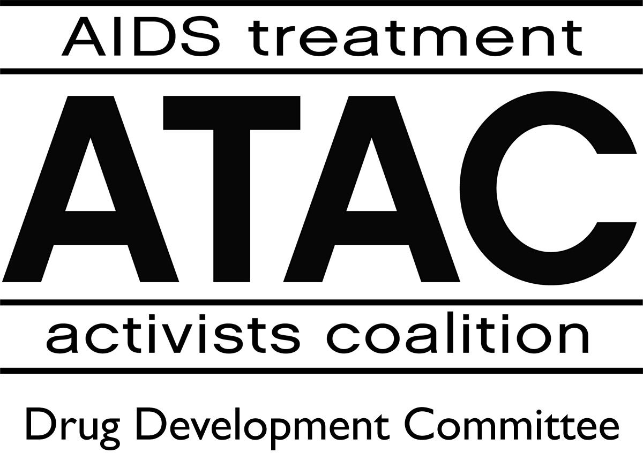
PRESS RELEASE
FOR IMMEDIATE RELEASE

Contact: Lynda Dee
(410) 332-1170
lyndamdee@aol.com

AIDS Activists Cry Foul as Drug Companies Push Prices to Record Levels

(NEW YORK, July 9) — A steady onslaught of “unreasonable, unacceptable, and unjustified” increases in the price of therapies to treat HIV has caused activists in the US to accuse drugmakers of artificially inflating the market at the expense of people living with HIV/AIDS. As an example, activists point to the recent launch of the new drug Aptivus, a protease inhibitor developed by Boehringer-Ingelheim, which came in at the highest price ever for this class of medication—more than $13,000 per year, which does not include the cost of other medications that must be taken in combination with Aptivus.
“We are approaching the point where a year’s worth of HIV medications in the US will cost anywhere from $30,000 to $50,000 a year. Every time a new medication is made available, it usually comes in at a new higher price than others in its class,” stated Nelson Vergel, a member of the AIDS Treatment Activists Coalition. “The same thing happened with Reyataz, another protease inhibitor made by Bristol-Myers Squibb. It was the first once-daily medication of this kind, and the company priced it at an all-time high, with regular increases since then. It now costs almost $11,000 per year. This behavior is simply unreasonable, unacceptable, and unjustified.”
Indeed, many healthcare and community groups question why there is no guidance for drug pricing based on type of medication or disease. In the US, prices charged for medications are often much higher than in other developed countries. This tends to work against patients, even those who have insurance. Howard Grossman, MD, Executive Director of the American Academy of HIV Medicine notes, “Many insurance companies have focused on the high price of drugs to treat HIV. Healthcare providers are finding their choices increasingly limited as higher-priced drugs are taken off ‘preferred’ lists, in some cases raising
(MORE)
patient copays from $20 to $75 or more per prescription. Anything that prevents doctors from prescribing the properly-indicated drugs reduces our chance of controlling HIV. High prices are driving this.”
But privately insured patients aren’t the only ones suffering under this no-hold-barred system of pricing for life-saving and medically necessary medications. Public payer systems, such as the underfunded AIDS Drug Assistance Programs (ADAPs), provide medications for more than half of all patients with HIV/AIDS in the US. These programs must renegotiate prices regularly with drug companies, and steep increases in medication prices make it difficult to provide medication to the same number of people each year. With numbers of new infections increasing steadily and flat funding for ADAPs, medication waiting lists have developed in several states. To make matters worse, new legislation forbids government negotiation with drug companies on prices. In other words, patients receiving government assistance for healthcare may not have access to new and better medications if excluded from formulary because of expense. Even if the medications are added, they will cause patients to meet individual spending caps even more quickly and will use up allotted budgets.
“Sadly, Boehringer-Ingelheim failed to realize that the size of the potential Aptivus market is directly tied to patients’ access through publicly funded programs, and they just made that market a lot smaller,” said Lei Chou, Director of Mobilization at the Community HIV/AIDS Mobilization Project (CHAMP). “State Medicaid Programs will delay coverage of the drug for months, AIDS Drug Assistance Programs will have to place access restrictions or may not cover it at all. This pricing decision will put Aptivus out of reach for the majority of patients who can benefit from it.” As companies continue to create a system of haves and have-nots for people living with HIV/AIDS, activists plans to redouble their efforts against price-gouging and profiteering. By working with legislators, consumer protection groups, and other advocacy groups, AIDS activists envision a future where unbridled greed does not dictate what treatments patients can afford or how public resources are spent in the effort to keep people alive.
ATAC (www.atac-usa.org) is a national coalition of AIDS activists, many living with HIV/AIDS, working together to end the AIDS epidemic by advancing research on HIV/AIDS.
###

