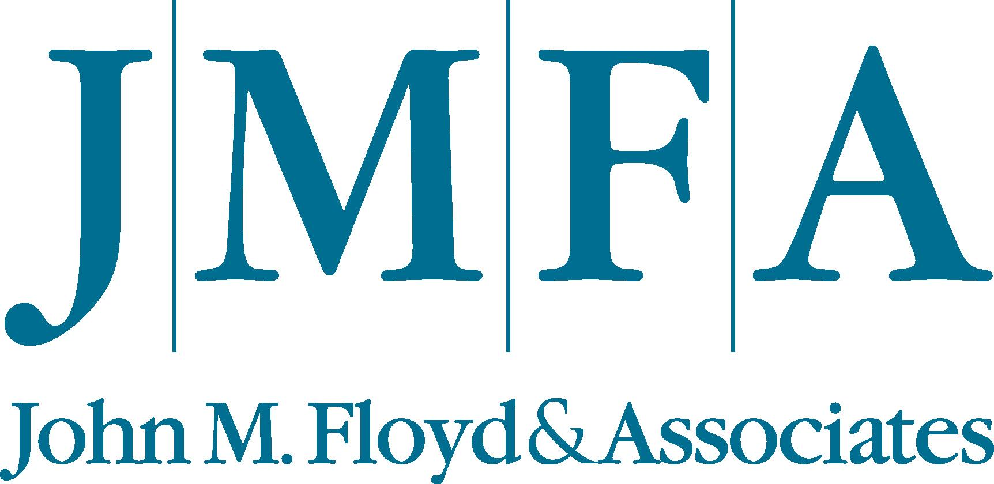 JMFA FACT SHEET

Company:
John M. Floyd & Associates, Inc. (JMFA), 125 N. Burnet, Baytown, TX 77520
800-809-2307 or 281-358-4026

History:
John M. Floyd & Associates was founded in 1972. The profitability-consulting firm has served more than 2,000 financial institutions in 49 states and Central America, adding billions in increased pre-tax earnings for its clients. JMFA has successfully implemented its overdraft privilege program in more than 900 banks, thrifts, S&Ls and credit unions.

Services:
Operational, financial and delivery systems re-engineering. JMFA also is recognized nationally for its training, incentive and earnings enhancement programs, as well as its product, service, pricing and technology improvement consulting services.

Key Products:
Focus is on compliance, accompanied by proven risk management tools. The JMFA Overdraft PrivilegeSM program is a non-discriminatory, automated service that helps accountholders avoid added costs and embarrassment from bounced checks or share drafts. The consumer-friendly program – 100% guaranteed compliant with federal and state regulations – helps financial institutions enhance accountholder satisfaction while increasing non-interest or fee income. Contract to implementation typically takes about eight weeks. Fees are flexible and performance-based, with fixed or contingency options. JMFA only makes money when the institution makes money.

Privilege Manager CRM^{tm} is proprietary software that automates tracking and reporting after overdraft privilege is installed.

JMFA Account AcquisitionSM is a turnkey checking or share draft account marketing program that also helps build branch traffic, establish new relationships, generate more cross-sell opportunities and increase fee income.

Loan OptimizerSM is effected through www.LoanOptimizer.com, the first bank-to-bank lending portal of its kind. It brings banks together through the power of the Internet and allows them to fund and participate in loans together.
Page 2 – JMFA FACT SHEET – May 12,, 2004

Management:
John M. Floyd, Chairman, CEO & Founder; Tony C. Blevins, Vice Chairman & CFO; Cher M. Floyd, Chief Operating Officer; Cheryl Lawson, EVP-Implementation; Kathy Morales, Chief Administrator, Steve Swanston, EVP-Sales, Stefani Soza, Marketing Mgr.

Field Executives:
National Director, League & Associations...Jared Cahill
Executive Regional Directors…Ron Jennings, Richard Miller, Mark Roe
Regional Directors…Bill Adkins, Alton Arnett, James Atwood, Wes Baggett, Darin Byrd, Chris Fisher, Gary Gilman, Sheri Hoffman, Mitch Hurd, Ed Juskowski, Ray Keel, John Kirk, Richard Lafferty, Greg Stumler, Waid Thompson, Kent Wyatt, Tom Young
Engagement Team…Training is what sets us apart from other profitability-consulting firms. Our Engagement Team has more than 900 years of combined experience in the financial services industry. They facilitate on site training at each institution for all employees at every level. Our training is designed to provide an opportunity for your staff to understand management objectives as well as the benefits of our program to account holders and the financial institution.

Banking Industry Partnerships:
John M. Floyd & Associates is an “Endorsed” or “Preferred Provider” for the JMFA Overdraft Privilege^{sm} program to the New Jersey Bankers Service Corporation, Wyoming Bankers Association, Independent Bankers Association of Texas, Community Bankers Association of Oklahoma, Community Bankers of Louisiana, Iowa Independent Bankers and Iowa’s Community Bankers.

Credit Union Industry Partnerships:
JMFA is a Strategic Alliance Provider for CUNA & Affiliates; endorsed by IntegraSys, a Fiserv Business Unit and leading core technology solutions provider for credit unions, and by Summit Information Systems; and is a “Preferred Provider,” “Business Partner” or “Service Partner” for the JMFA Overdraft Privilege^{sm} program with league, association or service corporations representing Alabama, Arizona, California/Nevada, Florida, Hawaii, Illinois, Indiana, Kentucky, Maryland, Michigan, Mississippi, Nebraska, New Jersey, New Mexico, Oregon, Pennsylvania, Tennessee, Texas, Washington and Vermont.

Web Sites:
www.JMFA.com;
www.LoanOptimizer.com

Page 3 – JMFA FACT SHEET – May 12, 2005

Key Facts & Statistics on Overdraft Programs:
- An estimated 2,500 to 3,000 of the 18,000 financial institutions in the United States now have defined and communicated overdraft programs.
- The typical fee charged on an insufficient funds (NSF) check is $17 to $35. The average is $22.50.
- Studies indicate the average customer or member writes about 3.4 NSF items/year.
- Unfair practices endemic to the implementation, marketing and management of some overdraft programs include consumer discrimination; over-promotion of the service; under-education of consumers about its use, and overdraft limits based on a “mystery matrix” not communicated to users.
- A JMFA Overdraft PrivilegeSM program generally increases the client’s NSF income by 50 percent to 300 percent.
- To date, the average improvement in NSF income for JMFA Overdraft Privilege^{sm} programs -- installed and tracked for at least six months -- is 119%.
- About 25% of an institution's accountholders provide all the NSF revenue before overdraft privilege. After installation of overdraft privilege, the remaining 75% are given the opportunity to use the service and do from time to time.
- JMFA’s Privilege Manager CRM^{tm} (collection management software) typically keeps charge-offs in an acceptable 4% to 5% range. The recovery rate after charge-offs is generally 25% to 40% when JMFA's operational recommendations are followed.
- JMFA has installed its program on nearly all credit union operating systems.
- An accountholder who writes an average of one NSF item per month has the equivalent earnings value of an accountholder who maintains an average collected checking/share draft account balance of $17,691¹. (That is based on a $25.80 NSF fee at a 1.75% Fed funds rate.)
- A well-managed overdraft program is a win-win-win for the consumer, merchant and institution, saving all embarrassment, productive time and money.
- Automated programs identify troubled accountholders for valid counseling.

NOTE: John M. Floyd has spoken coast-to-coast about the many benefits of well-managed overdraft programs and the potential abuses of those that are poorly implemented. He has addressed the Consumer Advisory Council to the Federal Reserve System; the American Bar Association’s Business Law Section and the Financial Issues Conference of the Consumer Federation of America and shared his viewpoints editorially in leading daily newspapers and magazines. He and key executives are available for speaking engagements.

FOR MORE INFORMATION, INTERVIEWS OR POTENTIAL SPEAKERS: Preston F. Kirk, APR, Kirk Public Relations, Austin TX, 830-693-4447; kirk@281.com

¹ Bankrate.com

