
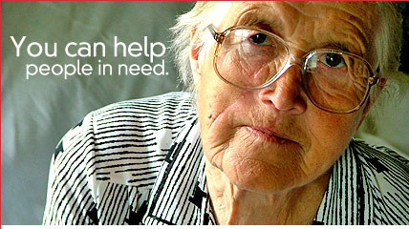 |  |  |   atastrophic Hurricane Katrina has devastated the entire gulf coast, leaving thousands dead and millions homeless. Now you can help the relief effort by donating your used cell phone. Even something as seemingly small as a used cell phone can go a long way toward relieving the suffering felt by Katrina’s victims.  With more than 300 million unused cell phones laying around in drawers and closets we all are likely to know someone who would like to help hurricane victims.  Whether you’re an individual or company, your  donations are welcome. 100% of the proceeds are going to benefit the American Red Cross.  INSTRUCTIONS:  1. Tell everyone you know or work with about this donation program!  2. Tell others about CashInMyCell.com and how they can help when you talk to them.  3. Donate your used cell phones today!

   | 

