Interview with Niki Yan
the Confessionist, the author of “ My Love for you, Tom Cruise – A desperate Chinese girl’s confession

Love, Career and Beyond (Niki talks herself)

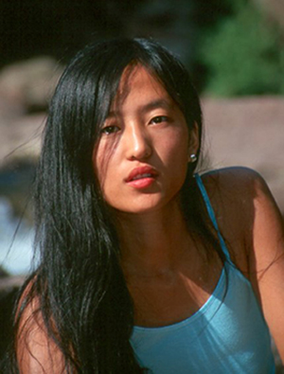

When the first time you saw Top Gun, you life was upside down, right?

Yeah. I was like:” I want to be Top Gun too, just like him!”

So, this book is a really good release for you?

Absolutely. I definitely feel so much better now. No more Tom Cruise! Man, (laughing). The book pretty much emptied me. I was like a pear, and Tom Cruise was a squeezer , all the juice is gone, and I have nothing left!

Yeah, writing does take a lot of YOU away!

Yup! cause when you were writing something from your heart, it takes passion, blood, sweats, even tears. And I was taken away! That’s what creation does for you. At the same time, I am satisfied, as you said, a good release, after I put the final period on this book, I was like: “WOO-HOO!” I was jumping around in the house; I felt I was like a pregnant woman just giving birth a child. It’s a GREAT feeling!

So how this book came to your mind?

I want to inspire other people, also express my gratitude to Tom Cruise. I felt it was my mission and I just had to do it. It came naturally, just like when you fall in love, you start losing weight. When you’re inspired by someone, you want to share with the world. This book is very personally, it’s all based on my own experience, physically, emotionally, spiritually, and I can’t write something I never experience.

So you really feel that strong for Tom, or he is just a metaphor as you mentioned in your book?

I don’t think they are separate. Because I feel that strongly for him, so he is the metaphor of my ultimate dream and love, cause he is my ultimate dream and love that’s why I feel strongly for him. In my book, Tom Cruise means Tom Cruise, the real person, and this person is my ultimate dream, it’s actually one thing. He represents a true American dream. He came from nothing, he achieved all the things by himself, and that’s very inspiring and encouraging.

Your role model?

Yes. When I talk about Tom, I mean his energy and attitude, the way he deals with his life. That’s what intrigues me. And I am still learning from him…cause for a responsible human, we’re always looking for the perfection of life…maybe we can never reach, but we can always get closer.

What’s the definition of a perfect life for you?

Be happy. Be grateful. And help others. Try to make the world better everyday. Being a complete human, you know?

So how much are you close to that?

[Laughing] I’m on my way. Half way maybe. But I think Tom Cruise is very close, that’s why I admire him, that’s why he is already ahead of us. But I’m also very grateful about what God already gave to me, being alive, and having the perfect body and mind. And I don’t take it for granted. I love myself, I don’t do stupid things to damage my mind and my body, I am happy, that’s why I can love someone else, like Tom Cruise, cause I can give. Tom has the tools from Scientology to improve his life, and I think that’s great, we call need some sort of belief to keep striving for the ultimate health and happiness.

You are not religious, aren’t you?

I’m spiritual.

So would you be a Scientologist ?

Well, Tom Cruise is my scientology. So, I am ok now.

Tom believes in reincarnation.

Me too. We are spiral being, we are eternal, we come to life many times.

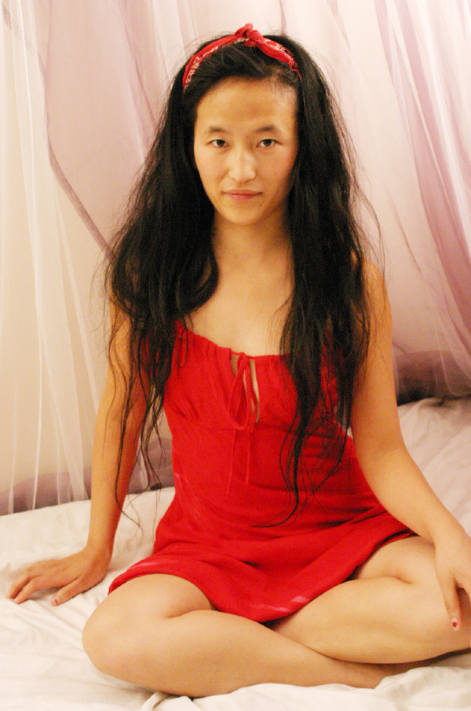

So are you still obsessed with him?

I was never obsessed with him. I never wanted his autograph or something. I am just a normal girl who wants to express myself, and Tom Cruise plays the role of bridge in my book and in my life. The bridge from a small village with limitation to my ultimate dream with honor and success.

My love for Tom is something larger, it’s appreciation and admiration, it’s universal love, it’s human, it’s one spirit’s expression to another.

He inspired me from a confused poor girl to a young talented writer and actress. I can’t enough about his impact on me on a spiritual level. This does not happen to everyone. This is already a miracle. I am so grateful.

Our longing is our calling. A woman definitely can appreciate a man at the purest level right? There got something simple like this. The passion INSIDE of the sea is much more deeper and powerful than the storms on the surface. Maybe my passion is in different form now, but you know there is something never changes, it may not visible, but it’s always there. It does not change by the time and space. It’s eternal.

So you never thought about marrying Tom?

To be honest, I never thought about it. I wrote this book to express my own appreciation about him, about another human. You have to understand Tom Cruise changed my life and he forged who I am today. He taught me the importance of courage and faith, love and compassion, determination and responsibility, What more can I ask from a human?

You really can’t expect anything more from another human, he is already magnificent, just because the way he is, I admire him as an actor, I appreciate him as a human, even more, he is compassionate and generous, faithful and responsible, he is a truly legend, he is the most beautiful person I have ever seen. Not only because he effected my life, but also he is going to effect my life, the inspiration has to go on.

As long as I feel full-filled inside, I am ok.

Well, you book is called: “ A desperate Chinese girl’s Confession…”

I have no problem to be sarcastic, and make fun of myself. I enjoy laughing. People say my laugh is outrageous. Well, that’s me, nobody can stop me from enjoying life and being funny. I like my book title. I laugh at it myself. It’s funny, it’s also different, and interesting.

You don’t knock on Tom’s door in the middle of the night any more?

I never knocked on his door in the middle of the night. I don’t even know where he lives! That’s not what I care about. I’m already grateful about what I have now.



You know, life is what happens to you when you’re making other plans. You do what you can, and good things will come to you, surprises, very good surprises. It’s all about attitude, it’s much more important than talent.

You think you got a good attitude?

Yeah, a positive attitude. I really don’t expect anything from Tom Cruise. When it happens, it happens. I can’t control that. I’m ONLY in charge of my own life. But it would be nice if he calls, if not, I’m still going to succeed.

That’s the right attitude to have.

Yup.

In your book, there are a bunch of poems you wrote for Tom. Just out of curiosity, how could you feel that emotional and deep for someone you don’t even know? I mean you met him stuff like that, but still nothing personal, you guys never hanged out…please explain how you do it? Especially the “Waiting for you for a thousand years.”

It’s a very good question, cause sometime I wonder myself. It even surprised me, after I wrote all those poems, and I go, “WOW! How could I write something like that? I’m pretty much a stranger to him. Well, all I can say is it’s Cruise power, he gave me the energy and inspiration, so I give the credits to him.

After I saw him that night, I got home, I just felt like something really powerful coming from inside, and I could not help, so I wrote the first poem for Tom. Everyday, everyday I had new feelings and new inspirations because of him, so I just put it on the paper as the form of poetry. And one day, I just felt like a STRONG feeling about him, I don’t know why, there was a tremendous storm and lightning running through my head, I could not control, so I wrote “Waiting for you for a Thousand years.”

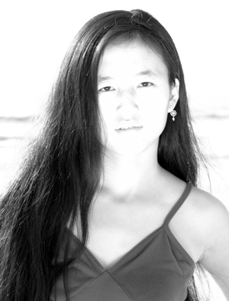

After I read it…I said WOW, this is amazing, a young girl from China feels such STONNGLY for Tom Cruise, 1000 years, man, all the lonely hearts in the world probably moved by the message you sent in this poem, a lot passion, faith, also pain in it…could you explain?

Well, some people probably would say I was bullshittng, it’s just too strong to be true…how the hell you felt like that about Tom Cruise?

Well, that’s only my intuition, instinct, and imagination. And I trust those.

A strong man with a kind heart, that’s kind of man I admire. When I was writing it, a desire for love, longing for something incredible unconditional came through and that’s the message I was trying to send. I want to sacrifice even myself to pursue and keep the love and faith I would have for something or somebody. You know? I just want to give…it moves me, like the last samurai, something never changes in the deepest of your heart, I think that’s most powerful forth, when we have it, we can make miracles happen. And it’s what I care in my life: persistence, loyalty, faith.

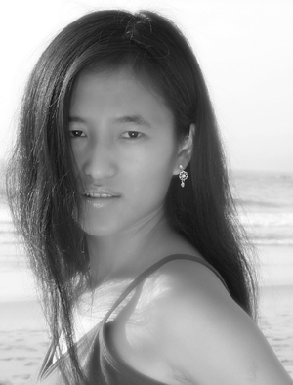

It’s a comfort for me to write such a long emotional poem, it’s heart-filling and soul-satisfying for me. It makes me believe eternity does exist.

You seem like a very sensitive, passionate person, the sensitivity will help you a lot for your acting?

Absolutely. That’s why I want to act. I like the expression of body language.

Could you tell me more details?

Well, I just felt like body language is a more direct way to express myself, art is expression, they are many forms of you can do to express, paining, singing, sculpture, dancing, writing, filming, acting, and I choose film and acting. Movie may not be the purest form of art, but it’s definitely the most powerful and richest form to send messages. It combined all the arts, it’s an ultimate art.

Why I want to act? Cause the energy inside of me want me to express myself; to explore how far a human being can go both emotionally and physically; to experience a lifetime adventure. I believe I have the natural talent of acting. I act by my instincts.

And life is a series of discovering and accomplishing yourself. If you have the talents, you better do something about it, and that’s my life goal, to use my talent create a life I desire.

The real life is very limited, but if you’re an actor, you would experience what you can’t in real life, and you could live 1000 times. And you don’t have to be yourself, just experience an amazing story which’s happening in another dimension. That’s another reason I choose acting. I love life too much , and I want to live a 1000 times!

And I agree what Tom said about acting, he said: “you have to let it flow…you do all your homework and all of your work artistically so you can just let it fly… all that preparation is for that burst of spontaneity, that spark, those moments…” That’s exactly how acting is. The thing is you got do your homework, you got understand the character completely and be that person as close as you can, then the burst will come, the spark will come spontaneously. And I like work with director who gives actors those freedom. Tom said that’s why he likes to work with Michael [Mann] and Spielberg.

Directing is probably the most creative part for a film, I want to try direct too.

How is your acting going?

I am doing it. And I have no doubt that I will be a great actress. Courage, talent, persistence, that’s the key.

When I first time moved to LA, people told me it’s not about what you know, it’s about who you know. It’s true. But the thing is you have to meet the right person, people say go to this party, go that party, so called networking party, industry party. But you know what? It’s just bunch of bullshit. Good products don’t need labels. You know what I mean? A lot of dangerous people around in this city, and they try to bring you down. They promise you this and that, but they are not true, you know? So I don’t go to those parties any more to try to meet a big producer or director. I don’t want to waste my time. I like to work on my own craft, that’s why I wrote own script. But real-deal parties should not be missed. I was about to kick my ass cause I missed the Christmas party at Tom Cruise’s House…that’s kind of party I’m talking about.

I know people who have living in Hollywood for 20 years but accomplished nothing, and all they did was an extra 20 years before and after, nothing changed. That’s a shame. I don’t wait on my ass to wait someone discover me overnight, and I don’t focus on one way to approach and not change either; if one way doesn’t work and I would like to change to different way, it’s not about what you do, it’s about how you do. If you believe your dream will come true, guess what? Your dream will come true, it’s that simple. The thing is you got find your own way to approach, cause millions of actors out there, you got to do something they never done, you got do something unique and different and tell people who you are. If we all wear the same cloth, I will wonder what my identity is. All I’m saying is being creative, being different, choose the road less-traveled.

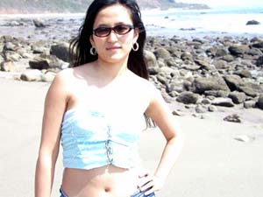

There is a Chinese saying: “There is nothing you can’t do, there is only things you can’t think of.” You create your own luck, your own destiny, so don’t give up your power. I have been so many auditions and casting calls, and get rejected all the time, but you know what ? I am going to make it. “Without bitter, the sweet is not as sweet!”

That’s the line from Vanilla Sky ?

Right.

So how’s your script going?

It’s finished. I try to get it into Tom Cruise’s hand, I expect him starring in it. In the mean time, I am working on a few other stories.

I can see your humor in your book, so are you only interested in acting in comedy or…

No, I don’t limit my self, I can do comedy, and I can do drama as well, even action…I’m very versatile. I can do a very sad scene with you now, I can cry really badly if you want me …

No, no…not now, maybe some other time.

I can do a big range of emotions. Even though I am a comedian in the real life, all my friends and people I met said I should be on stage as comedian, like Magarate Cho, I’m going to give it a try. No funny no money, No money no honey,

So no funny no honey?

That’s right. I’m also very active physically, I’m like Tom, very active. I practice yoga, dance, martial arts etc.

Kung fu?

Yeah.

Have you taken any class for that?

Yes, since high school.

Versatile, huh?

I just enjoy doing those. They are my hobbies and it’s good for doing action films. So that I can jump around without hurting myself…

You can always get stunt.

No, I like doing it on my own.

Cool. Could you show me some kicks?

Now?

Yeah. You would probably kick my ass…and I don’t run fast…

That’s right.

Maybe Tom will fight you in Mission Impossible 4 or something…

Can’t wait.

So did you really get training for climbing Everest?

Sort of.

You really want to go? You think you will make it? Oh, forgot, you will go with Tom, I don’t need to worry about that..

Nope.[Laughs]
I love adventures. And I’m always looking for new challenges. I am an outdoor person, I love all physical challenges. Seriously I would go with him immediately.

2006?

Yeah, so I still got time to prepare.

Let me know how it goes. And if anything happens, I will call your parents.

I will keep you updated, but I think I would be Ok.

Understandable. So Niki what is your favorite actor? Beside Tom Cruise of course…

There are a lot great actors out there… I would like to work with Johnny Depp. Did you see “Finding Nederland?” A beautiful touching film, you got see it. Johnny’s best performance so far.

What to do a film with Tom Cruise?

Of course, that’s what my script for.

You will be the female lead and he will be the male lead?

Yup.

Do you see a lot movies?

Yeah, all the time. I got see a lot free screenings.

How?

Well, a lot studios do advance screenings around the city esp. in Hollywood.

You live in Hollywood right?

Yeah, the heart of Hollywood.

So you like living in Hollywood?

Well, once I get the money I’ll move away.

So you really think you are going to succeed in the movie industry?

Of course.



Contact Niki: Stonesky2004[at]aol[dot]com; 323-464-0418

