- 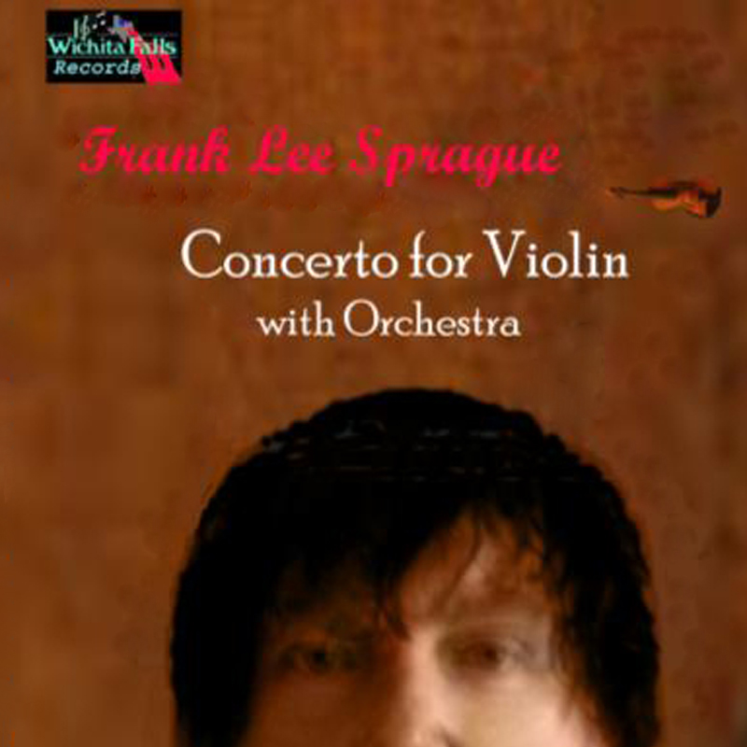Street date : March 4th 2006
- Artist name : Frank Lee Sprague
- Release title : Concerto for Violin with Orchestra
- Genre : Classical, Orchestra, Concerto
- Label : Wichita Falls Records (WFR344)
- UPC / Barcode : 634479266577
- Breakout tracks : Tempo de Walse, Allegro Assai
- Marketing info: IRIS Distribution, Wichita Falls Records
Artist's history Frank Lee Sprague is an American composer with over 1000 works to his credit. Many of his compositions have been debuted and performed in Los Angeles by the best musicians in the world including Ernest Ehrheardt, Karen Elain, Robert Korda, Brian Leonard, and more.
Originally from Wichita Falls, Texas, Frank has spent his life studying, writing, and performing music. His main instrument is the guitar. He has many works for guitar and also guitar with various chamber ensembles.
His newest recording is his Concerto for Violin with Orchestra.

This is music by a master craftsman, played to the hilt and recorded with stunning realism and fidelity. A performance of great emotional extremes, one that wrings every drop of expression from the music. The first steps on this Sprague pilgrimage lift the heart for the journey to come. Sprague has become among the most esteemed musical figures of his generation. Each work bears the unmistakable stamp of a wildly fertile musical imagination and a distinctive voice forged out of the wide-ranging musical languages.

Frank Lee Sprague is a new breed among American composers. His Violin Concerto is unique and fresh. The recording is gorgeous...an unusually beautiful disc. Superbly played, vividly recorded, simply the last word in unobtrusive virtuosity and sumptuous blending of tones. There's so much color and invention packed into this composition and
this world premiere recording offers a musical journey to the listener.

An outstanding contribution to the still far-too-small Sprague discography. This irresistible discovery, winningly championed by a new orchestra with this long-overdue first recording of his Violin Concerto, proves Frank Lee Sprague a musical genius of Mozartean universality and range. Virtuoso compositional skills and an amazing ear...full of passion, joy, sorrow, and love.
An ecstatically beautiful piece. Indispensible...get the CD!

  - Past sales history for the artist : From the Symphonic Poem released on the Wichita Falls Records Label through the highly successful Piano Quartet Frank Lee Sprague has a history of success in sales, reviews, and fan reaction.
  - Overall marketing plan for the release :Mass promotion efforts include paid advertisements as well as blog and website announcements and live concert touring worldwide.
  - Past and current radioplay : Frank Lee Sprague has a history of being well received in all markets and in all media including college and commercial stations and internet radio as well as NPR who featured 2 shows (All Songs Considered, All Things Considered) on Frank’s music.
  - Current and upcoming tour plans : Frank has 2 recent successful tours of Japan under his belt, and amongst his touring plans is an appearance in Liverpool, England. He recently appeared at the IPO pop festival in Los Angeles, California which has resulted in a live concert DVD.
  - press coverage : Frank Lee Sprague has received rave reviews in Playboy Magazine, Washington Post, etc, and continues to accumulate favorable reviews in all media including websites such as Buhdge.com
- Management: Art Fein (323)-851-5092 sofein@aol.com
- fls@frankleesprague.com www.frankleesprague.com www.flsmp.com

