- 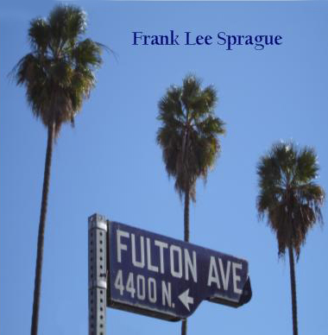Street date : March 4th 2006
- Artist name : Frank Lee Sprague
- Release title : Fulton Avenue
- Genre : Acoustic, Rock N Roll, Pop, Singer Songwriter
- Label : Wichita Falls Records (WFR342)
- UPC / Barcode : 634479243073
- Breakout tracks : Another World, My Dream Was You, Mixed Up
- Marketing info: The Orchard, IRIS Distribution, Wichita Falls Records
Artist's history : Critics and fans raved over Frank Lee Sprague’s 2004 album, Merseybeat and his highly anticipated sequel, Cavern. Now his all new acoustic LP is available from Wichita Falls Records.
Known for his remarkable ability to synthesize authentic rock ‘n’ roll styles into his own West Texas imprint, Frank Lee Sprague’s work has wowed reviewers in Rolling Stone, Playboy, The Washington Post, The New Yorker, and many other magazines and newspapers. He has appeared on CBS nationwide television and National Public Radio, and has performed live around the world, including several successful tours of Japan. With two Merseybeat-style albums under his belt, he will perform live at the Cavern Club in Liverpool in spring 2006.
Out of West Texas comes one of America’s premiere singer/songwriters ready to break into the mainstream. Frank Lee Sprague has released music in the past that refuses to be pigeon holed although many of his songs would fit well into one or more of these genres; Rock’n’roll, Pop, Singer/songwriter, Adult contemporary, British Invasion, Americana, Roots, AOR, Alternative, Surf, Instrumental rock, Classic country, Rockabilly, Swing, Modern rock, etc.
Starting to get the idea? Well, think again: Sprague is also a serious composer of classical music with over 1000 works to his credit!

Now, after releasing 2 Merseybeat style CD’s that have gained him even more respect from critics the world over, Frank has completed his latest LP FULTON AVENUE featuring 14 all new/original songs which are mostly acoustic.

Sprague has earned his reputation as one of the finest guitarists playing today, and on this new record he performs on classical guitar, acoustic guitar, as well as many other string instruments and acoustic instruments. Each song calls for it’s own unique and unmatched style of original guitar playing that Frank is famous for, and fans of acoustic music will be delighted at the performances as well as the songs. The album is completed by 2 songs with electric guitar, and Frank reveals his one of a kind talent for that instrument as well.

  - Past sales history for the artist : From the Sprague Brothers releases on the Hightone Record Label through the highly successful releases in Japan on the EssBee label and the El Toro Records label in Spain and now his 3 LP’s released on Wichita Falls Records Frank Lee Sprague has a history of success in sales, reviews, and fan reaction.
  - Overall marketing plan for the release :Mass promotion efforts include paid advertisements as well as blog and website announcements and live concert touring worldwide.
  - Past and current radioplay : Frank Lee Sprague has a history of being well received in all markets and in all media including college and commercial stations and internet radio as well as NPR who featured 2 shows (All Songs Considered, All Things Considered) on Frank’s music.
  - Current and upcoming tour plans : Frank has 2 recent successful tours of Japan under his belt, and amongst his touring plans is an appearance at the Cavern Club in Liverpool, England. He recently appeared at the IPO pop festival in Los Angeles, California which has resulted in a live concert DVD.
  - press coverage : Frank Lee Sprague has received rave reviews in Playboy Magazine, Washington Post, etc, and continues to accumulate favorable reviews in all media including websites such as Pop Matters.com
- Management: Art Fein (323)-851-5092 sofein@aol.com
- fls@frankleesprague.com www.frankleesprague.com

