Primary Skills Arts Institute June 2006 Position Statement
Buker Community Center, 32 State Street, Augusta, Maine 04332 www.pskills.org 207-446-9769 primary@pskills.org

Goal: Equality, Respect, and Mutual Understanding through Cultural Preservation

Mission: Our mission is to fuse concepts, theories, and philosophies of Native American, European American, and West African cultures with other world cultures to create cultural diversity programs.

Vision:
- Providing sound and innovative cultural programming that integrates unifying cultural concepts and activities to offer communities and individuals new ways of seeing, thinking and new beginnings;
- Retaining and designing a sustainable Art Explorium to safe keep and house a living Performing Arts Center, a Cultural Museum, and Learning Center in Maine;
- Collaborating and providing supportive services in our immediate community:
* Mental health/special needs * K-12 school communities
* Colleges, churches, and businesses * Prisons
* Retirement homes * Students at Risk programs

Philosophy: P.S.A.I participants transcend cultural barriers through chants, stories, sounds, poetry, movement and colors. Our programs offer self developmental, community awareness, cultural identity, cultural diversity, cultural acceptance, and cultural toleration skills through the use of basic math, geometry, history, culture, and geography. We design our programs with socially acceptable concepts and themes to address issues such as: self-esteem, prejudice, harassment, non-violence, conflict resolution/mediation, peer leadership and supporting roles, responsibility, identity development, transferable skills, communication, language, violence, suicide, genocide, and general physical, emotional, and mental well-being.
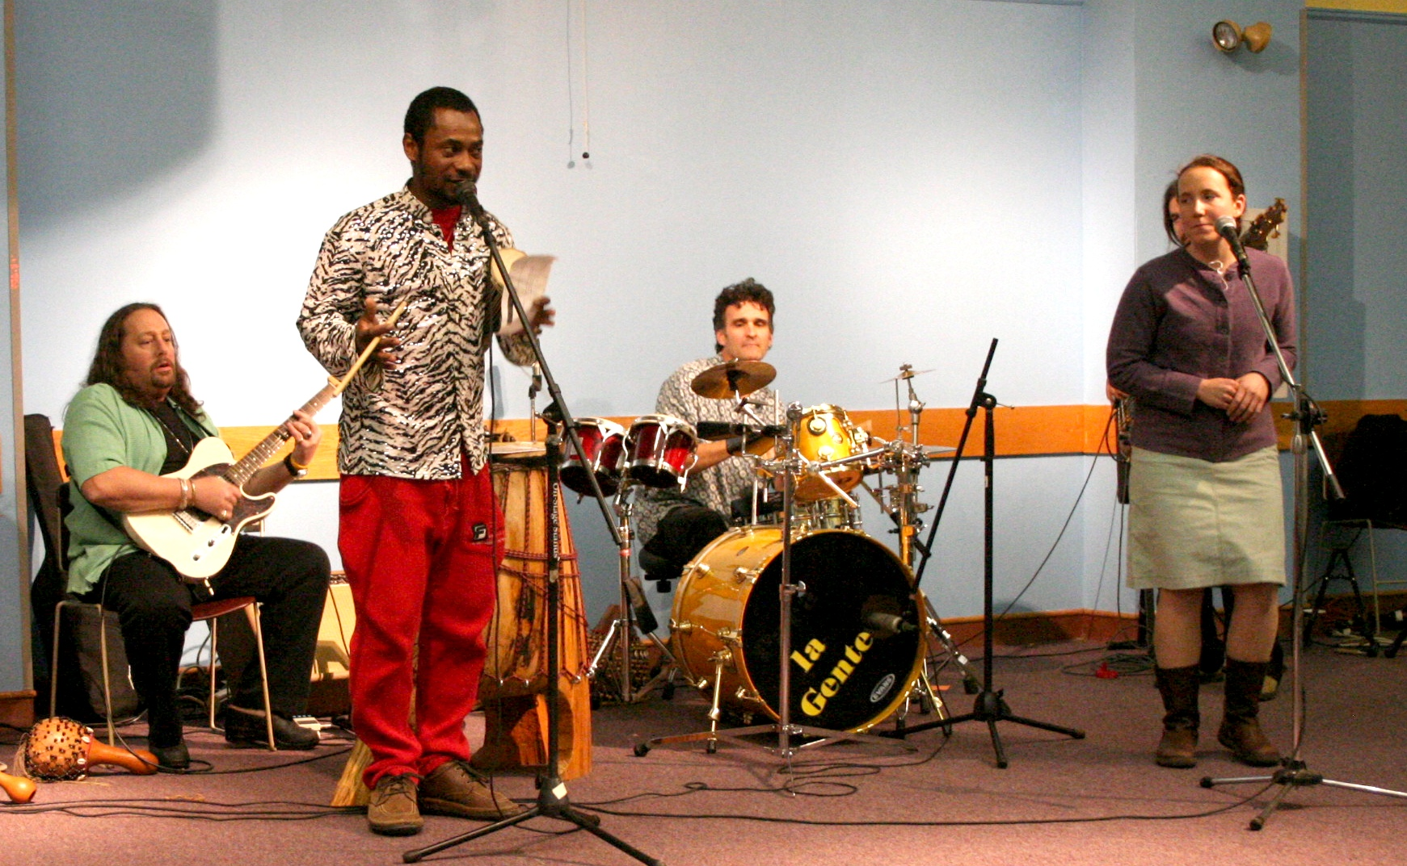
P.S.A.I. offers interdisciplinary activities to promote self-developmental skills in communication, self-awareness, a concern for others and the environment. By using the non-material arts, informational technology, and multi-media in social-recreational activities we promote environmental, physical, cognitive, and emotional well-being. Collectively this promotes community learning, supports creativity, and increases societal and cultural interdependence.

Background: Since 1995, PSAI's founders saw the pressing need for social growth and the cultivation of global citizenships through a centralized multi-cultural arts organization in Maine. By empowering individuals to break the barriers of cultural bias through sound, movement, drumming, communication, and other tools; we envision a world where the cultural arts are used as essential educational models to understand modern communities today, to see how people affect the planet, and to assure a healthy and sustainable tomorrow.
PSAI secured its 501-c-3 non-profit status in 2005 to promote diversity and enhance cognitive, physical, environmental, and emotional well-being through integrated learning and audiovisual (non-electronic and electronic) developmental activities. It is a grassroots, multi-cultural arts, educational, and heritage organization with 501(c)3 non-profit status providing a diversity of programs to Maine's youth, citizens, and beyond. PSAI is part of the Enrichment Program of the Maine Attorney General’s Civil Rights Branch. In addition to school and community presentations, they have presented at the American Folk Festival in Bangor, Maine and will be presenting at the 25th Lowell Folk Festival, Lowell, Massachusetts. Director, Kwabena Owasu, native of Ghana, was presenting in his homeland by the age of nine, has presented extensively in the United States, and is currently pursuing a Masters Degree in Criminal Law. By May of 2006 they had already doubled their number of presentations from the full year of 2005.
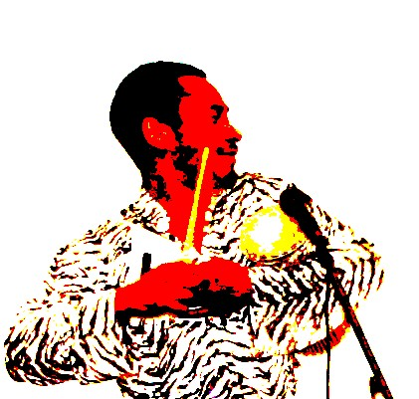
Director, Kwabena Owasu

Organizational Goals:
Please see attached sheet.

The staff of PSAI is trained:
- to establish a workforce;
- to promote integrated living systems;
- to demonstrate cultural harmony and offer interactive social platforms that engage people in civic and legislative participation regardless of age, gender, race or ethnicity;
- to cultivate diversity in individuals;
- to create networks that interlink our past to the present, and contributes to our evolving cultural and environmental awareness's needed for a global stability in a cross-multi-cultural century.

Programming: Our multi-cultural perspective programming reaches audiences of many backgrounds while addressing environmental, integrated community development, and cultural issues. The Primary Skills Art Institute's programs provide integrated multi-cultural art activities using elements from music, dance, spoken word, chants, song, storytelling, poetry, masks, puppets, yoga, and brain gym. Incorporating history, math, science, geography, and language, we demonstrate individual and cultural diversity through the arts. Our experiential techniques invite participants to embody what he/she is learning by listening, seeing, feeling, interacting, thinking, and responding. PSAI's programs are designed to offer history, math, science, geography, and language; to bring and demonstrate diversity through the arts, and are beneficial to all occasions. Individualized programs are sculpted with our clients and tailored to fit a wide variety of situations and developmental stages. Using ancient and modern poly-rhythmic systems (drumming, movement, communication) we (P.S.A.I. and the participants) create patterns and structures that evoke creative memory. Through this they experience transferable skills and stream (open) communication. Working on a sub-conscious level, our participants are empowered to contribute and produce rather than consume. By offering participants the opportunity to experience culturally appropriate patterns and ways to co-exist, we create a supportive rather than a competitive environment. This work promotes both group consensus decision-making and multi-faceted decision-making.
Through drumming, sound, song, movement, call and response, and the use of a variety of arts tools, PSAI stimulates equality and cultural preservation through the following:
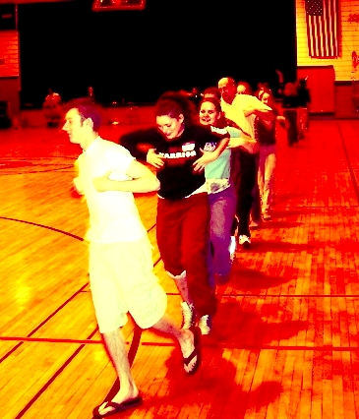
Sight | Sound into Language
- Visual-motor coordination  - Visual-figure coordination  - Visual-awareness  - None-visual discrimination  - Visual-form manipulation  - Observation  - Choreography  - Design | - Oral  - History  - Verbalization  - Articulation  - Listening  - Language  - Vocabulary  - Feeling  - Counting  - Listening skills  - Rhythmic skills  - Inter-sensory skills  - Auditory-acuity  - Auditory memory  - Auditory sequencing  - None-Music discrimination
Rhythm | Movement
- Positive motion  - Negative motion  - Communication skills  - Auditory-vocal association  - Inter-sensory skills  - Time management skills  - Spatial-form manipulation  - Travel  - Design  - Patterns  - Composition  - Height  - Distance  - Visualization | - Space  - Shape  - Flow  - Effort  - Observation  - Short-term memory  - Crossing the midline  - Motor skills  - Peer relationship  - Disinhibition skills  - Develop a buddy system  - Spatial-form manipulation  - Figure-ground differentiation  - Small muscle coordination  - Large muscle coordination
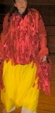
Immediate Needs:
Networking
Community Center Space Renovation
Board Development
Program Promotion
Curriculum aligned with Maine State Learning Results
Grants, Donations
Presenter recruitment and training

Long Terms Needs:
Facility
Staff Development

