The Art of Healing With BioMagnetism
By Carole Bergeron R.N.

When I first met Peter Kulish, founder of the Magnetizer BioPhysics Research Institute, he was lecturing on his life purpose- spreading the science of magnetism. The subject of the lecture was healing the human body with BioMagnetism. His intensity and passion was displayed with his wild silver hair and flashing blue eyes penetrated a skeptical group of seekers and healers. His case studies were unbelievable. They didn’t match any experience I had in a 30-year career in complementary medicine. At the same time, his understanding of the sciences was undeniable in line with his genuine concern for the planet - demonstrated by his life-long work to remedy our energy and pollution crisis.

Kulish elaborated about case after case being resolved almost immediately with the most chronic cases bringing about major change in a couple of weeks. He spoke of broken bones healing in 10 days without pain or swelling and with immediate relief upon proper application with his BioMagnets. Three months later, I saw this happen to my 59 year-old girlfriend who broke her elbow. Her healing was pain-free, with no swelling [in 6 days] and no residual effects to her being.

Kulish spoke of a cirrhotic liver condition reversing in three days demonstrated by a decrease in liver enzymes (ALT and AST lab values) after a Super BioMagnet was applied directly over it. Again, I saw the same results on a person with type 2 diabetes admitted for cirrhotic liver disease. Acities (abdominal swelling related to decreased liver function) reduced as free radical damage resolved and the liver’s healing ability returned resulting in the hospital release of the patient.

He spoke of the biomagnetic energy, that when properly applied, creates the proper ionic flow at the cellular membrane (Zeta Potential) by increasing the electromotive ion concentration ‘gradient’ between the intracellular (internal cell/cytoplasm) and extracellular (external) environment. This electromotive gradient [known as Parallel Capacitance] is the electrical potential difference across the membrane that is essential to cell survival. It is responsible for the efficient support transfer of oxygen, carbon dioxide, and elements in and out of the cell. The higher the capacitance, the more efficient the cellular metabolism is.

He spoke of his Daytime, Nighttime, and Meridian therapies for energizing and balancing the biochemistry within the body with consistent positive results. Having used microscopy as a main research tool to study the many effects on cells in circulation, I understood the importance of re-establishing the Zeta Potential. This potential keeps the red blood cells flowing freely in circulation and allows for optimal exchange of nutrients through increased surface area. Increased Zeta potential in the blood flow translates into increased ability to heal damaged tissues.

Kulish’s knowledge of the sciences was evident, so further investigation was needed. Checking Peter Kulish under Google reviled that he is a recognized international scientific expert and leader in the science and application of magnetism, author of several books and scientific papers on magnetism including Conquering Pain; the Art of Healing with BioMagnetism. His work crosses the continents and has brought him great fame in Asia.

Often many great healers’ motivation for discovery can be personal illness or a family member. Kulish’s need to heal his daughter of elephant man’s disease led him into the study of genetic pathways and how to elevate neural transmission through weak gene receptor sites. His twenty six years of research led to his understanding of the correct polarity pathways for energy stimulation. The design of the proper magnetic field frequencies and depth needed to penetrate inflamed tissues to change the positively charged, stressed cells to healthy, negative charges which has been shown to reduce inflammation within minutes to hours.

This is where I began my study of magnetism to use as a powerful healing tool. After many cases resulting in consistent data, biomagnetic energy therapy has become my first protocol to establish balance at a cellular level for increasing vitality. Below are a few of my findings that are striking, yet are indicative of the general response in the great reduction of free radical activity. Now, after using the therapies for some time, I am reporting the same remarkable findings that I first heard of in Peter Kulish’s lecture.

The following microscopic, blood analysis pictures are examples of forty-minutes before and after biomagnetic therapy using the Institute’s medium size rare-earth magnetic wafers negative over the sternum/heart location (Daytime Therapy). The slides pictured here were taken from a 48-year-old male, who was in acute whiplash pain from a bad car accident.

Since this patient’s February 2005 accident, the individual suffered acute trauma as debilitating pain in the form of constant severe headaches, blurred vision, insomnia, continual nausea, limited mobility, and a loss of 20 pounds from vomiting. Prior to examination, the subject had just come from a long trip that had further his general pain level.

In the first sample, the red blood cells are seen in the rouleau formation (an abnormal stacking of the red blood cells) with fibrin - shown as the faint lines crossing in the background. In this case, the rouleau configuration of the blood cells may be related to a great deal of inflammation in the body.

When fibrin is formed from inflammation, one end is positively charged, the other end is negatively charged. This will cause the red blood cells to clump together in the rouleau formation. When the red blood cells are congested in this manner, there is decreased surface area for exchange of oxygen and nutrients in the capillary beds and reduced ability of the cells to pick up waste to return to the liver and lungs for detoxification. This condition results in decreased circulation, especially to the injured site, leading to more pain and tightness, as well as increased free-radical activity and cell death.

Sample 1 – Live, Before Sample 2 – Live, After 40 minutes of Daytime Therapy
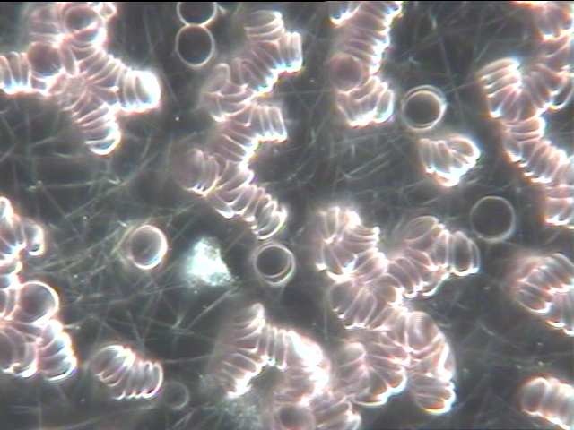
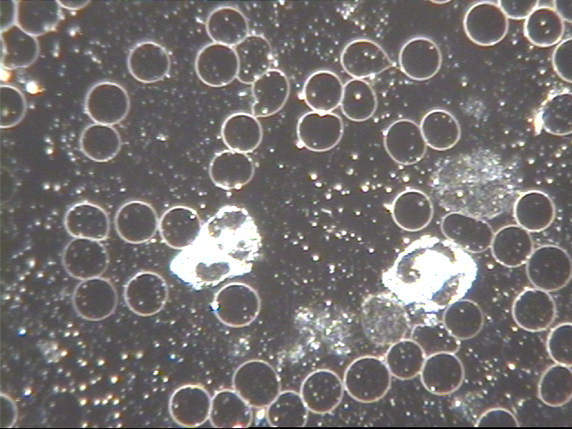

The second sample is after the forty-minute Daytime Therapy. The rouleau formation of the unhealthy blood cells was dispersed into the healthy singular cells as shown by re-establishment of the cell’s Zeta potential (slight negative charge around the cells).

I have seen this kind of [rouleau] change of the live sample in the same time frame with therapies such as protiolytic enzymes, HCL, and alkalizing agents like minerals particularly fulmic acid. However, I have never in 30 years seen such quick reductive changes in oxidative stress. The samples below appear to indicate a reversal of tissue damage by eliminating the free-radicals – all of which in this case was accomplished in 40 minutes.

It is well documented that free radical activity is directly related to illness and aging. Providing the proper electromotive energy to the cells appears to immediately stop the oxidative process - imagine the implications. The reduction of oxidative stress may be one of the reasons why pain is resolved immediately [in acute cases] when the proper electromotive therapy is applied. The following is the example of oxidative stress resolved in 40 minutes.

Sample 1 – Dry, Pre-treatment Sample 2 – Dry, Treated 40 minutes
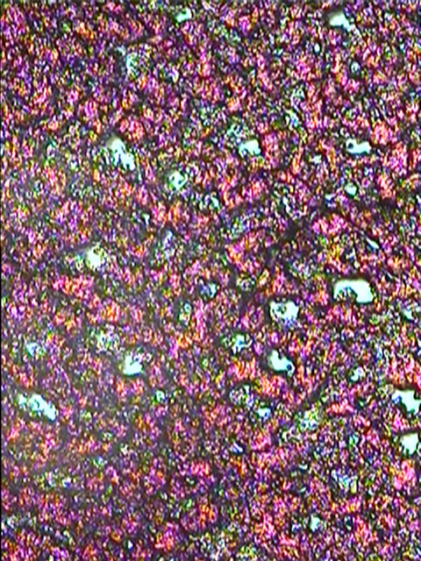
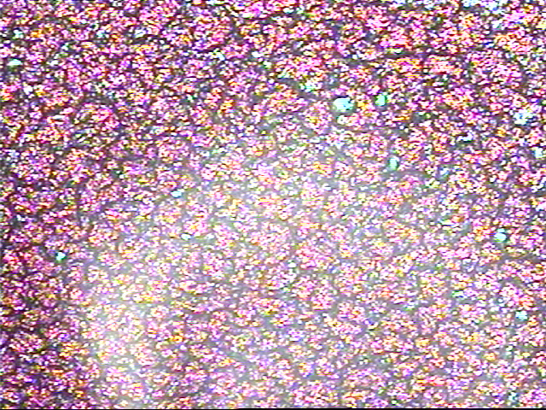
Sample 1: - The dry cell (a.k.a. Bowen Test, from Dr. Bowen, out of Mass. General Hospital) shows evidence of oxidative stress/free radical activity that is observed in this sample as the little white (nugget shaped) areas throughout the sample. This is a good indicator of free radical activity in the tissues. This may indicate tissue damage, typical of stress to the Central Nervous System from the neck injury. The increased tissue damage, along with decreased circulation and emotional stress, will result in more free radical activity as well as more pain.

Sample 2 was taken after the 40 minute Daytime Therapy. Looking closely below the light reflection on the slide, the oxidative stress/free radical activity (little white nuggets) has vastly decreased, so tissue damage may have decreased as well. By initiating and elevating the negative charge around the cells (Zeta potential), the free radical activity appears to have normalized. Kulish indicates simply that since free-radicals are positive, the negative electromotive stream from the BioMagnets simply neutralize the free-radicals rather than their reaching potential balance by seeking their [negative] electron need from healthy tissue.

Normally it could take weeks to months to change this level of damage. This very simple 40 minute energy therapy was able to re-establish healthy ionic (anionic) charge to create balance so the body can improve circulation systemically including the injured site. When balance is created, the body performs at maximum potential and can heal faster. This demonstration has enlightened me as to why magnetic fields can work so fast with chronic problems and provide immediate relief with acute injuries.

Within one week of constant energy therapy, the subject was able to have his first full night of sleep since his accident four months prior. His headaches are a lot less; his blurred vision and nausea are gone; and he is now able to do physical therapy which has given him enough increased mobility to go back to work. He is doing a daily regimen of the Daytime, Meridian Energizing and lower Cerebral Vestibular System (CVS - at the base of his neck while sleeping) Therapies.

His spirits have also improved, as recovery is now in sight. Before the bio-magnetic treatments, he was looking at the possibility of surgery as his only option.

Bio Cellular Electrical Analysis with BIA Testing

The Bio Impedance Analysis (BIA) machine is a FDA registered instrument that analyzes and measures the electrical values of the [Parallel Capacitance] cells.

The properties of the BIA circuit in the body are well defined. The method [of measurement] is precise, sensitive and specific in its ability to illustrate any changes inherent in the biological subject.

The BIA provides a scientific index - a 'snapshot' of cellular level dynamics and architecture - giving valuable and immediate data of the individual’s state of health and healing data from protocols for medical research, clinical practice and the health care professional’s analysis and recommendations.

BIA - Parallel Capacitance Body Composition Report # 111804MW

History: The subject is a 53 yr. old female has a fifteen-year history of mal-absorption, fibromyalgia, and extreme fatigue that has incapacitated her for many years. She has been under the care of a multitude of practitioners. She tests for chemical poisoning. Due to her mal-absorption issues, even a slight overload of nutritional supplementation would throw her into a crisis.

Date: | 18-Nov-04 | 14-Jun-05 | 14-Jun-05
Actual CAP: | 400 | 400 | 507

Note: From Nov 4th to June 5th the subject’s capacitance remained the same even with a diet high in nutrition - but minimal supplementation due to mal-absorption. Within an hour of using the CVS application (referenced in the “Conquering Pain” book), her cellular capacitance rose 107 points, indicating a large increase in the Zeta electromotive potential to the cells.

Parallel capacitance results of Subject 111804MW
Her capacitance was very low for a 3-year period I have known her, only rising 25 points after multiple therapies, including a custom nutritional program.
The subject’s inability to absorb or detoxify over a fifteen-year period made it very difficult for her health to improve and many therapies would simply set her back.
During the last 2 tests from Nov 4th to June 5th the subject’s capacitance remained the same, which was typical of her fixed pattern.
The subject was given the MagnetizerBioPhysics Research Institute protocol – lower CVS - a 2-stack of Power Wafers negative on the back of her neck (at the hairline). Within an hour, her capacitance rose 107 points, indicating an increase in electromotive energy to the cells.
Ever since the initial treatment, she has been reporting a tremendous increase in energy. She followed up with the Meridian Energizing Therapy three times daily as well as the CVS application. She was able to resume her favorite activity of singing and song writing with a band, within one month of both applications.
This dynamic improvement was monumental, as for many years the subject had been unable to perform the most basic activity, including standing for long periods without severe pain. The chemical poisoning that she suffered from resulted in the blockage of important pathways and she did not have the electromotive energy in her cells for proper metabolic function. Her state of health was stuck in a toxic condition.
Conclusion: The subject’s cells low charged electromotive state was immediately elevated to a properly charged state, which re-started the cells natural ionic forces (micro electric channels). This resulted in proper cellular function of which started the metabolizing of the micronutrients and detoxification of the chemical poisoning.

From the magnetic application, the subject was able to re-establish enough cellular energy (by increasing the cellular ion-exchange amplitude and thereby the parallel capacitance) to heal herself. Her pain has reduced from a 10, down to a 3, on her worse days and is pain free on others. Her absorption has increased, allowing her to add supplementation. She is now able to move closer to a normal functioning lifestyle.
Capacitance (pico Farads) | Cell health based on parallel capacitance
Above 1009 | Extremely healthy
774-1008 | Optimal health
617-773 | Average
460-616 | Below average
304-459 | Low energy
Below 303 | Warning alert

I have since tested 100’s of people. Some are posted under reports on www.magnetizerinstitute.org . A few of these reports are very significant to me as they are the clients dearest to my heart that have been imprisoned in a body that was stuck from metal and chemical poisoning. They persevered with their very difficult journey as they slowly improved over years but not enough for them to function in daily activities without great fatigue and pain. I have learned so much about their personal courage as I continuously searched with them for answers.

When they did the basic protocols from “Conquering Pain” by Peter Kulish, the results were dramatic and continue. They have energy for the first time. They now have the electromotive energy for cellular movement. Their nutrients are getting absorbed giving them much needed fuel. Their former inability to generate enough energy for healing resulted in food putrefying producing auto-intoxification. Now that same healthy food is providing nourishment as the G-I system is able to repair. Now B12 can be absorbed since inflammation of the gut is reduced. This may explain one of the reasons of why we see neuro-electromotive damage and why chronic cases, after proper electromotive stimulation, begin to improve.

The Magnetizer BioPhysics Research Institute was set up as a planetary human resource center for the investigation and worldwide promulgation for establishing the correct biomagnetic energy medicine protocols and therapies. The time has come as many great minds join together to impact our future as we work toward evolving our species. I have joined in this wonderful journey and will be part of the team gathering the data to compile the best protocols for optimal performance. Please feel free to join and share with this in this advanced supplementary energy medicine.

Respectfully submitted by:

Carole Bergeron R.N.
Waltham Mass.
www.caroleb@rcn.com

Our Senior Medical Director is Thomas Levy M.D.,J.D., one of the leading and internationally known experts in complementary medicine well known for his books on Vitamin C, his joint authorship and pioneering effort with Hal Huggins D.D. exposing mercury toxicity in amalgams.

Director Brian Shair is a graduate in neuro-science from Rutgers University. He has a great passion for the intricacies of brain chemistries and optimal learning.

Associate Director Phillip Schaeffer, well know publicist, corporate developer, former consultant to the Royal Society of Medicine, strategic coordinator for the UN on global economy.

Associate Director Charles Yeh, Taiwan, involved in Bio energy Asia, got Magnetizer recognized by the Tawian Asian Energy Association.

Director Peter Kulish, Founder and developer of the protocols and investigator of the scientific methodology of BioMagnetic Alternative Energy Medicine Magneto Biophysics, has taught all over Asia and has introduced his Energy Medicine to Medical Colleges and Universities including Bejing, Bangkok, Kuala Lumpar, Philippines, Brazil, Venezuela. His material is taught throughout the world as the proper scientific methodology of Energy medicine. The Institute Web site will contain our collective on going research. We welcome your comments and questions.

