Inclement Weather Survey Results

- Have any of the following types of inclement weather negatively impacted you in the past 12 months? (check all that apply)
  - Very high temperatures
  - Very low temperatures
  - Rain or thunderstorms
  - Ice or snow storms
  - Hurricanes
  - Tornadoes

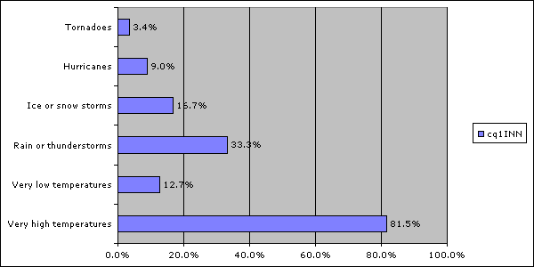

- Please indicate which types of inclement weather that are most concerning to you: (check all that apply)
  - Very high temperatures
  - Very low temperatures
  - Rain or thunderstorms
  - Ice or snow storms
  - Hurricanes
  - Tornadoes

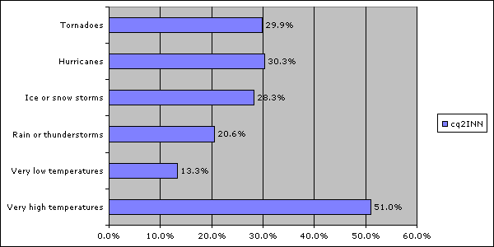

- For each of the following types of inclement weather that you chose above, please indicate whether you feel they have gotten more or less frequent in the past 12 months compared to previous years:

 | More Frequent | Less Frequent
Very high temperatures
Very low temperatures
Rain or thunderstorms
Ice or snow storms
Hurricanes
Tornadoes

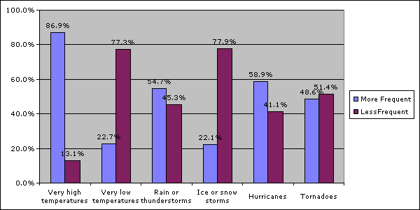

- Please indicate which types of inclement weather you feel have gotten more or less severe in the past 12 months compared to previous years:

 | More Severe | Less Severe
Very high temperatures
Very low temperatures
Rain or thunderstorms
Ice or snow storms
Hurricanes
Tornadoes

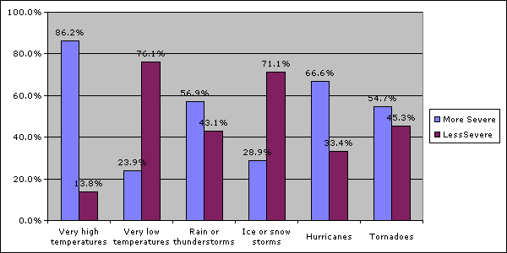

- Please indicate which types of inclement weather you feel prepared to handle if they were to occur again today?

 | Prepared to Handle | Unprepared to Handle
Very high temperatures
Very low temperatures
Rain or thunderstorms
Ice or snow storms
Hurricanes
Tornadoes

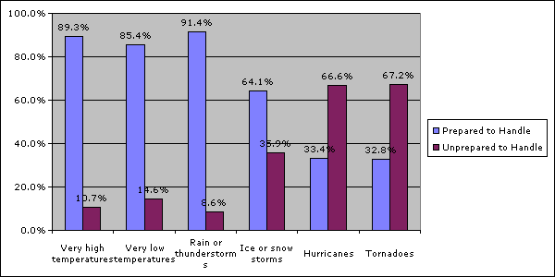

- Have you or a family member ever been injured or killed as a direct result of the following types of inclement weather?

 | Yes | No
Very high temperatures
Very low temperatures
Rain or thunderstorms
Ice or snow storms
Hurricanes
Tornadoes

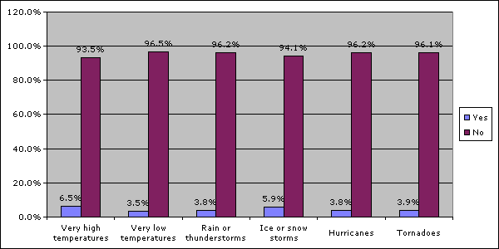
- Who do you think should take primary responsibility for making sure you are sufficiently prepared for inclement weather?
  - Myself
  - My family
  - The government
  - Other: ______________

