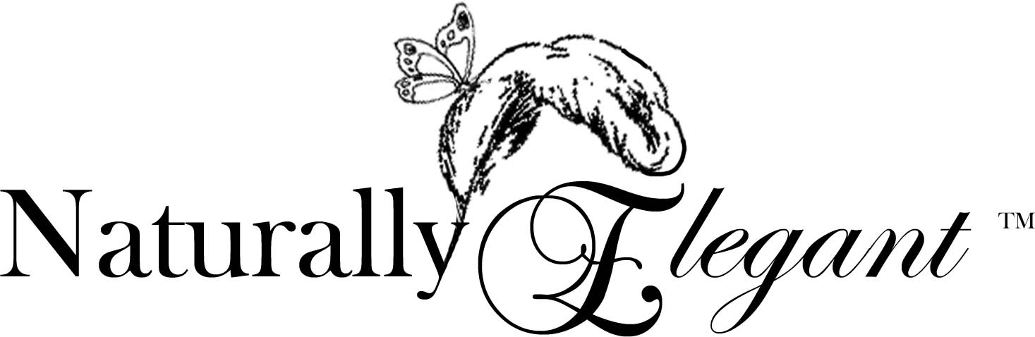
Naturally Elegant creates natural products to promote your health and well being, plus enhance the beauty of your surroundings. We offer 100 percent soy candles, beeswax candles, natural body products, gifts and unique home accessories. Our novel product and gift packaging is hand-designed exclusively for Naturally Elegant by our award-winning Accessories Designer.
What Makes Naturally Elegant Different?
We strongly believe in utilizing natural resources to create all of our products. Our 100 percent soy candles are:
- Safe and Non-Toxic - Our 100 percent soy wax candles emit virtually no black soot when burning.
- Extremely Fragrant - Our 100 percent soy candles were designed to be extremely fragrant whether burning or not.
- Free of Synthetic Dyes - Offering only the natural color of soy wax ensures your favorite fragrances will fit your decor. By removing color, the amount of soot emitted is further decreased.
- Handmade in the United States - The soybeans used to make soy wax are grown on American soil, and our candles are hand-poured in the United States.
- Uniquely Packaged - All our products are boxed and ready for gift-giving. We also offer unique gift sets, including realtor, corporate, wedding, party favors and centerpieces.
Contact Information
Kristin Horbach
Home Phone: 847-303-0870
Cell Phone: 847-644-5647
Company Phone: 847-303-0865
Address: 4 Shagbark Road, Rolling Meadows, IL 60008
E-mail: Kristin@naturallyelegant.net
Web site: www.naturallyelegant.net
The Company
Naturally Elegant is a 100 percent women-owned company. The co-founders, like most women, love having their homes smell great with warm ambiance. The best way to achieve this is with lighted, scented candles throughout the house. Burning paraffin candles led to black soot damage and adverse health effects. These women were determined to correct these problems, and through their combined talents, they achieved their goals.
Naturally Elegant is a home-based business. The candles are hand-poured in Rolling Meadows. Then, sent to Lemont for packaging and shipment.
Our Co-Founders
Kristin Horbach holds a science degree and possesses a strong research background. Her research and testing led to the creation of our soy candle formulations. Dianna Cozzie has design background with one of the largest upscale retail stores in the country. By combining their talents, clients receive the best of both worlds -- natural products with a designer touch.
Kristin Horbach graduated with a degree in biology from the University of Illinois in Champaign-Urbana. She worked for over seven years in pharmaceutical clinical research with large companies including Abbott Laboratories and Pharmacia. In 2002, she left her career in clinical research to pursue her own business.
In early 2003, Kristin began testing soy candle formulations, trying hundreds of fragrances. She discovered only 10 percent of fragrances smelled great and burned properly. This is what sets Naturally Elegant candles apart from other soy candles on the market.
Kristin is currently writing a research paper on the benefits of soy wax candles and the potential dangers of paraffin wax candles.
Dianna Cozzie is an award-winning designer. She has worked for Nordstrom where her designs have been showcased. For 10 years, she ran her own business, designing corporate gifts. Her work entailed theme party decor for such clients as Ritz-Carlton Hotel, Allstate Insurance and General Electric.
Dianna created the look of Naturally Elegant including the logo, labeling, packaging and gift design. She also designed the Web site layout and is currently working on lines of designer gifts for realtors, corporations, weddings and other special occasions.
Contact Information
Kristin Horbach
Home Phone: 847-303-0870
Cell Phone: 847-644-5647
Company Phone: 847-303-0865
Address: 4 Shagbark Road, Rolling Meadows, IL 60008
E-mail: Kristin@naturallyelegant.net
Web site: www.naturallyelegant.net
Research Information
Kristin is currently writing a research paper on the benefits of soy wax candles and the potential dangers of paraffin wax. A brief summary follows:
In 2001, the Environmental Protection Agency (EPA) reported that burning "candles" releases¹:
- Particulate matter in the form of black soot
- Several harmful toxins
The report did not state "paraffin" wax candles, but this was extrapolated since the chemicals detected during testing are known chemicals used in the processing of paraffin wax.
Black soot can cause property damage by blackening, walls, ceilings and carpets¹. The black soot particles are small and can potentially penetrate the deepest areas of the lungs, but further research has not been done on the subject¹.
Another study tested paraffin wax candles and soy wax candles for soot emissions. The result showed a 90 percent decrease in the amount of soot produced by soy wax candles vs. paraffin wax candles².
The EPA report also stated as a worse case scenario that exposure to three harmful chemicals occurs when burning paraffin candles. In addition, a 1999 independent research study from the University of Florida tested 91 candles and found up to 10 additional chemical emissions³. Some of the chemicals found range from probable to known cancer-causing chemicals for animals and humans.
More About Paraffin
Paraffin is the grayish-black sludge leftover from petroleum refinery processing. Most of the candles on the market today are made with paraffin wax.
As a natural alternative to paraffin wax candles, Naturally Elegant offers 100 percent pure soy candles. Our candles are designed to:
- Emit as little soot as possible when burning
- Burn completely without wasted leftover wax
- Smell fabulous, whether burning or not
There are many benefits to soy wax candles as a natural alternative to paraffin wax candles. Soy wax:
- Burns clean, with little carbon build-up. Soy wax candles produce about 90 percent less black soot in the form of small particles that may potentially enter your lungs.
- Is a non-petroleum, renewable resource.
- Is biodegradable.
- Contributes to the reduction of our dependency on crude oil, as paraffin is a by-product of petroleum processing.
Research Information (Continued)

- Is made predominantly from domestically grown crops supporting U.S. farmers and our economy.
- Burns longer and cooler than paraffin candle waxes.
- Cleans up with soap and hot water.
- Is environmentally friendly, promoting the growth and care of the environment by utilizing plants.
- Knight, L. et al. (2001) Candles and incense as potential sources of indoor air pollution: market analysis and literature review. US Environmental Protection Agency, EPA-600/R-01-001
- Renzaei, K. et al. (2002) Combustion characteristics of candles made from hydrogenated soybean oil. Journal of American Oil Chemists Society. 79-803-808.
- Krause, D. Characterization of scented candle emissions and associated public health risks. PhD dissertation, University of South Florida, Dept of Environmental and Occupational Health, College of Public Health, Aug 1999. Summarized in LEAD Action News, Volume 7, No. 4.

Contact Information
Kristin Horbach
Home Phone: 847-303-0870
Cell Phone: 847-644-5647
Company Phone: 847-303-0865
Address: 4 Shagbark Road, Rolling Meadows, IL 60008
E-mail: Kristin@naturallyelegant.net
Web site: www.naturallyelegant.net

Tips for Buying and Using Candles
When purchasing or using candles, avoid the following:
- Candles that simply state "soy" on the label. If the candle does not state "100 percent soy," it likely contains other additives, possibly paraffin wax. 100 percent soy is extremely difficult to work with, so many companies add paraffin wax to increase fragrance or enhance appearance.
- Colored candles. Naturally Elegant has found that synthetic dyes contribute to the release of black soot. We have eliminated synthetic dyes from our soy candles.
- Trimming wicks every time you burn your candle. When a candle is made properly, it is not necessary to trim wicks with every use. Naturally Elegant suggests trimming their candles’ wicks only if smoking occurs. Trimming wicks too short may result in unconsumed wax.
- Pillars or tapers that say "soy" candle. Soy is a soft wax and cannot be made into a freestanding pillar or taper. Paraffin wax may be used as the main ingredient, with a very small amount of soy added. Opt for beeswax tapers and pillars as a natural alternative.

Kristin Horbach
Home Phone: 847-303-0870
Cell Phone: 847-644-5647
Company Phone: 847-303-0865
Address: 4 Shagbark Road, Rolling Meadows, IL 60008
E-mail: Kristin@naturallyelegant.net
Web site: www.naturallyelegant.net

