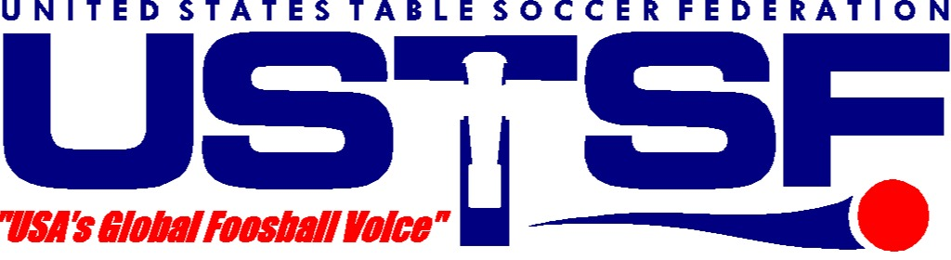 January 10, 2007
P. O. BOX 343292, BARTLETT, TN 38184 USA

ATTENTION: NEWS, EVENTS, SPORTS EDITORS

FOR IMMEDIATE RELEASE

INDEPENDENDENT FOOSBALL PROMOTIONS (IFP)

ANNOUNCES THE
$35,000 13th ANNUAL SUPERBOWL OF FOOSBALL

- Kentucky Tournament Gains International Attention -

LEXINGTON, KY – All over the world, athletes are training, conditioning and studying each other's moves in preparation for an incredible sports event: the 13th Annual Superbowl of Foosball. Yes, you read that right: Foosball. To be held January 24-28 at the Lexington Holiday Inn North, this event is expected to draw many of the best foosball (a.k.a. "table soccer") players in the nation and numerous top international players as well.

Already, avid foosball enthusiasts will be closely watching the Kentucky tournament’s possible match-ups between the likes of the United Kingdom’s superstar Rob Atha, 22, hot off a European Tour victory in Austria, and top Americans such as defending champions Billy Pappas, 22, of Lowell, MA and Tony Spredeman, 22, of Cudahy, WI. Pappas and Spredeman, also having made their mark in recent major international events, will be joined at this tournament by most of the U.S. National Team and at least 400 male and female competitors, all vying for a total of $35,000 in cash and prizes.

Now recognized as an International Table Soccer Federation (ITSF) Master Series event, the annual Superbowl of Foosball has even been elevated to international tour status. Players from as far away as Hungary, Ireland and Costa Rica will compete against America’s best in Singles, Doubles, Mixed Doubles, and several specialty events. With seven skill-level divisions and special 17 & under, and 12 & under events for younger players, all comers are welcome to participate -- there’s something for everyone!

The tournament is organized by Kentucky’s own Independent Foosball Promotions and is sanctioned by ITSF and the United States Table Soccer Federation. Sponsors of the event include TornadoFoosball.com, Budweiser, Rent Way, Little Caesars Pizza, and the Lexington Holiday Inn North, while sponsors of the U.S. National Team include Brunswick’s Valley-Dynamo, Warrior Custom Golf, Nike, Bonzini™ USA and Foosball.com. All competition will be held on Tornado Table Soccer tables, a product of Brunswick Corp. The event is open to spectators and there is no admission fee to enter the tournament room. Opening events begin at 8:00 p.m. on Wednesday, January 24th, with most finals played on Saturday and Sunday the 27th and 28th.

With over 50 other ITSF 2007 World Tour events scheduled to take place in over 40 participating countries across five continents in places as diverse as Atlanta, Dallas, Denver, Minneapolis, Las Vegas, Tokyo, Paris, Vienna, Prague, Budapest, Costa Rica, Denmark, Singapore, South Africa and the UK, this year’s tour will be the largest worldwide table soccer pro tour ever!!

For additional details about the event and the sport, please see the following websites:

www.table-soccer.org - ITSF web site; International Rankings, Rules and more
www.ustsf.org - Official web site of the United States Table Soccer Federation
www.vifa.com - USTSA web site/U.S.A. rankings/International League info
www.foosball.com - General information about the sport of table soccer
www.foosworld.com - Information about players and regional events across the U.S.A.

For more information, photos, or for an electronic version of this release, please contact:
Mary Moore, Tournament Director, Tel: 1-859-268-8502; Email: ifpfoos@alltel.net
Larry Davis, Executive Director, USTSF, Tel: 1-563-580-9485; Email: quantum_foos@hotmail.com

- 30 -

