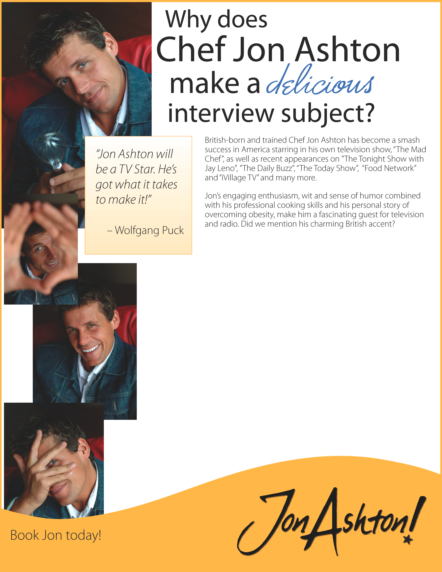
- Generation O: why Jon is so compelled to fight the war against childhood obesity that impact over 12 million children (ages 2-19) in the United States. Jon is well versed in all the health issues related to obesity including diabetes, high blood pressure, heart disease and cancer.

- How to prepare and pack healthy, delicious meals and snacks on-the-go in less than ten minutes.

- Battle of the bulge: the personal story of a television chef shedding 60 pounds while surrounded by temptation.

- Attention Mom: how to change up your children’s meals and snacks into healthy alternatives with little to no fussing.

Get the dish on these great interview topics:

- Growing up in Liverpool: the difference between English and American foods, obesity, portions and health issues.

- Why take-out when you can take-in? Jon gives all time favorite take-out foods a healthy make-over saving hundreds of empty calories per serving!

- Food and flavor trends for 2007

- All the dish on celebrity chefs-he’s worked with many of them including Rachel Ray, Wolfgang Puck, Bobby Flay, Emeril Lagasse, Al Roker, George Foreman and many more!

Laura Davis – Cell: 207-240-9693
laura@rinckadvertising.com

