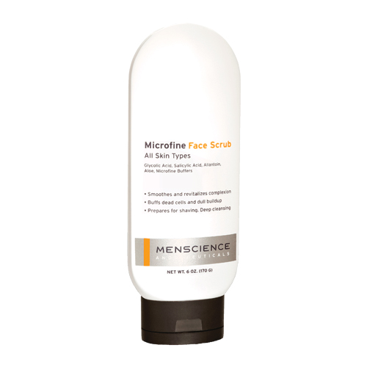
PRODUCT:
RECOMMENDED FOR:
Deep Cleansing
Renew and Smooth
Ingrown Hairs

BENEFITS:INGREDIENTS:
PURPOSE:
Use of this exfoliating product is the fastest and most effective way to revitalize the complexion, deep clean pores and prepare skin for shaving.

Buffs away dead skin cells and dull buildup, revealing new cells for an even skin tone.

Smoothes and revitalizes complexion by gently shedding upper layer of skin cells and promoting new, healthy cell growth. Deep cleans impurities from within pores and combats ingrown hairs.

Softens and prepares skin for a smoother, closer shave.
Microfine Buffers

Glycolic and Salicylic Acids

Allantoin, Aloe

WHAT’S UNIQUE ABOUT THIS PRODUCT:
Contains unique combination of biological and physical exfoliating agents. Three types of Microfine particles physically buff away rough upper layer of cells, and a 5% concentration of unbuffered Glycolic Acid and 1% concentration of Salicylic Acid deep clean pores and encourage growth of new cells.

METHOD OF USE:
Apply to wet face and neck. Massage in a circular motion for up to 2 minutes. Rinse well. Use 3-4 times per week. No need to wash face afterwards.

COMPLEMENTARY PRODUCTS:
Daily Face Wash; Advanced Face Lotion

RETAIL PRICE:
$29.00 (6 oz.)
SKU:
11031
MICROFINE FACE SCRUB
All Skin Types

INSERT PRODUCT IMAGE HERE

