For Immediate Release: Media Contact:
June 1, 2007 Rushing Media
April Rushing
818-253-5385

BELLA NELLA BRIDE THE ONLY SALON EXCLUSIVELY FOR THE BRIDE AND BRIDAL PARTY EXPANDS TO BEVERLY HILLS AND BEYOND
International Beauty Experts Bella and Nella Launch Multiple Beauty Teams and Add a Location to Give Brides All Access to the Additional Luxury of a Complete Beauty Design Team

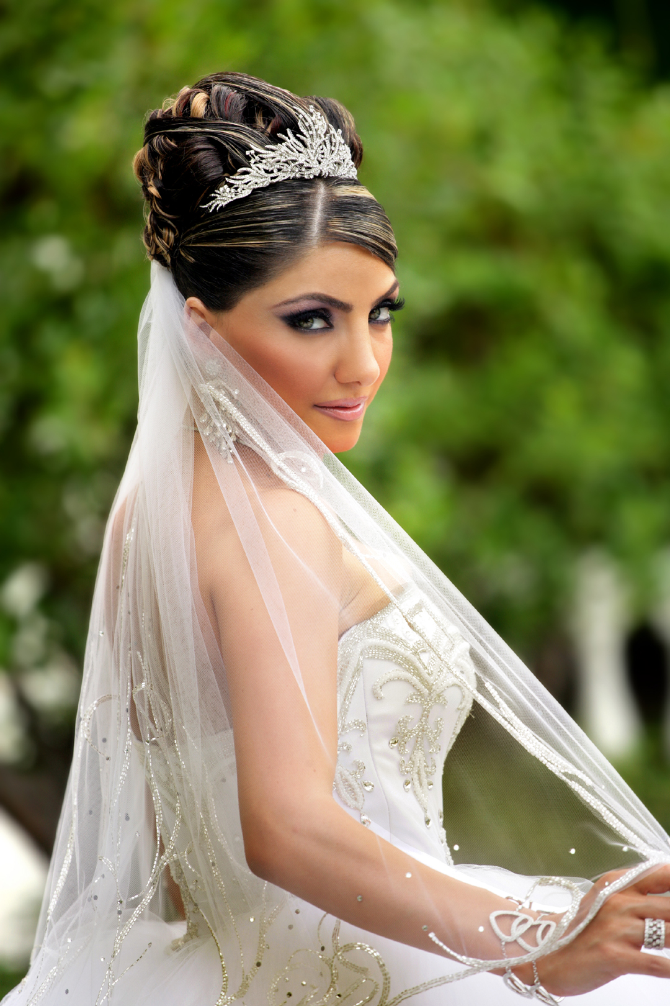
(Beverly Hills, CA) – Couture is now a beauty option for brides. Bella Nella Bride is a salon exclusively for the bride and the bridal party. Their expertise in custom designed hairstyles and flawless makeup has expanded to include the added convenience of multiple beauty teams to service as many brides as possible with the ability to travel to wedding sites or prepare the bride and her bridal party in one of two salon locations in Glendale or soon in Beverly Hills, California.

The unique concept to expand the one-stop bridal beauty destination to service many weddings destinations through multiple mobile teams and several salon locations is the inspiration of owner and hair designer Bella Shahmoradian who along with her sister and makeup designer, Nella Ebrahimi are behind the success of the luxury salon. Bella Nella Bride is the perfect marriage of their expertise, combined twenty-six years experience and extensive training with international beauty industry masters. “With the bride there is only one day, one chance, and one moment to get it perfect. That is the challenge we meet each and every time.” Shamoradian continues, “We wanted to make our bridal expertise and beauty philosophy available to the as many brides as possible.” Bella and Nella have extensively trained multiple teams of hair and make-up artists in their philosophy of complete customized design.

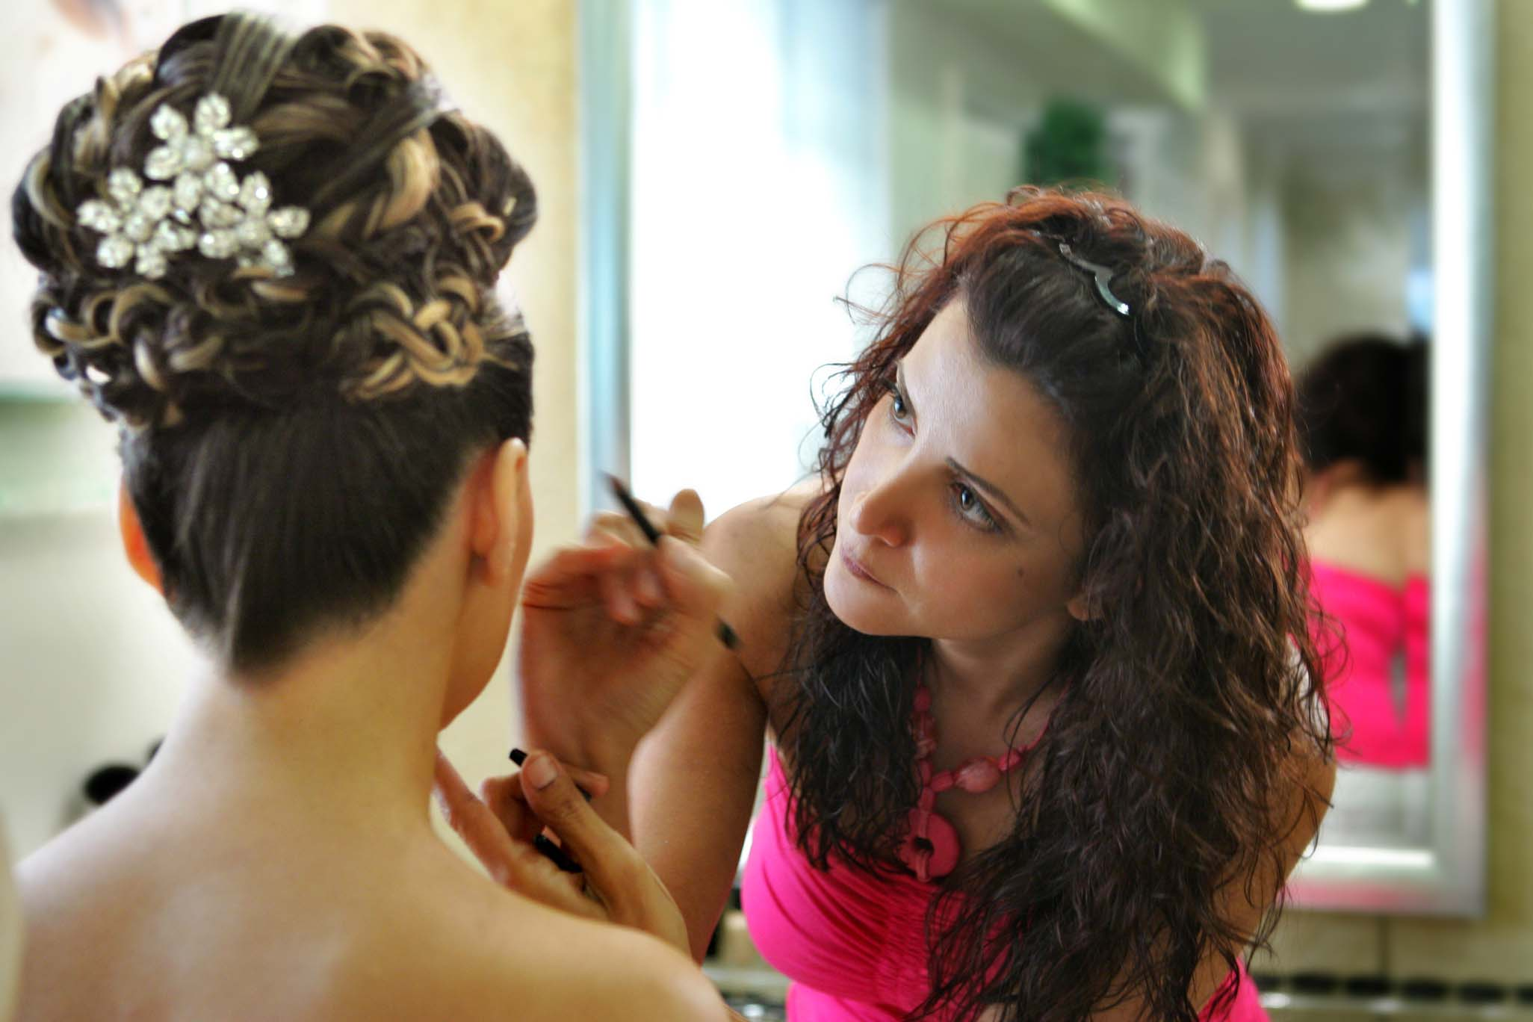
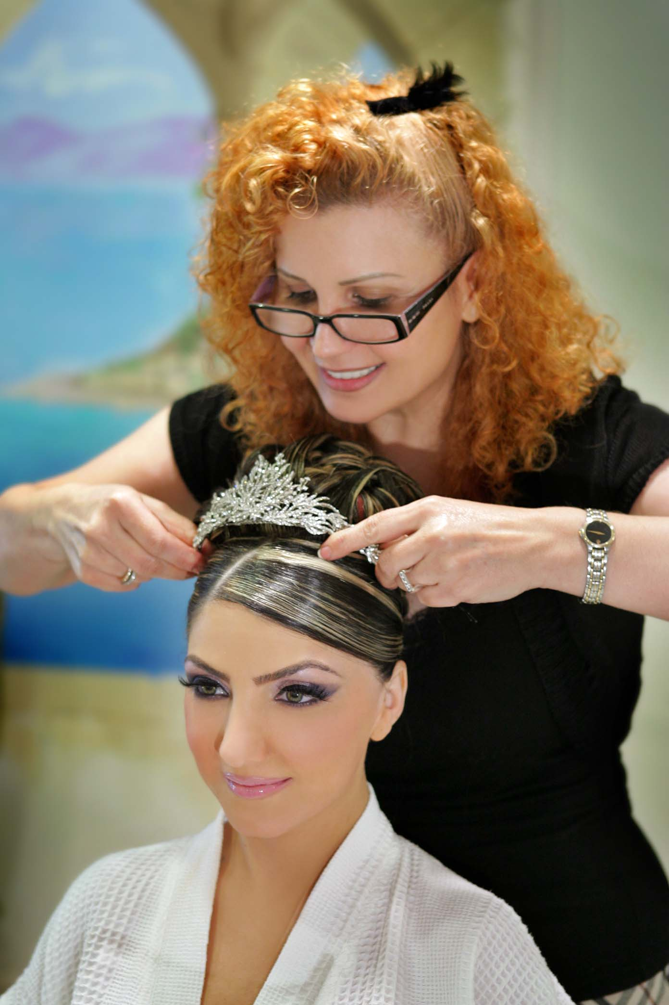
Bella Nella Bride offers the bride several options when booking the wedding day appointment. She can schedule exclusively with Bella Shahmoradian and Nella Ebrahimi in the salon or she can schedule with a Bella Nella Bride team in the salon or at her wedding site. She also has the option to book a separate team for her bridal party and the mothers either at the salon or on site. The bride’s overall look, colors and theme are taken into consideration when creating the perfect look. Ebrahimi describes their philosophy, “We aim to bring out the bride’s natural beauty.” The Bride first meets with Bella Nella Bride two to four weeks before the wedding for a consultation. At the appointment, Shahmoradian discusses the design of the dress, jewelry and hair accessories with the bride. On the wedding day, the bride arrives at the salon or the Bella Nella Bride team arrives on site, at least four hours before her picture time. A complementary breakfast is served, before her hair and makeup are started. “The bride’s hair and makeup have everything to do with how she feels on that day” Shahmoradian explains. “And we are experts in getting the bride to her photographer on time, every time.”

-more-

Bella Nella Bride
Page 2

All Special Occasion packages include hair and makeup. The Platinum package exclusively includes a facial and full body massage the week of the wedding. The packages are Bridal Gold, $550; Bridal Platinum, $750; Engagement, $450 and All Other Occasions, $400. Bella Nella Bride also has specially trained beauty teams to do hair and makeup on-site or in the salon for the bridal party and mothers. Prices are available on request. In response to customer demand Bella Nella Bride’s premiere luxury beauty service will expand to Beverly Hills in the summer of 2007.

Bella Nella Bride is the recipient of the “Top 200 fastest Growing Salons” award in 2005 and 2006 from Salon Today. They are also a member of the elite internationally renowned Haute Coiffure Franҫiase and a testing salon for L’Oreal Professional and Kérastase. Bella Nella Bride locations are; 9909 S. Santa Monica Boulevard, Beverly Hills, CA 90212, 310-277-0901 and 413 East Glenoaks Boulevard, Suite A, Glendale, CA 91207, 818-291-0781. For a complete description of the packages and portfolio of brides visit the website at www.bellanella.com. For media inquiries please contact April Rushing at April@RushingMedia.com or 818-253-5385.

#

