IF YOU CHEW IT
WE DO IT!

FOR SKILLED CULINARY HELP FOR YOUR PROFESSIONAL FOOD SERVICE

WE KNOW OUR PEOPLE & WE UNDERSTAND YOUR BUSINESS
Scheduled Fall Classes:
Manager ServSafe
8/27 & 8/28
Workplace Safety
TBA
Employee ServSafe
9/8
Sold Out!

Snapchef Goes Back To College

Roxbury Community College is about to get its main cafeteria supercharged! A collaboration of some of the area’s most savvy food service companies will be working together to bring food options to the students and faculty of this community asset.

City Fresh, a minority owned food producer with partner Unidine, a major contract caterer, will be running the operation. Snapchef services Unidine in Massachusetts and City Fresh too. City Fresh and Snapchef are Inner City Entrepreneurs.
ICE, as it is known, helps community based businesses to the next level. It is organized by Root Cause, affiliated with Boston University and Mayor Manino.

City Fresh graduated and Snapchef will graduate this year.

Snapchef is currently in the midst of a pilot training program they call The Workplace Doorway. With Boston Connects (A City of Boston Agency) helping with funding the second group of apprentices are just getting started. City Fresh has support form Boston Connects too.

Snapchef is part of an Articulation Agreement with RCC, signed with great fanfare last spring! Snapchef trainees may receive college credit for The Workplace Doorway “earn & learn” training.

Bottom line: Snapchef’s current class may be employed by City Fresh and receive training by Snapchef trainers at the RCC cafeteria!

Snapchef will supply certified on the job training, students will be paid. City Fresh saves thousands in recruiting and gets the full range of Snapchef services!

A Win-Win for everyone including Boston!

Call The Snapchef Hotline

Trained, Certified,
Background Checked,
Bonded and Insured
Culinary Help –
Servers, Bartenders,
Cooks, Chefs and more

617-264-CHEF
(2433)

Snapchef’s Staff Boston’s Top Hotels

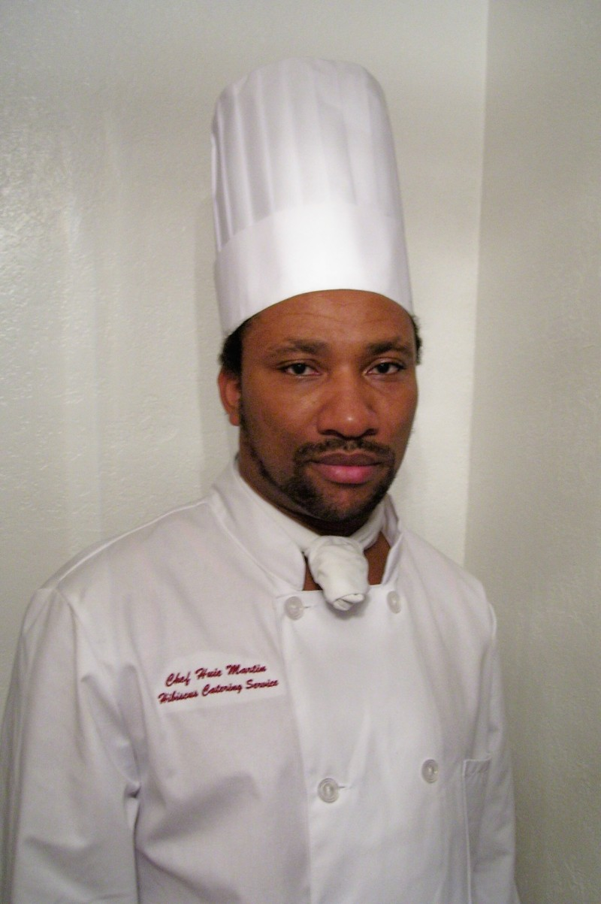
The Snapchef Corner – Up Close & Personal
Darren and Tina just had their baby boy on 8/11. He’s a favorite at several high profile accounts- congratulations Darren!
Randy, aka Chef Randy, has interviewed in LA for Hell’s Kitchen and it went well! Good luck Randy and don’t forget to give Snapchef a plug!
Allen just got accepted a permanent job from one of our best clients in their prestigious Boston location! Allen has worked hard to put his life back on track at Snapchef for almost two years! Through The Snapchef Temp-to-Perm Program he’s made it happen! Best wishes from all of the Snapchef family! Great job Allen and congrats!


This last spring Executive Chef Robert Daugherty of The Hyatt Regency in Cambridge called in Snapchef to help in the busy season.

Snapchef was proud supplementing his wonderful staff. Chef Daugherty had recently taken the reins but was far from new to the world of fine cuisine. He brought with him a lifetime of culinary excellence.
His biography is all about the love of food. He went to The Culinary Institute of America. Then he apprenticed at the Westin Century Plaza Hotel in Los Angeles.

In Washington D.C. he served as Sous Chef and then Executive Chef in LeGrand Bistro at the Westin Hotel. The family relocated to Boston and he opened The Grille at Hobbs Brook at the Doubletree Guest Suites.

Then he served as The Executive Chef at the Doubletree Islander Hotel in Newport.
In 2007Chef became Executive Chef of Hyatt Regency Cambridge.
Snapchef is committed to assist the community in getting people jobs that need a helping hand. Similarly, Chef Robert has worked with the Child & Family Services of Newport County, Stopover Services, Days of Taste, and the Providence Ronald McDonald House and served as President of the R.I. Chapter of the American Culinary Federation.

Snapchef salutes a great chef and is grateful for the opportunity to send our people to benefit from his expertise.

Hospitality Spotlight – The Hyatt Regency Cambridge


“No really great man ever thought
himself so.”
William Hazlitt,

Snapchef has a mission!

The official mission statement reads as follows:
To provide service excellence in staffing our clients in the HOSPITALITY, LODGING AND FOOD SERVICE businesses through industry specific training. To draw & develop staff from inner-city communities, building and maintaining education and training facilities while ENCOURAGING community participation in the projected growth in food & beverage industry.

Snapchef is a for-profit company that behaves in many ways as a non-profit. Its community goals and work set it apart from all other staffing agencies. Snapchef does work with Job Corps, the Commonwealth of Massachusetts, the City of Boston and now the State of New Hampshire. All programs target different populations to help. The goal: access to jobs in the food & beverage industry! As the programs become bigger and more inclusive Snapchef needs guidance and support from people in government and private industry that share the Snapchef vision. It calls for an active Board.
To jump start the process a Chairman of The Board has been selected: Dr. Patrick van Rooyen. He believes in the Snapchef model of “earn & learn” training.

thirty-years of business experience globally and is an adviser to corporations and government agencies, international keynote speaker at a range of international conferences, former Executive Chairman of the USA International Group (a business network of 18 corporations in 13 countries), award-winning Academy Director with the New England Job Corps Career Academies, served on the Massachusetts Workforce Industry Council. His achievements include a U.N. Peace Medal for his work with refugees. A former professional Army Officer, he maintains strong links with the military and in 2005 he was named U.S. Army Civilian of the Year.
Snapchef is currently gathering professionals from the food service industry including executive chefs and managers but also professionals from other lines of business that share a sense of purpose with operating at the grass roots level to get people on their feet in a sustainable program within a robust segment of the economy.
IF YOU ARE INTERESTED IN JOINING THE NEW ADVISORY BOARD EMAIL todd@snapchef.com or call 617-264-CHEF. “This is a work in progress” says Todd Snopkowski, owner and founder “It’s growing so fast that we need a dedicated group of talented and committed folks to do it right.”

Snapchef Begins To Build a Board

Dr. Patrick van Rooyen
His bio is daunting. Here are highlights: With thirty-years of business experience globally as adviser to corporations and government, as former Executive Chairman of the USA International Group, Director with the New England Job Corps Career Academies, on the Massachusetts Workforce Industry Council he will provide leadership in helping Snapchef to do good in the community. His Achievements include a U.N. Peace Medal for his work with refugees and being named U.S. Army Civilian of the Year.
If you share the Snapchef vision of helping the community we’d love to hear form you!

todd@snapchef.com

Snapchef has been asked to bring its “earn & learn” pilot north.
Here is the Press release published by the 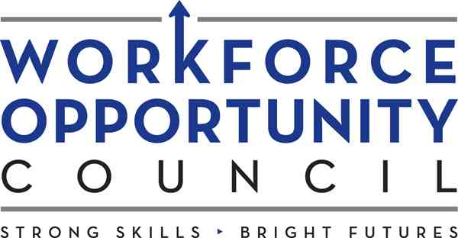
Concord, New Hampshire, Wednesday August 10, 2007:
With the strong support of Governor John Lynch, the New Hampshire Workforce Opportunity Council has announced funding for two new tuition-free Culinary Arts Pilot Programs starting September 4th, 2007 and offered in Manchester creating job and career opportunities for the unemployed and dislocated workers over the age of 18 years.
The project concept was created in conjunction by Manchester based Workforce Training Resources LLC, designed on a successful pilot called Workplace Doorway developed and launched by partner corporation Snapchef Inc. The course provides an eight week-intensive program covering all essential skills in the restaurant and food service industry including the national SERVSAFE (Sanitation) and TIPS Certification (Safe Alcohol Service), all the gold standard in the robust Manchester and New Hampshire hospitality career sector.
The courses require a minimum commitment of six-hours each day with a strong work-based learning component. “Earn and Learn” is the cornerstone of the training concept implemented by Snapchef in running the program in partnership with Workforce Training Resources LLC. Snapchef has years of success in providing supplementary staffing the biggest and the best in the food service industry including convention centers, first class hotels and food service contractors.

Snapchef will leverage its connections to get jobs for the students. Students will also get support from a number of Manchester and New Hampshire employers that have already expressed a willingness to work with the program and hire graduates.
The first course commences on September 4th and the courses have no cost for participants. "These programs offer unique opportunities for New Hampshire and Manchester residents that are out of work or require new skills in a high demand industry", said Workforce Opportunity Council, Chairman, Dick Anagnost. "The demand in our state for entry-level skilled workers for the restaurant and hospitality industry is extremely high and graduates from these courses with strong employability skills will find ample opportunity for careers in New Hampshire".
The second course, planned to commence in January is planned to include additional skills in restaurant and food services franchise management focusing on the substantial career opportunities and strong demand for entry level employees sought by employers in this field. About 25 applicants will be selected for each course based on their commitment to complete the program and seek employment in the restaurant or food service industry.
The courses will be initially based in Manchester and are being provided with the support of the Manchester Housing and Redevelopment Authority. Based on positive course outcomes, the program coordinators, Workforce Training Resources plan to expand the courses throughout New Hampshire.
and ultimately success!” “We can’t fix people but we can assist in bringing out their potential”

New Hampshire Welcomes Snapchef Training

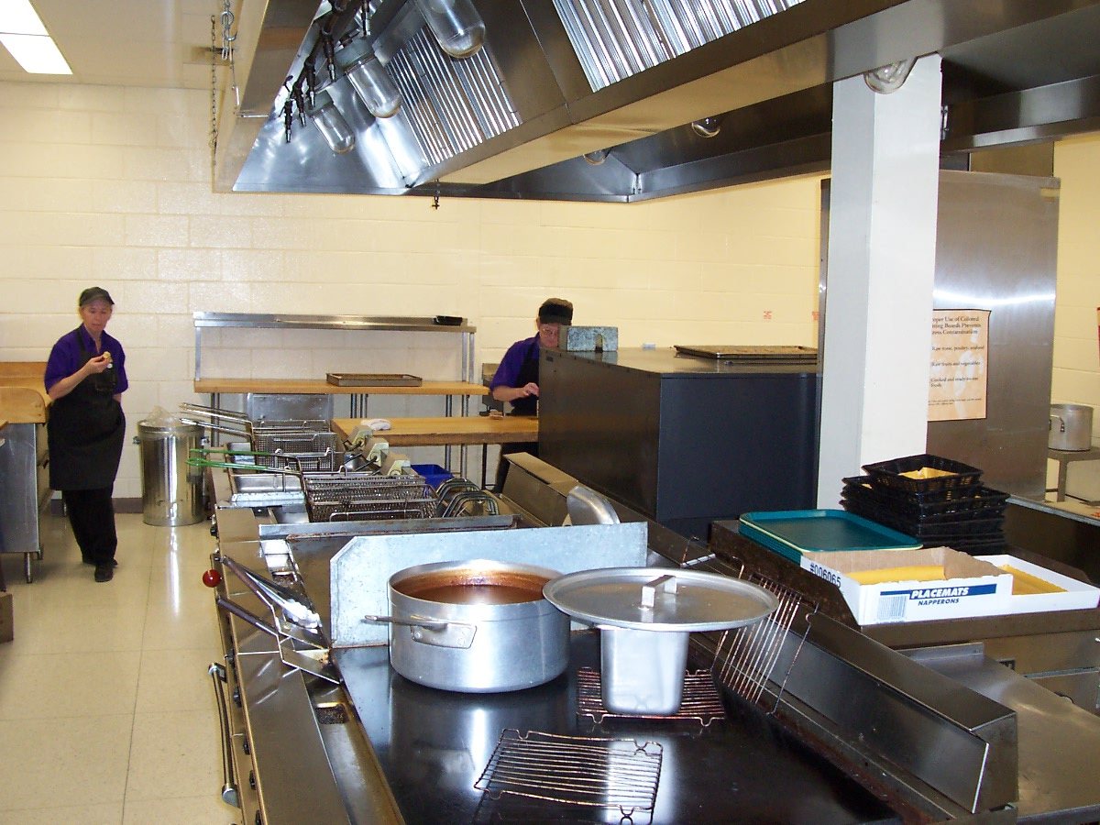

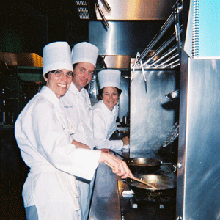
“We can't solve problems by using the same kind of thinking we used when we created them.”
Albert Einstien

Learning is not a spectator sport!

Snapchef teaches a ServSafe Course for employees that is designed to build stronger teams in terms of sanitation standards.
This course has been designed using The NRAEF literature and employee certificate. It is only three hours long and a fraction of the cost. “We use the same power point show as the manager’s course but we stick to the basics that employees need every day!” says Ed Christian, VP of Ops and Senior Certified Trainer at Snapchef.
The Westin Copley has chosen to have every kitchen employee take this course! This will raise the bar for the management team. This allows the hotel to have the responsibility for the quality of the course rest with a Snapchef, a third party. Trainers that are professionals thus limiting liability but also know how to drive home the critical information.
Snapchef also has developed a course based on NRAEF Workplace Safety. It serves to reduce insurance costs in several ways. Slips, burns, lifting injuries, cuts etc. all are costly in terms of employee productivity; this is real savings come through accident prevention.

SNAPCHEF GIVES EMPLOYEE SERVSAFE & WORKPLACE SAFETY
Snapchef
Train & Staff
239 Dorchester Street
South Boston, MA 02127

Phone:
(617) 264-CHEF
(2433)

Fax:
(617) 906-5342

E-Mail:
todd@snapchef.com
ed@snapchef.com

This course builds safety awareness and can save a bundle of money!

“Losing key staff to accidents lowers the quality of your service” says Todd Snopkowski, owner and founder, “Managers mean well and try to do the training themselves but posters on the wall DO NOT CUT IT, The Course is cheap and down to earth and worth its weight in gold!”





We’re on the Web!
See us at:
snapchef.com

Snapchef
Train & Staff
239 Dorchester Street
South Boston, MA 02127


FALL EDITION

