
See what you can gain by swapping unhealthy snacks for convenient, nutritious Sunsweet Ones™

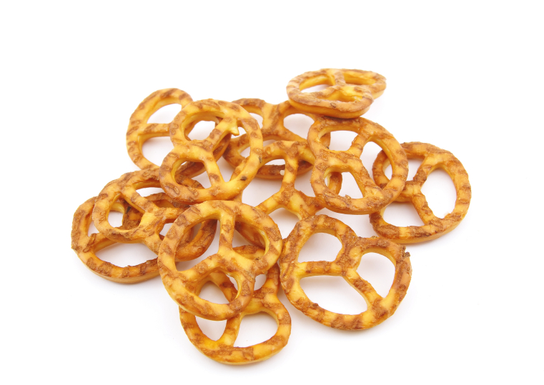
PRETZELS: Eating four Sunsweet Ones™ instead of a 1.5-ounce bag of pretzels (seven pretzels) means your body gets 572 fewer mg of sodium yet gains:
- 1.7 grams more fiber
- Five times the potassium (290 mg versus 58 mg)
- 1.5 times the daily value of copper (6% Daily Value instead of 4% DV)
- Four times the daily value of vitamin B6 (4% DV instead of 1% DV)

MICROWAVE POPCORN: Eating one serving, four Sunsweet Ones™ instead of three cups of microwave popcorn slashes calories almost in half, saves 14 grams of fat and 350 mg of sodium, plus more fiber! In addition, your body will enjoy more of these healthful nutrients:

- Almost five times the amount of potassium (290 mg instead of 60 mg)
- Double the daily value of copper (6% DV instead of 3%)
- Four times the daily value of riboflavin (4% DV instead of 1% DV)
- Six times the daily value of vitamin A (6% DV instead of 1 % DV)

MILK CHOCOLATE BAR: Satisfying your sweet tooth with four Sunsweet Ones™ instead of eating a 1.5-ounce milk chocolate bar saves 135 calories and 13 grams of fat. Making this smart swap just 26 times can mean losing a pound of body weight! In addition, you’ll be healthier from:

- Twice as much fiber (3 grams versus 1.5 grams)
- Almost double the amount of potassium (290 mg versus 164 mg)
- Four times the daily value of niacin (4% DV instead of 1% DV)
- Four times the daily value of vitamin B6 (4% DV instead of 1% DV)

(more)

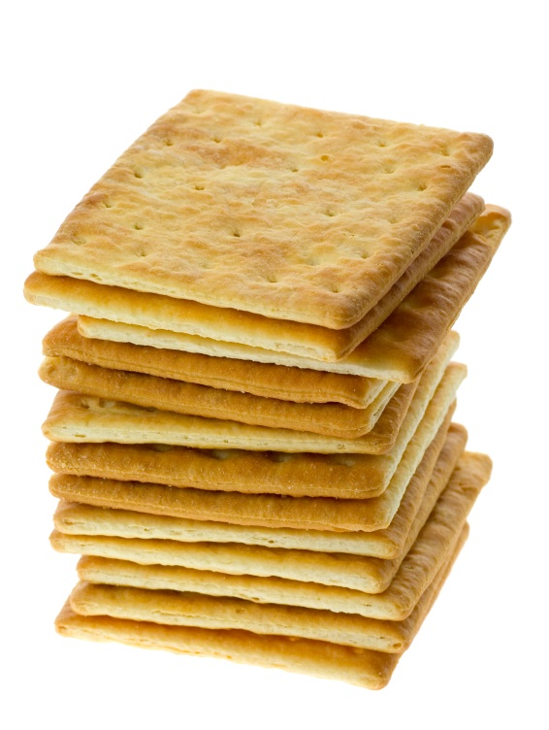
CHEESE FLAVORED CRACKERS: Instead of snacking on a 1.5-ounce bag of cheesy crackers (28 crackers), help yourself to four Sunsweet Ones™. This sensible switch wipes out 419 mg of sodium and serves up heaping amounts of these nutrients:
- Three times as much fiber (3 grams instead of 1 gram)
- More than 4 times the potassium (290 mg instead of just 62 mg)
- More of your daily value of copper (6% DV instead of 4% DV)
- Six times the daily value of vitamin A (6% DV instead of 1% DV)

TORTILLA CHIPS: Saying “adios” to a single serving of tortilla chips (15 chips) and “hola” to just four Sunsweet Ones™ eliminates almost seven grams of fat yet offers all these important nutrients:
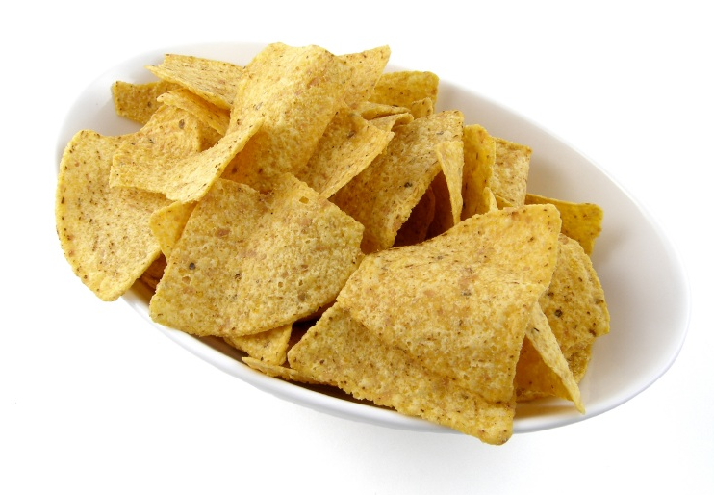
- Twice as much fiber (3 grams versus 1.5 grams)
- Four times the amount of potassium (290 mg instead of 60 mg)
- 6% daily value of manganese, tortilla chips have none
- 6% daily value of vitamin A, tortilla chips have none

CHOCOLATE COVERED PEANUT CANDIES: Eating four Sunsweet Ones™ instead of devouring an entire single serving bag of chocolate covered peanut candies lightens your caloric load by 178 calories and fat content by 14 grams! Making this trade just 20 times can mean the difference between gaining or losing a pound of body weight. Plus, you’ll get:

- More fiber (3 grams versus 2 grams)
- 100 mg more potassium (290 mg instead of 187 mg)
- Double the daily value of vitamin B6 (4% DV instead of 2% DV)
- Six times the daily value of vitamin A (6% DV instead of 1% DV)

STRAWBERRY LICORICE TWISTS: Wind your taste buds around four Sunsweet Ones™ instead of four pieces of strawberry licorice twists. Doing so means you’re body gets these 10 vitamins and minerals that are completely missing from strawberry-flavored “vines”:

- Three grams of fiber, strawberry twists have none
- 2% daily value of calcium, strawberry twists have none
- 4% daily value of magnesium, strawberry twists have none
- 290 mg potassium or 8% daily value, strawberry twists have none

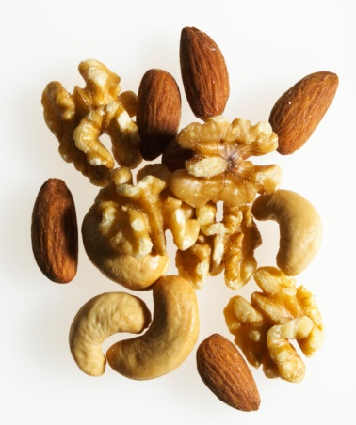
SALTED MIXED NUTS: Sunsweet Ones™ provide comparable nutritional benefits to mixed nuts; the real gain here is actually the loss of calories and fat. Indulging in four Sunsweet Ones™ instead of reaching for a one-ounce handful of mixed dry nuts will deliver 14 less grams of fat to your waistline and also boasts:
- Six times the daily value of vitamin A (6% DV instead of 0%)
- Significantly less sodium per serving (5 mg of sodium versus 190 mg)
- Significantly less calories per serving (100 calories versus 168 calories)

(more)
GRANOLA BAR: When we stacked Sunsweet Ones™ up against the trusty granola bar, known for years as the healthy snack, Ones not only avoided most of the sodium, but proved to be nutritionally superior. If you swap one granola bar for four Sunsweet Ones, you’ll gain the following:
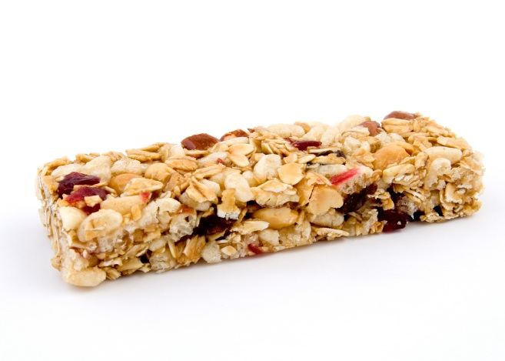
- 196 more milligrams of potassium (290 mg instead of 94 mg)
- Double the fiber (3 grams instead of 1.5 grams)
- Four times the daily value of vitamin B6 (4% DV instead of 1%)
- 5.5 less grams of fat (0 g versus 5.5 g)


FROZEN YOGURT: A sweet tooth can be the most difficult habit to curb. Replacing 1/2 cup soft-serve frozen yogurt with four Sunsweet Ones™ can satisfy that sweet tooth and will cut your sodium intake by 58 mg. Additional benefits include:
- Three grams of fiber (as opposed to zero in frozen yogurt)
- Zero fat intake (0 grams versus 4 grams)
- Nearly double the amount of potassium (290 mg instead of 152 mg)
- Six times the daily value of manganese (6% DV instead of 0%)

POTATO CHIPS: There’s a reason this snack leaves your fingers greasy. Potato chips pack in 10 grams of fat and also contain 149 mg of sodium per 1 ounce serving. By swapping four Sunsweet Ones™ for 10 potato chips, you’ll gain:
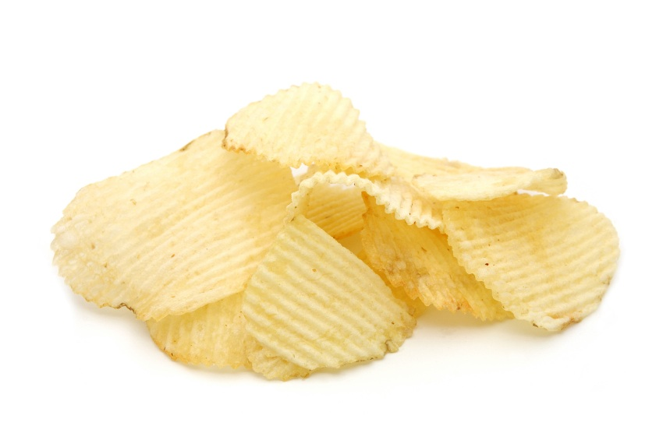
- More than double the amount of fiber (3 grams versus 1.2 grams)
- Six times the daily value of vitamin A (6% DV instead of 0%)
- Nearly triple the amount of calcium (20 grams versus 7 grams)
- 55 less calories per serving

For more information on the Sunsweet Swap and Sunsweet Ones™, please contact:
Christine Moravec
916-492-5303
Christine.Moravec@fleishman.com

# # #

Source for Nutrient data used to base comparisons:
U.S. Department of Agriculture, Agricultural Research Service, 2006. USDA Nutrient Database for Standard Reference, Release 19. Nutrient Data Laboratory Home Page, http://www.ars.usda.gov/nutrientdata

