QuickPure™ Water Purifiers
by Alab, LLC

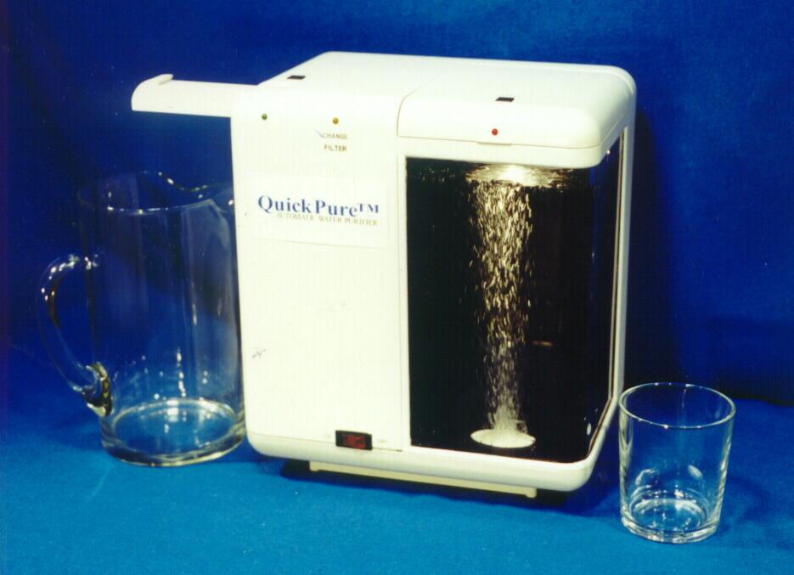

Americans and people in other developed countries want to improve the taste and odor of drinking water, but are becoming more concerned about possible contamination--especially germs. People have realized that some germs, such as Cryptosporidium and Giardia, can survive conventional municipal water treatment. Even water that is safe when it leaves the municipal treatment plant can become contaminated as it travels from treatment plants to homes.
Healthier lifestyles in recent years have pushed bottled water sales to over $11 billion and caused an explosion in the home water filter market. Now, interest in a clean germ-free environment including pure water, is driving the market to step-up products that purify as well as filter water.

Safe water is the major concern in less developed countries, where waterborne diseases and chemical contamination are more common than in developed countries. Water sources are often polluted by lack of sewage treatment. Drinking unpurified water can be more than unpleasant: it can cause serious diseases or death. As people in less developed countries raise their standard of living and become more aware of how people in developed countries live, their demand grows for good tasting, safe drinking water. Water purifiers that are inexpensive and easy to use could save tens of thousands of lives.

QuickPure™ purifiers do much more than filters; they kill all (not just some) germs as well as reducing chemical contaminants and improving taste and odor.
Fast and simple to operate, these appliances can purify 1 gallon for only 2 cents in 3 minutes!
The name QuickPure™ comes from quick, because it takes only three minutes, and pure because it really purifies.
After years of research and development, ALAB has now achieved this goal using patented revolutionary QuickPure™ ozone technology. Operation can be completely automatic (controlled by electronic micro-controllers), no chemicals are added to the water, and no installation is required! Products are ready for use right out of the box...plug and purify!

QuickPure™ technology permits a broad range of features. For example, all designs use only a small amount of electric power that can be supplied by an electric cord or by replaceable or rechargeable batteries. Some models may be adapted for very frequent use, or for use to purify cloudy, seriously polluted water.

ALAB is looking for a licensee to manufacture and distribute these devices.

Contact
Alab, LLC
27 Boulder Creek Drive, Rush, NY 14543
Tel 585-533-2115
alab@quickpure.com www.quickpure.com

