about the artist
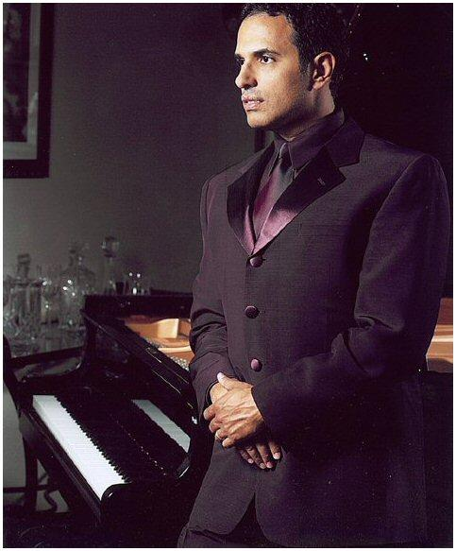

Born in Bronx, New York to an Austrian father and Cuban mother, Michael Paige grew up in a multi-cultural setting. As a child, he studied piano and played at the Carnegie Hall for the Children’s Concert Series, knowing at the age of 14 that music would be a big part of his life. Michael has Bachelors in music and now resides in Las Vegas where he’s currently completing his masters in music at UNLV, and continues to perform at such prominent hotels as in The Mirage, The Bellagio, Treasure Island, The Luxor and Rio.

Michael Paige’s journey as the “New Voice of Romance” has just begun. The assortment of Michael’s self-titled debut album encompasses love ballads and dance music crossing over to a blend of continental flavors. Michael’s style and hands-on approach makes him multi-talented in all aspects of music; writing and publishing his own music, singing in six languages and playing the piano. Michael’s recording label, Astrum Records, has also surrounded his project around some of the most talented people in the record industry.

websites
www.michaelpaigeworld.com

www.myspace.com/michaelpaigefans

www.youtube.com/michaelpaigevideos

self titled cd art + bar code
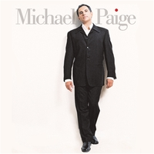

music w/ video
FOR YOU: Song [3:59] | Video [3:55]
DANCE: Song [3:55] | Video [3:59]
team behind the music
Don Grierson: A&R
- - former Senior Vice President of A&R at Sony/Epic Records

Tony Smith: Music Producer
- - worked on projects with Dolly Parton, Barbra Streisand, Lionel Richie, Whitney Houston and Johnny Mathis to name a few.

Michael Thompson: Guitarist
- - worked with Quincy Jones on his “Q’s Juke Joint” album.

Steve Farris: Guitarist
- - played guitar for Eddie Money, later went on to form the group Mr. Mister and also performed for Celine Dion.

Bruce Gaitsch: Song-Writer
- - wrote hit song “La Isla Bonita” on Madonna’s “True Blue” record, which has gone on to be #1 in over 24 countries worldwide.

Linda Thompson: Song-Writer
- - nominated for both an Oscar and a Grammy for her song in the movie, “Bodyguard.”

Amy Foster-Gillies: Song-Writer
- - written songs for Eric Benet, Diana Krall, Michael Buble and Andrea Bocelli.

