
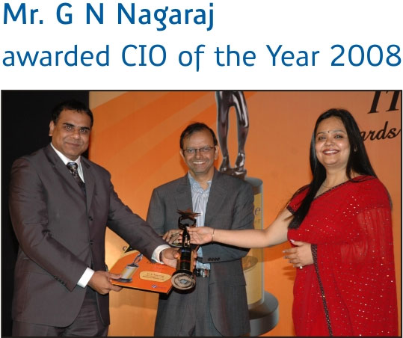
Mr. G. N. Nagaraj, Sr. Vice President and Chief Technology Officer, Reliance Money, was declared the CIO of the Year 2008, at the IT People Awards Night, held on Jan 18, 2008 at Taj Lands End, Mumbai.

This award recognizes individuals who have contributed immensely to the IT sector and brought the much needed vibrancy and competitive culture into this dynamic industry.

The award honours visionaries, recognizing IT Stars with a belief that excellence still counts.

Reliance Money and its team, congratulate Mr. G. N. Nagaraj for winning this prestigious award and making the company proud.



