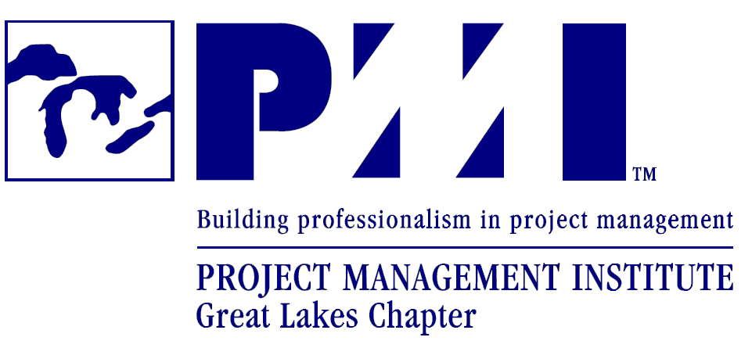
Media contact:
Ben Stickler, PMI-GLC Advertising Director
advertisingdir@pmiglc.org

For Immediate Release
14 March 2008

PMI GREAT LAKES CHAPTER TO HOST 2008 SPRING SYMPOSIUM ON APRIL 24

TROY, MICHIGAN, USA – The Great Lakes Chapter of the Project Management Institute (PMI GLC) today announced its annual Spring Symposium "Diversity: A Successful Approach" for 2008 will be held April 24 from 7:00 AM to 4:30 PM in Sterling Heights, Michigan. The general public is invited to the one day event and may register online at www.pmiglc.org. The cost for non-members to register is $175 by March 23. The cost will increase to $225 after March 23, and again increase to $250 after April 13.

The PMI GLC 2008 Spring Symposium is an educational and networking forum that provides a platform for the best minds in academia and industry to share the latest developments and advancements in the field of Project Management. The offerings this year include two dynamic keynote speakers, Hugh Woodward and Yogen Rahangdale, a choice of 12 presentations covering various topics, and short poster presentations about project management issues. Breakfast, lunch, and all day refreshments are also included. The past five Symposiums have been highly successful sold out events with management practitioners attending from numerous Midwestern states and Canada.

The 2008 Spring Symposium offers an excellent opportunity for attendees to learn about project management concepts and meet practicing managers that have a significant influence in their organizations. Managers from major corporations in a variety of industries will attend the event. The size and scope of the event provides a unique networking opportunity.

Registration information and details on the day’s events including each individual session are located on the PMI GLC website - http://www.pmiglc.org/pd/2008symposium/index.html.

About PMI® Great Lakes Chapter:
As a part of a PMI® worldwide effort, the mission of PMI® Great Lakes Chapter is to promote and enhance project management knowledge, skills, and leadership. The Great Lakes Chapter is one of the world’s largest PMI® Chapters with over 2200 members in the tri-county area. For more information, please visit www.pmiglc.org.
.
About PMI®
With nearly 250,000 members in more than 160 countries, Project Management Institute (PMI®) is the leading membership association for the project management profession. PMI is actively engaged in leading the profession by setting professional standards, conducting research and providing access to a wealth of information and resources. PMI also promotes career and professional development and offers certification, networking and community involvement opportunities. For more than 39 years, PMI has advanced the careers of practitioners who have made project management indispensable in achieving business results. Please visit www.pmi.org for more information.

###

