Media Contact:
Anne Carlantone/Christina Occhipinti
Robin Leedy & Associates, Inc.
(914) 241-0086, ext. 12
acarlantone@robinleedyassociates.com

EXPERT BIOS: ROHTO® STYLE EXPERT

GITA BASS: Celebrity Makeup Artist
“You Can’t Look Great if Your Eyes Don’t Look Great”

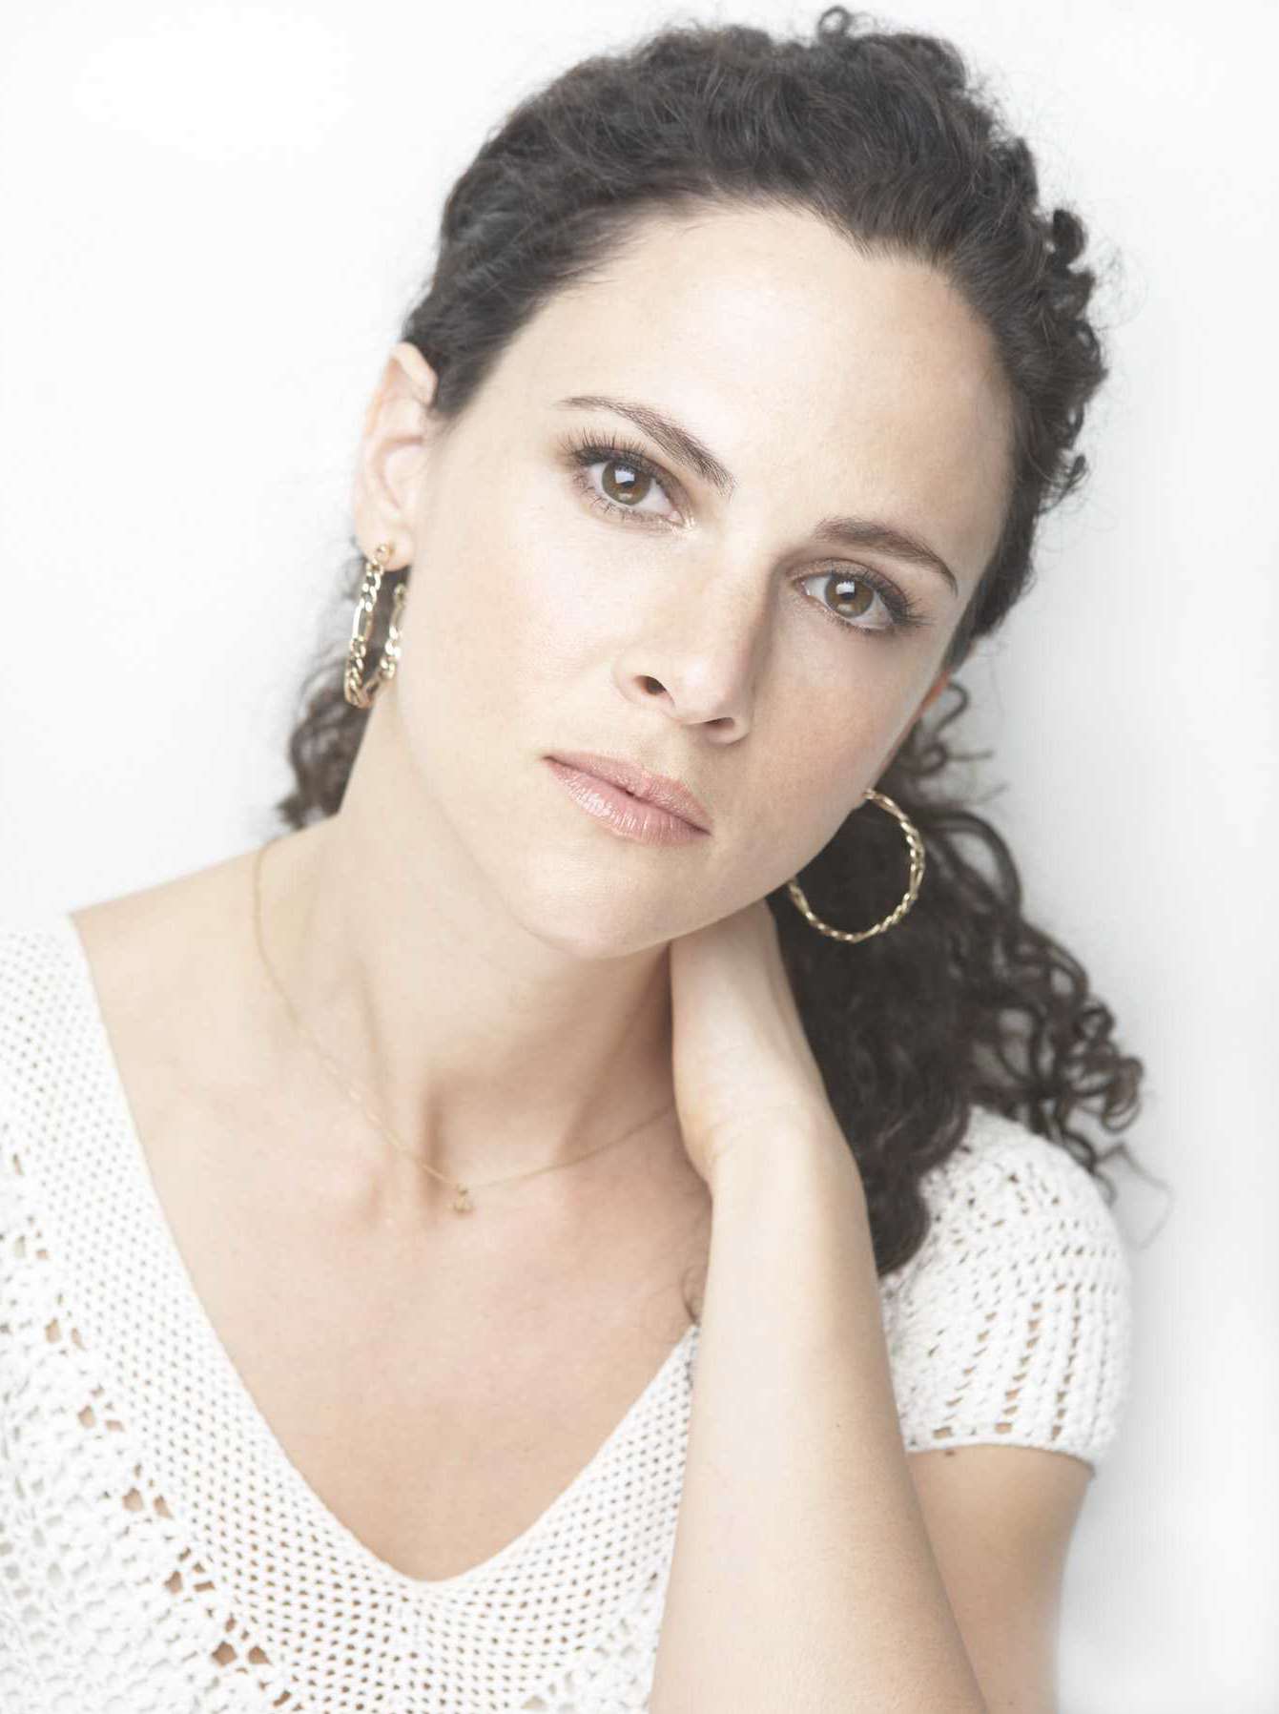
A native Australian, Gita Bass has worked extensively in New York and Europe on numerous celebrities, campaigns and runway shows. Bass’ work can be seen on the editorial pages of fashion and beauty magazines, including Glamour, Lucky and InStyle, as well as in men’s magazines, including Details, Men’s Health and Nylon Guys.

Bass has also been involved in countless advertising campaigns and editorials, where she has worked with celebrities like Cate Blanchett, Toni Colette, Tina Fey, Taye Diggs, Jonathan Rhys Meyers, Ryan Reynolds and more. She has also worked with renowned photographers like Annie Liebovitz, Marc Baptiste and Jacques Malignon, among others.

Through her work, Bass possesses an amazing ability to incorporate a fresh, new approach with an air of classic nobility.

-0-

