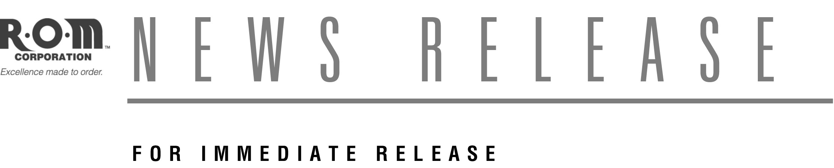

R•O•M Enhances Website With Products
For RV, Service and Utility Vehicles

New Resource Features R-O-M Roll-Up Doors for service, utility and recreational vehicles

BELTON, MO (July 2008) –– Long known as the leading provider of compartment access solutions for the Fire Service, R•O•M Corporation has now added RV, Service and Utility Vehicle market information to our website at www.romcorp.com. Dealers, OEMs, distributors and end users of roll-up doors for RV, Service and Utility fleets can now learn more about R•O•M Roll-Up Doors that have been providing secure compartment access solutions to their industry for decades, and Truck Bed Covers that are available to spec on new vehicles or retrofit on existing ones.

Industry-leading options such as Perfect Match Wet Paint, LED lighting and power-operated doors enable R·O·M Roll-Up Doors and Truck Bed Covers to easily accommodate any RV, service and utility compartment access scenario better than swing-out and lift doors.

R•O•M Corporation has been serving the Fire Service, Food Distribution and Building Security industries for over 65 years. Products such as Roll-Up Doors, RoadwarrioR and Sidekick Safety Walkramps, Thermowarrior Bulkhead System and LinksGuard Security Closures have achieved industry-leading status in their respective markets.

More information is available by visiting www.romcorp.com/service-utility or by calling 800-827-3692.

For more information, contact:
Steve Briggs Darrin Widick
R•O•M Corporation Widick Marketing
6800 E. 163rd St. 415 Delaware, Suite 200
Belton, MO 64012 Kansas City, MO 64105
Phone: 800-827-3692 Phone: 816-753-2420 ext. 334
SteveBriggs@ROMCorp.com DarrinWidick@Widick.com

