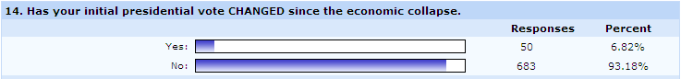

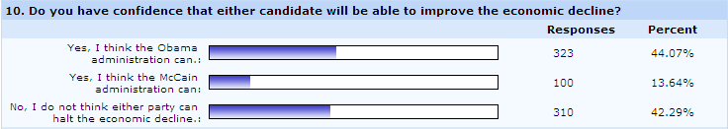

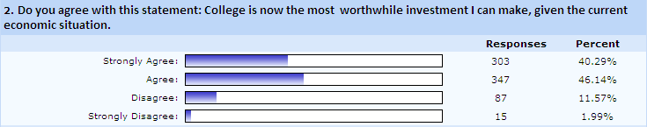

Poll Results
- 65% of students surveyed plan to vote for Obama,
- 26% will vote for McCain.
