D.I.S.C. SPORTS AND SPINE CENTER

FACT SHEET
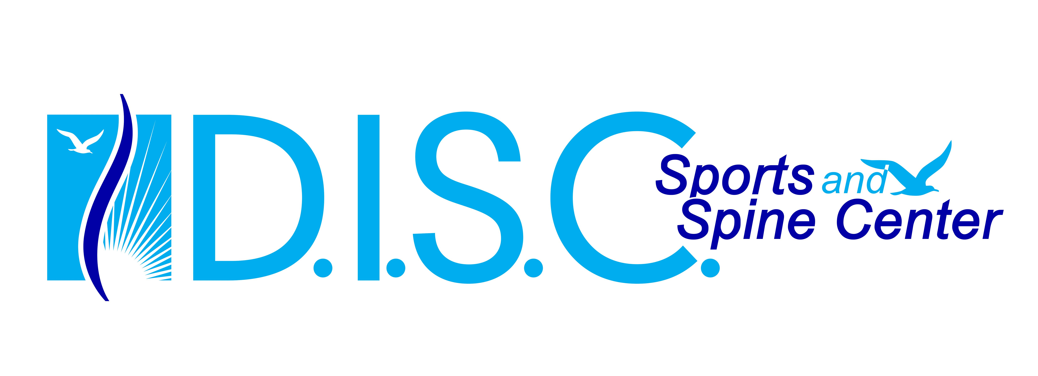

D.I.S.C. Overview: D.I.S.C. is re-defining patient care with a multidisciplinary center that has the expertise of a variety of specialists from the fields of spinal neurosurgery, orthopedic surgery, physical medicine, pain management, chiropractic services, acupuncture and oriental medicine all working together to find the best solution for each individual. D.I.S.C. offers the next generation of diagnostic imagining and a complete world-class surgery center with three suites specializing in minimally invasive procedures. Throughout the center you will find a dedicated team of highly qualified experts offering unparalleled medical services combined with old-fashioned personal care.

Dr. Robert S. Bray Jr., CEO & Founding Director:

- One of the preeminent neurologic spinal surgeons in the country
- Forefront of medical advances for minimally invasive surgeries, with more than 25 patents
- Innovator of advanced design techniques, instruments and devices
- 27-year medical career, he has performed more than 9,000 microsurgical procedures
- Over 85% of his cases are performed outpatient (national average is 5-10%)
- Developed the high-powered Zeiss Microscope that enabled MIS procedures
- Revolutionizing treatments for those that suffer from back and neck pain
- Lectures and teaches nationally and around the world.
- Able to provide expert analysis for national breaking news stories or features as it relates to back or neck issues

Our Surgery Center:

- 100% HEPA filter greatly reduces risk of infection
- UVC Emitter (Ultraviolet) further destroys airborne germs and bacteria
- Positive Patient Satisfaction Surveys more than 95%
- High Nursing to Patient Ratio
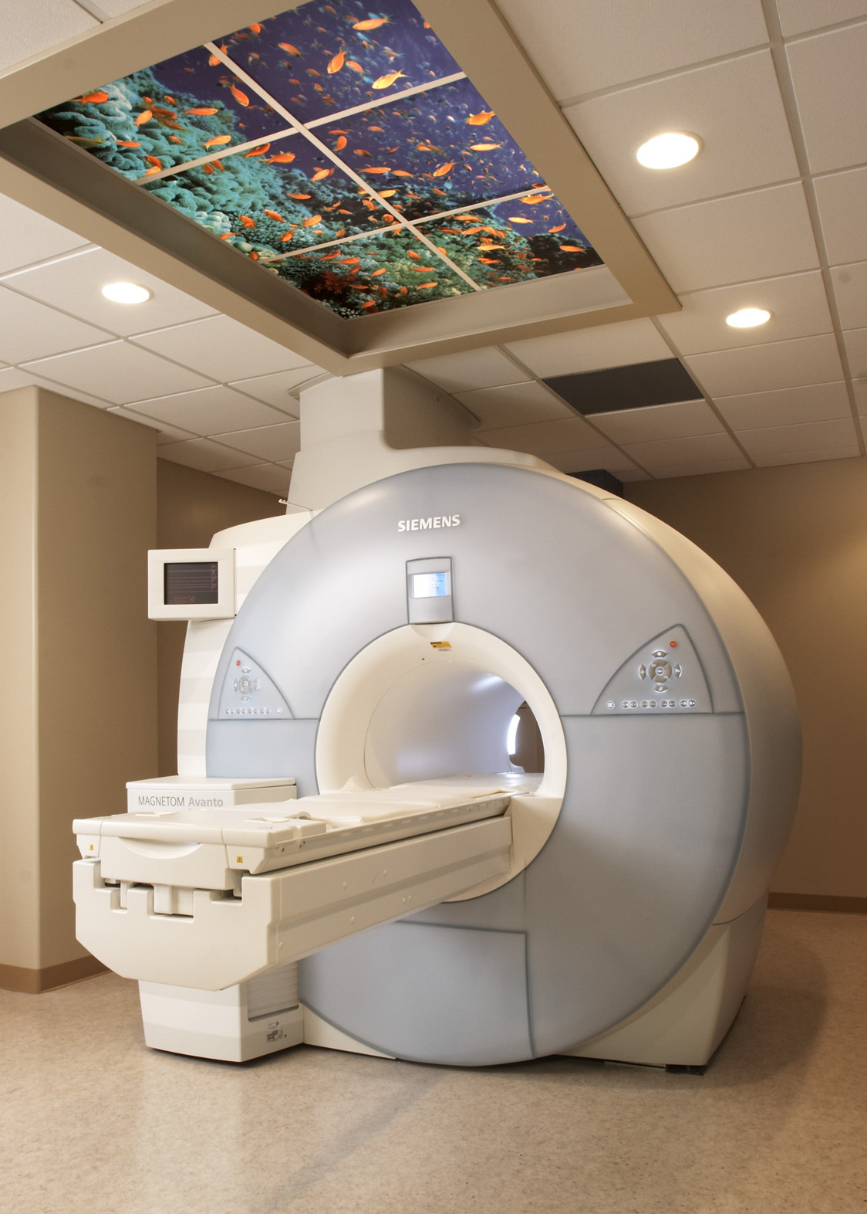
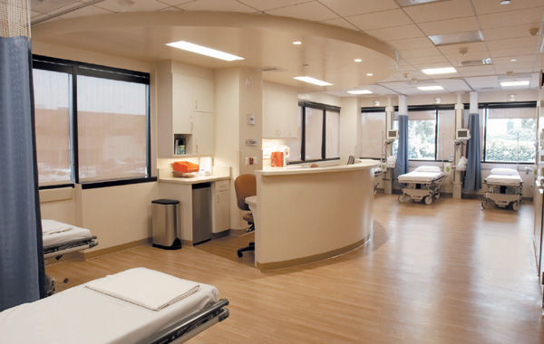
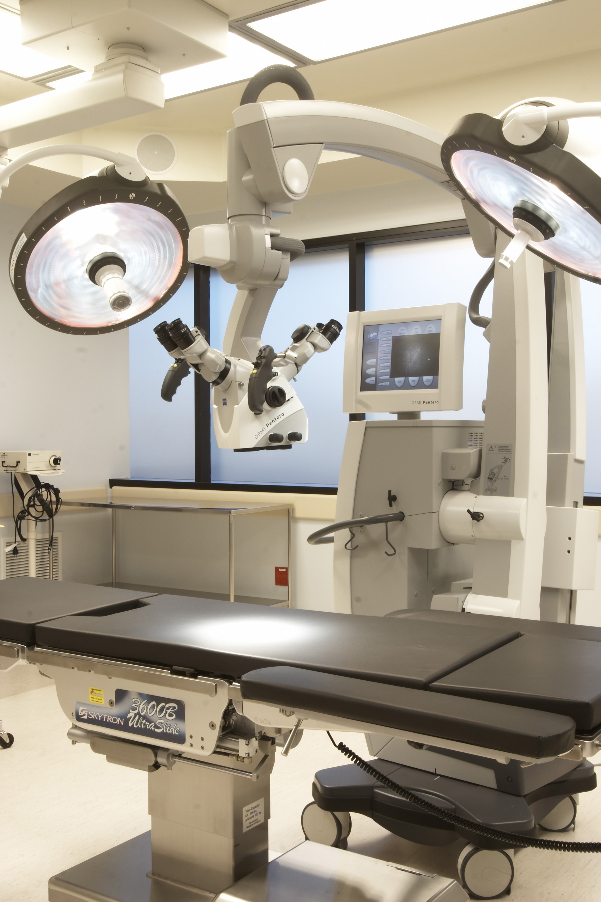

D.I.S.C. Fact Sheet/Page 2

Facility Key Facts

In a 125,000 sq. ft. building the D.I.S.C. space of 55,000 sq. ft. includes:
- 7,200 sq. ft. surgery center with 3 Digital ORs, 8 Recovery beds, 4 Pre-OP beds. The surgery center is 100% HEPA filtered to prevent infection.
- 5,000 sq. ft. imaging center including next generation MRI, CT and X-ray
- 8,000 sq. ft. of Soft Tissue and Physical Therapy space
- Doctors and management offices

Leading-Edge Research

- NeoDisc – A small device to replace the bad disk with something that is designed to replicate the cushioning and motion characteristics of a healthy disk, rather then have fusion surgery.

State-of-theArt Technology

Our comprehensive medical facility offers:
- An Imaging Center with next generation MRI, CT and Digital X-ray
- A Soft Tissue Center, which treats all forms of musculoskeletal, joint and sports injuries through completely non-invasive treatment techniques, including soft tissue mobilization, acupuncture and oriental medicine.
- An Outpatient Surgical Center equipped for advanced Microsurgical and Advanced Arthroscopic procedures.
- A doctor-designed Digital OR which can integrates all the OR systems and connects the facility’s information system to the Internet enabling medical staff to access patient information, consult with other specialists and document procedures.

Location and Services

Located in the heart of Marina del Rey (across the street from Jerry’s Deli). D.I.S.C. redefines medical care as we know it today. D.I.S.C. offers a variety of professional services including patient evaluation, diagnostic testing, pain management, psychological testing and support, outpatient surgery and recovery, rehabilitation therapies, Digital X-Ray, MRI, and CT imaging capabilities.



