Appendix
Survey Results
Full results and product images available upon request from TippingSprung

Question 10. BEST BRAND EXTENSION
(for an innovative and impactful extension, in harmony with the core brand)
 |  | votes | 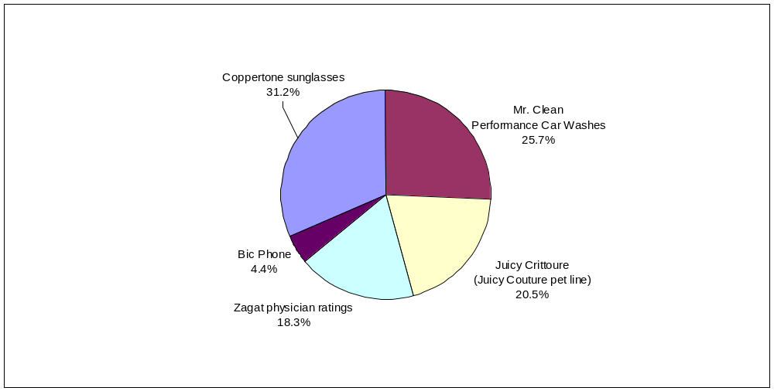
1 | Coppertone sunglasses | 215
2 | Mr. Clean Performance Car Washes | 177
3 | Juicy Crittoure (Juicy Couture pet line) | 141
4 | Zagat physician ratings | 126
5 | Bic Phone | 30

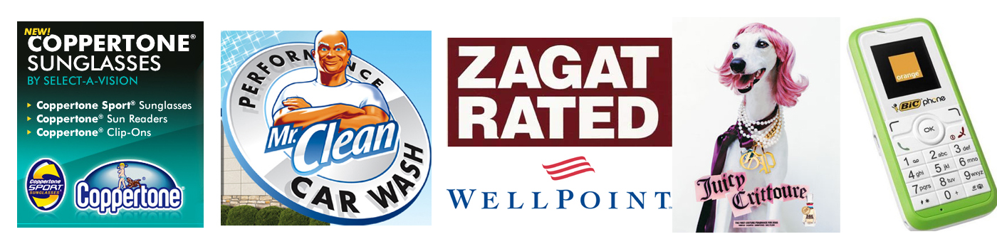

Question 9. WHAT WERE THEY THINKING?
(for the extension that least fits the brand’s core values)
 |  | votes | 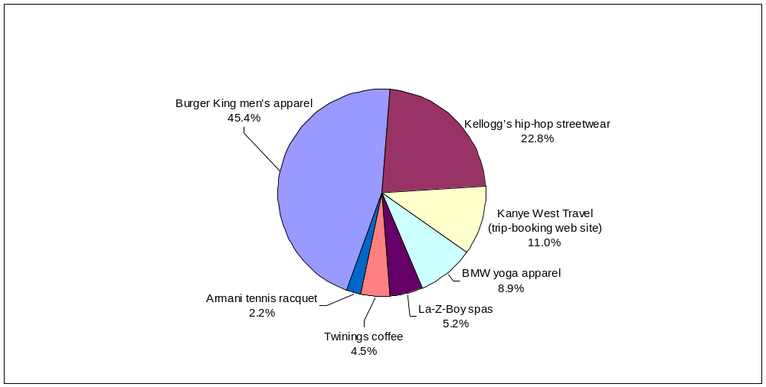
1 | Burger King men’s apparel | 313
2 | Kellogg’s hip-hop streetwear | 157
3 | Kanye West Travel (trip-booking web site) | 76
4 | BMW yoga apparel | 61
5 | La-Z-Boy spas | 36
6 | Twinings coffee | 31
7 | Armani tennis racquet | 15
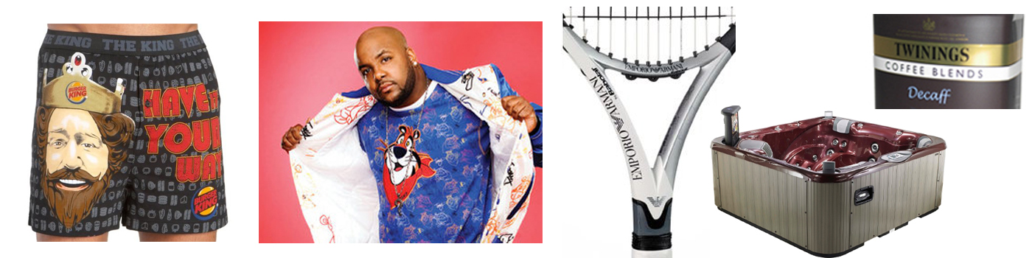
Question 1. IN THIS ECONOMY? (for the most ill-timed upmarket move)
 |  | votes | 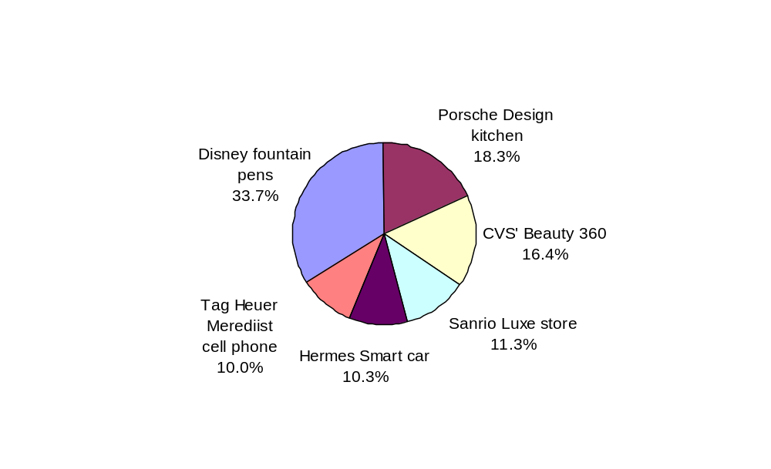
1 | Disney Sleeping Beauty executive fountain pens (up to $1,200) | 232
2 | Porsche Design kitchen ($100,000) | 126
3 | CVS' Beauty 360 (upscale cosmetics stores) | 113
4 | Sanrio Luxe store (upscale Hello Kitty stores) | 78
5 | Hermes Smart car ($48,000) | 71
6 | Tag Heuer Merediist cell phone ($6,000) | 69

Question 2. LITTLE BIT OF LUXE (best low-cost guilty pleasure in a down economy)
 |  | votes | 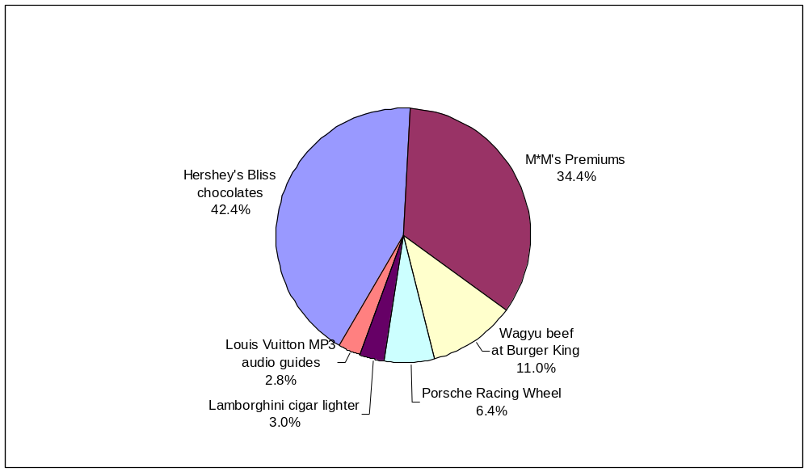
1 | Hershey's Bliss chocolates | 292
2 | M*M's Premiums | 237
3 | Wagyu beef at Burger King | 76
4 | Porsche Wireless Racing Wheel (for video games) | 44
5 | Lamborghini cigar lighter | 21
6 | Louis Vuitton Soundwalk MP3 audio guides | 19

Question 3. AT YOUR SERVICE (best extension in the service category)
 |  | votes | 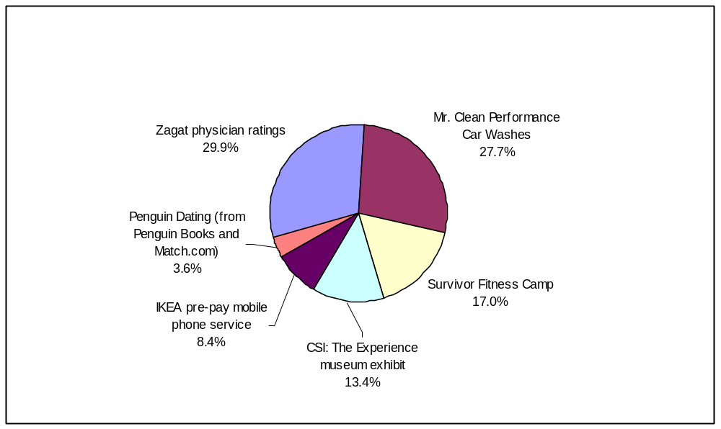
1 | Zagat physician ratings | 206
2 | Mr. Clean Performance Car Washes | 191
3 | Survivor Fitness Camp | 117
4 | CSI: The Experience museum exhibit | 92
5 | IKEA pre-pay mobile phone service | 58
6 | Penguin Dating (from Penguin Books and Match.com) | 25

Question 4. BEST TRAINING EXTENSION
 |  | votes | 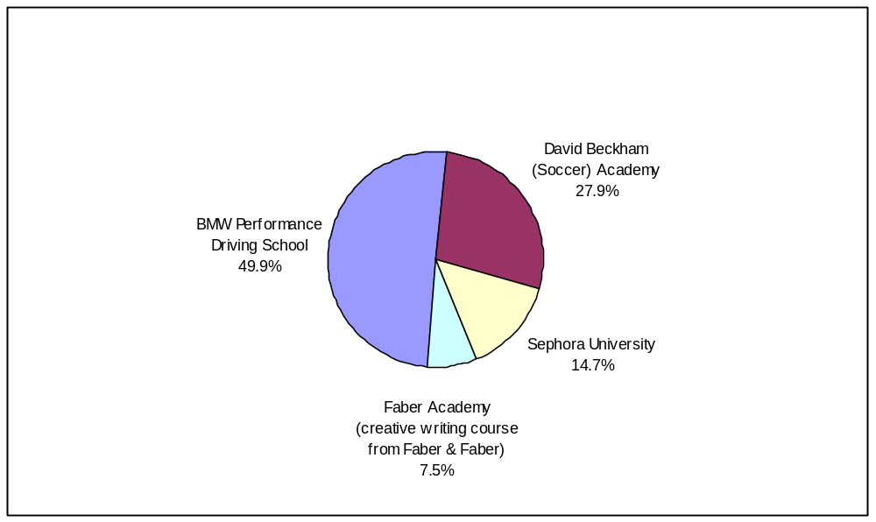
1 | BMW Performance Driving School | 344
2 | David Beckham (Soccer) Academy | 192
3 | Sephora University | 101
4 | Faber Academy (creative writing course from Faber & Faber) | 52

Question 5. GOOD CAUSE MARKETING (good idea or not?)
(for each item, vote whether it's a good or a bad idea)
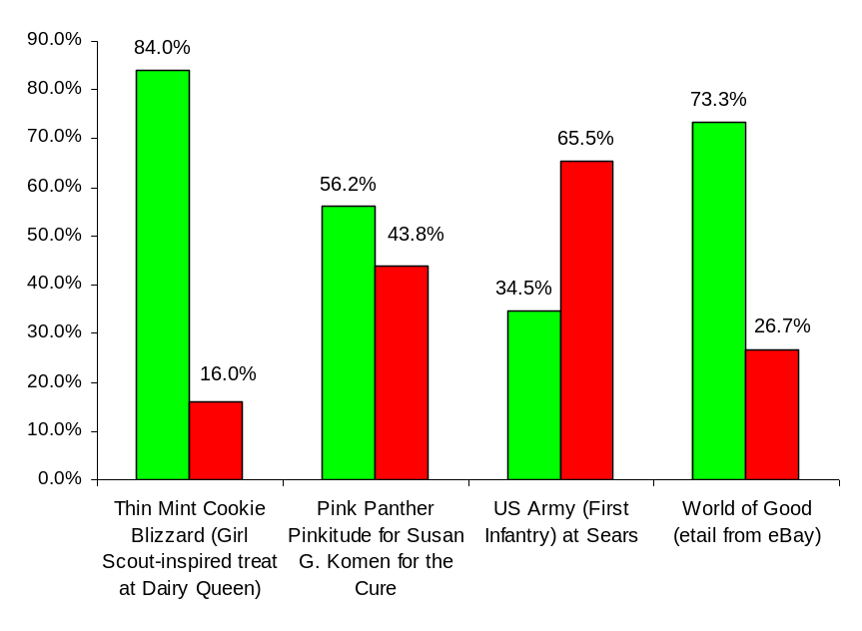
Question 6. GREEN OR GREENWASH? (thumbs up/down)
(for each item, vote whether it's a good or a bad idea)
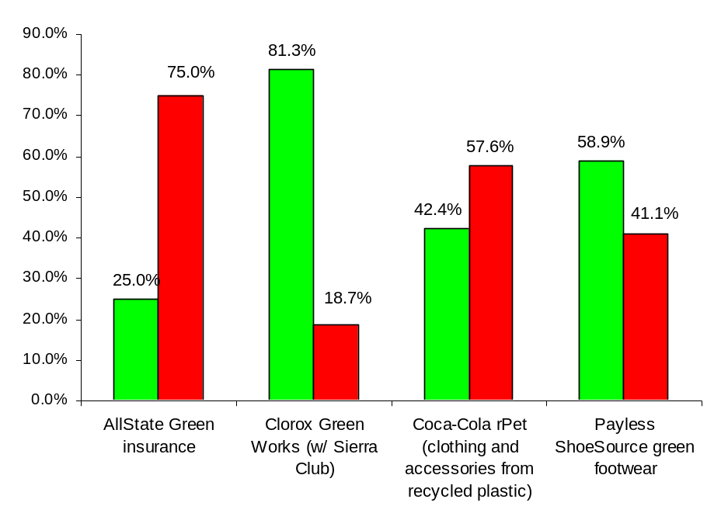
Question 8. BEVERAGE EXTENSIONS (thumbs up/down)
(for each item, vote whether it's a good or a bad idea)


