


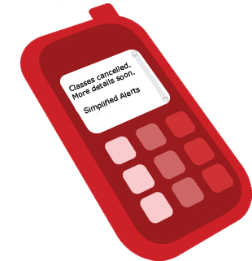
SimplifiedAlerts

Mobile and email alerts notification system

www.SimplifiedAlerts.com/Schools

Alert parents and staff in case of emergencies

SMS Alerts for Schools

Send an urgent school alert to hundreds of parents' mobile phones or emails - instantly!

Set-up is Simple
The Administrator has control
- Create multiple message groups and categories
- Create message templates for quick sends-- Import and update user lists
- View sent messages and message logs
- Typically takes minutes

Subscribing is Simple
Parents opt-in

-Each school or district gets its’ own sign-up page - easily linked from your website or an email
- Parents and staff securely sign-up and opt-in to your message list
- Recipients can actively manage their preferences (interests, phone number, carrier)

Sending is Simple
Takes less than a
minute to send
- Sent to both mobile devices and email accounts
- Optional email only send
- Pre-schedule messages
- Pre-select recipients by category
- High deliverability rates
- Works with all cell phone providers

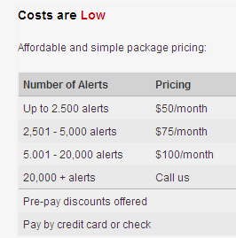
SimplifiedAlerts is a secure Internet-based, mass SMS alert notification system designed for independent and public school systems and colleges.
SimplifiedAlerts allows administrators to send permission-based SMS advisory, weather, sports updates
and emergency alerts to parents
and school staff in minutes.
SimplifiedAlerts creates text messages that are quickly sent to
a user’s cell phone, email account
and other mobile devices.
SimplifiedAlerts is priced competitively, costing just pennies
per text message.
SimplifiedAlerts can be customized and branded for any school or district.

866-TEXT-888
866-983-8888
sales@simplifiedalerts.com
Try SimplifiedAlerts today at no charge.
Visit www.SimplifiedAlerts.com/Schools

A Product of SimplifiedSolutions LLC | 150 N. Michigan Ave. Ste. 2800 Chicago, IL 60601

