Contact: Kim Klietz
PR Coordinator
Chief Manufacturing
952-277-3867
kim.klietz@milestone.com

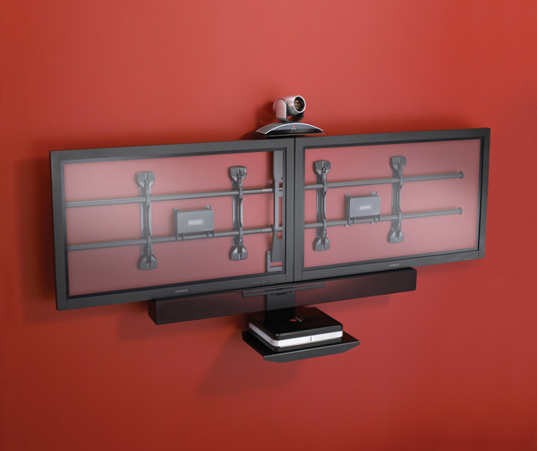

FOR IMMEDIATE RELEASE

Chief® Installer-Inspired FUSION™ Series Fixed and Tilt Mounts Shipping Late January!
It’s time for a change, so take control of your install with the new FUSION Series, designed to solve some of the toughest installation challenges.

Minneapolis, MN. -- (January 2009) – www.chiefmfg.com – Chief Manufacturing, the industry leader in projector, monitor and flat panel TV mounting solutions, as well as progressive online tools, is excited to announce that the FUSION Series will begin shipping at the end of January. The mounts focus on usability and speed of installation and were designed to solve some of the toughest installation challenges.

Inspired by installers, Chief’s new FUSION universal mounting system is an industry-first series of mounts with the most progressive collection of features available today. The new low-profile design is available in fixed or tilt models for 26”-75” TVs. FUSION mounts include never before seen features that free up valuable installation times and allow for customization, adjustments and self-leveling even after mounted to the wall.

Features
To develop the FUSION Series, the Chief product development team observed specific challenges that professional installers faced when mounting flat panel TVs. These challenges, ranging from inconvenient stud location to perfect leveling of the flat panel, directly influenced the design of FUSION, which features the 4 C’s of mounting:

1. Centerless™ Lateral Shift: Get up to 16” of post-installation lateral shift (8” left/right of uprights).
2. ControlZone™ Height & Roll Adjustment: This industry-first feature allows post-installation fine-tuning of height and leveling, and adjustments are applied to the entire configuration, not just the TV.
3. Centris™ Low-Profile Tilt: Provides effortless tilting by using the center of gravity to balance the screen – no tools necessary!
4. Click-Connect™ Tool-Less Latching: Hear an audible click when the screen safely engages with the mount. Use the built-in cable stand to gain easy access under the screen.

Applications
Chief’s FUSION Series mounts are ideal for a variety of applications including video conferencing, telepresence and multi-monitor solutions to create video walls. With Chief mounts, you can create media-rich environments with strong, flexible mounting solutions. Chief’s FUSION Series mounts create state-of-the-art scalable wall mounting systems for flat panel displays, cameras and components; providing ease of installation and post-installation adjustments.

Accessories
A full line of supporting accessories can be integrated with the FUSION mounts, extending the same adjustment benefits to the entire configuration. Mix and match accessories with any FUSION mount for the perfect installation in every application. Accessories include center and left/right speaker adapters; surge adapters; component shelves; video conferencing shelves; and connector kits.

For more information about these new mounts, download the FUSION brochure on Chief’s website.

About Chief
Chief Manufacturing is a division of Milestone AV Technologies, a Duchossois Group Company, and has more than 30 years of proven product and service excellence. Committed to responding to industry needs in the Pro AV, Residential and Office markets, Chief offers a complete line of mounts, lifts and accessories for flat panel displays and projectors.

Chief continues to design innovative mounting solutions that complement the technology they support. With multiple product awards and patented designs, Chief provides unique mount features, and is recognized for delivering not only quality products, but knowledgeable, helpful customer service.

U.S. and Europe sales offices support a global network spanning the Americas, Europe, the Pacific Rim and beyond. Chief distribution centers are located in Minnesota and the Netherlands. www.chiefmfg.com.

-###-

