Contact: Karen Mefford
Marketing Manager
Chief Manufacturing
952-894-6280
karen.mefford@chiefmfg.com
www.chiefmfg.com



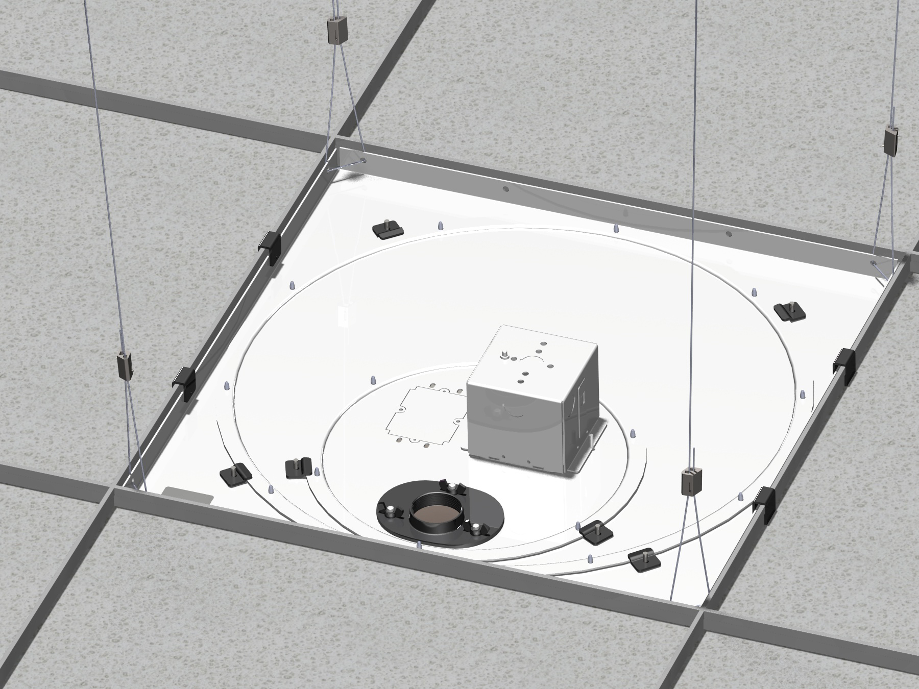

FOR IMMEDIATE RELEASE

Chief Now Offers a New Category of Power Management Products
The accessories provide discrete, high-performance power conditioning plus surge protection all-in-one SKU for suspended ceiling and in-wall applications.

Minneapolis, MN, USA -- (February 2009) – www.chiefmfg.com – Chief Manufacturing, the industry leader in projector mounts, monitor mounts and flat panel TV mounting solutions, as well as progressive online tools, is excited to announce that a new line of Power Management Products is now shipping!

Chief now offers high-performance power conditioning and surge protection built in to accessories used for installing projectors and flat panels. This unique design integrates the power conditioner with the outlet for improved audio and video performance, while seamlessly integrating with your installation. Chief also saves valuable installation time by preassembling the outlet and electrical box to ensure protection for all of your audio/visual equipment.

Choose from a variety of power-infused products that now include a Power Outlet Conditioner, including the CMS440P™ Suspended Ceiling Kit, the CMS445P™ Suspended Ceiling Tile Replacement Kit and the PAC521P™ In-Wall Box for flat panel TV wall mount applications. The ceiling kit and in-wall box accessories replace the need for an outlet while providing AC cleaning for the best equipment performance.

Chief also offers the power conditioner as a separate SKU, the PX2W™ Power Outlet Conditioner. The PX2W can be ordered separately and be used with existing CMS440 and CMS445 installations, or installed in the wall like a standard electrical outlet.

Chief will also add a new power accessory to the lineup in March 2009. The In-Wall Power Extension System for flat panel TV installations installs behind the flat panel, and connects remotely to an outlet or power conditioner. More information coming soon!

About Chief
Chief Manufacturing is a division of Milestone AV Technologies, a Duchossois Group Company, and has more than 30 years of proven product and service excellence. Committed to responding to industry needs in the Pro AV, Residential and Office Markets, Chief offers a complete line of mounts, lifts and accessories for flat panel displays and projectors.

Chief continues to design innovative mounting solutions that complement the technology they support. With multiple product awards and patented designs, Chief provides unique mount features, and is recognized for delivering not only quality products, but also knowledgeable, helpful customer service.

U.S. and Europe sales offices support a global network spanning the Americas, Europe, the Pacific Rim and beyond. Chief distribution centers are located in Minnesota, Hong Kong, and the Netherlands. www.chiefmfg.com.

-###-

