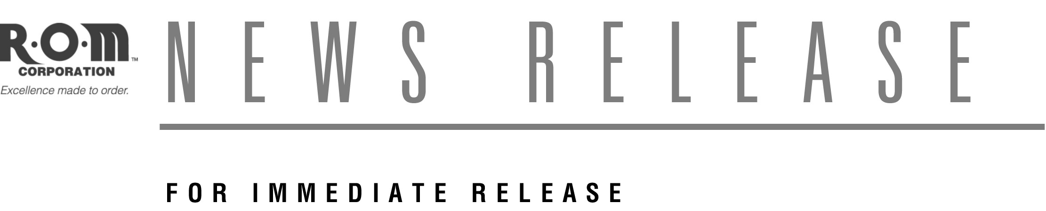

R•O•M Corporation Promotes Touchton
To Emergency and Specialty Products Manager

BELTON, MO (March 2009) – R•O•M Corporation, a leading manufacturer of products for the fire service, food distribution and building security industries, has promoted Steve Touchton to the newly created position of emergency and specialty products manager. Touchton will manage sales of the firm’s compartment access products, including R•O•M Roll-up Doors, Cargo Trays, LED Compartment Lighting and Hose Bed Covers.

Touchton joined R•O•M in 2005 as the Mid-Central territory manager. He traveled five states and one Canadian province providing on-site assistance with OEM and end-user design and installation needs. The Air Force veteran holds a BS in Safety Engineering and has over 15 years of experience serving the fire service and other specialty markets.

“As we continue our growth as a single-source provider of compartment access solutions, Steve has already proven to be a valuable resource for our fire service and specialty customers,” says R•O•M president Steve Briggs. “His engineering and sales expertise, product knowledge and creative problem solving skills help R•O•M’s customers succeed by operating safely and efficiently.”

Touchton will help direct a sales team of 20 members, including customer development representatives, sales support personnel and nationwide territory managers. He’ll continue to help the company’s engineering team identify product enhancements and pursue new product opportunities.

About R•O•M Corporation
Headquartered in a state-of-the-art, 65,000 sq. ft. facility in suburban Kansas City, MO, R•O•M engineers, manufactures and distributes products worldwide. It specializes in the fire service and foodservice industries, and also serves the building security and specialty markets such as RVs, service and utility fleets, and other niches. The company’s website is www.romcorp.com.
###

For more information, contact:
Marcus Allen Darrin Widick
R•O•M Corporation Widick Marketing
6800 E. 163rd St. 415 Delaware, Suite 200
Belton, MO 64012 Kansas City, MO 64105
Phone: 800-827-3692 ext. 202 Phone: 816-753-2420 ext. 334
sales@romcorp.com info@widick.com

