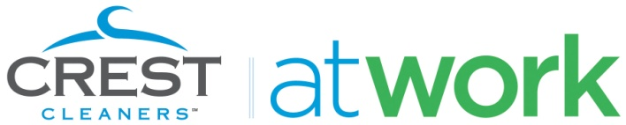
Media Contact
Mike Conti
Crest Cleaners
P: 703.714.0070 x. 110
E: mike@crestcleaners.com

FOR IMMEDIATE RELEASE
Introducing Crest at Work: The Laundry & Dry Cleaning Pickup and
Delivery Service for Washington D.C.-Area Businesses and Their Employees

New Service from 16-Location D.C. Area Dry Cleaner Provides One of the
Most Popular Employee Benefits to Fairfax County and Montgomery County Businesses

April 19, 2010 - McLean, Va. – Crest Cleaners, a Washington D.C. area dry cleaner with 16 locations throughout the metro area, announced the launch of its Crest at Work service today. Crest at Work provides a fast, flexible and convenient laundry and dry cleaning delivery service to businesses in Fairfax and Montgomery Counties.
“Most business owners would agree that keeping employees happy and looking good is of paramount importance, yet the typical employee cringes at the thought of making an extra stop on the way home from work,” said Mike Conti, chief operating officer of Crest Cleaners. “Crest at Work solves that problem for both the employee and the business, by delivering high quality laundry and dry cleaning services to offices all over the metro area.”
Crest at Work serves a variety of clients throughout the Washington D.C. metro area and can clean everything including restaurant linens, lab coats, service uniforms, and of course the standard shirts, pants, suits and dresses. Businesses interested in taking advantage of Crest at Work’s free pickup and delivery service can get started in three simple steps:

- Set up an appointment with a Crest at Work Service Manager by calling 703.216.5136 in Maryland or 703.483.1775 in Virginia, or by visiting www.CrestAtWork.com.

- After your appointment, your Crest at Work Service Manager will leave you with some bags for your employees and ideas for communicating the new employee benefit.

- Your Service Manager comes back to pick up the bags, everything is cleaned at Crest-owned locations, then delivered back to your office within a few days.

“We speak to a lot of customers who tell us that they’d use Crest more if one of our locations was just a bit closer to their home or office, said David Slan, president of Crest Cleaners. “By providing the convenience of delivery right to your office, now there’s a Crest Cleaners wherever you are.”

(Optional paragraph)
As it does in its 16 locations, Crest at Work provides environmentally friendly cleaning services to businesses as well. Crest uses only biodegradable, organic cleaning agents and the company’s commitment to reduce its environmental footprint leaves Crest far ahead of even EPA standards. In addition to its Clean Care system, Crest also maintains a hangar recycling program designed to make a dent in the large volume of hangars that end up in US landfills.

About Crest at Work
Crest at Work, a division of Crest Cleaners, offers high quality, convenient laundry and dry cleaning services to companies throughout the Washington D.C. metropolitan area. Dozens of area companies – ranging from laboratories to restaurant chains to large technology companies – take advantage of Crest at Work’s fast and reliable delivery services. With an experienced and reliable roster of service managers, Crest at Work provides environmentally friendly cleaning services to its corporate customers and in its 16 area locations.

For more information, visit www.crestatwork.com.

###

