ABOUT GUY GAVRIEL KAY

GUY GAVRIEL KAY is the #1 internationally bestselling author of ten previous novels and an acclaimed collection of poetry, Beyond This Dark House.
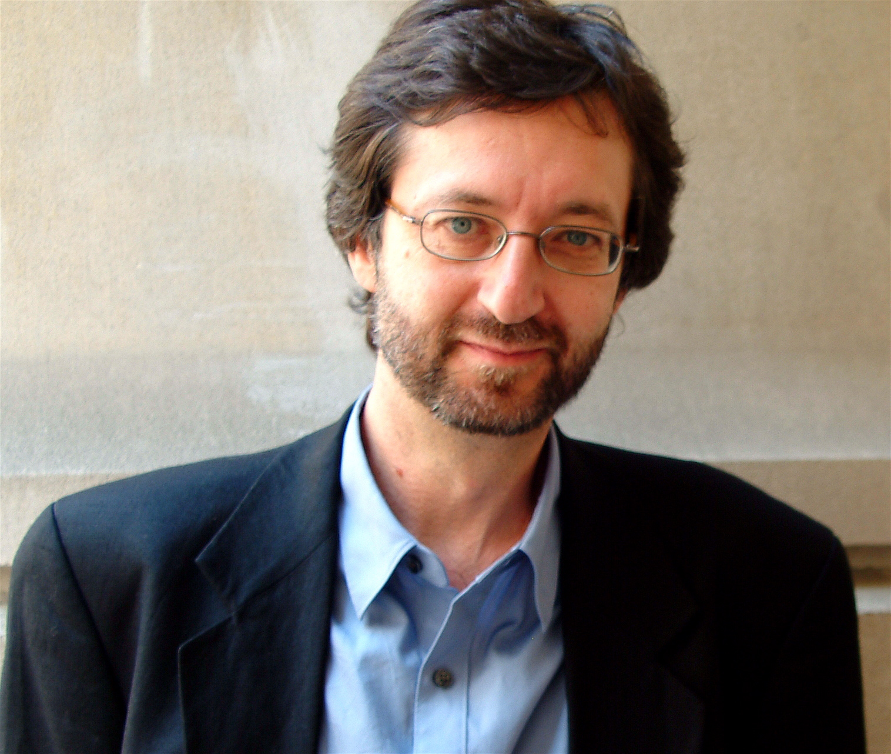

Kay was born in Weyburn, Saskatchewan, and raised in Winnipeg. In the 1970's he was retained by the Estate of J.R.R. Tolkien to assist in the editorial construction of Tolkien's posthumously published The Silmarillion. He returned to Canada from Oxford to take a law degree at the University of Toronto and was called to the Bar in Ontario.
Photo credit: Beth Gwinn

Kay became Principal Writer and Associate Producer for the CBC radio series, "The Scales of Justice", dramatizing major criminal trials in Canadian history. He also wrote several episodes when the series later moved to television. He has written social and political commentary for the National Post and the Globe and Mail and for The Guardian in England, and has spoken on a variety of topics at universities and conferences around the world.

In 1984, Kay's first novel, The Summer Tree, the first volume of The Fionavar Tapestry, was published to considerable acclaim in Canada, the United States and the United Kingdom, and then in a number of countries and languages. In 1990 Viking Canada's edition of his novel Tigana reached the national bestseller list, and his next book A Song for Arbonne debuted at #1 in Canada.

Translations now exceed twenty languages and Kay has toured and read on behalf of his publishers and at literary events in Canada, the United States, England, Poland, France, Russia, Croatia, Serbia, Mexico and Greece, among others, with his next international appearance being slated for June 2010 in Shanghai and Beijing. He has been nominated for and has won numerous literary awards including the World Fantasy Award and is the recipient of the International Goliardos Prize (presented in Mexico City) for his contributions to the literature of the fantastic. Guy Gavriel Kay’s work has inspired artists and writers around the world to create original music, verse, and art.

Kay lives in Toronto with his wife and sons.

***To celebrate the worldwide launch of Guy Gavriel Kay’s much anticipated new novel Under Heaven, Penguin Group (Canada) auctioned the first book off the press anywhere in the world, autographed by the author.***

Please visit: www.guygavrielkay.ca and www.brightweavings.com
for additional information.

