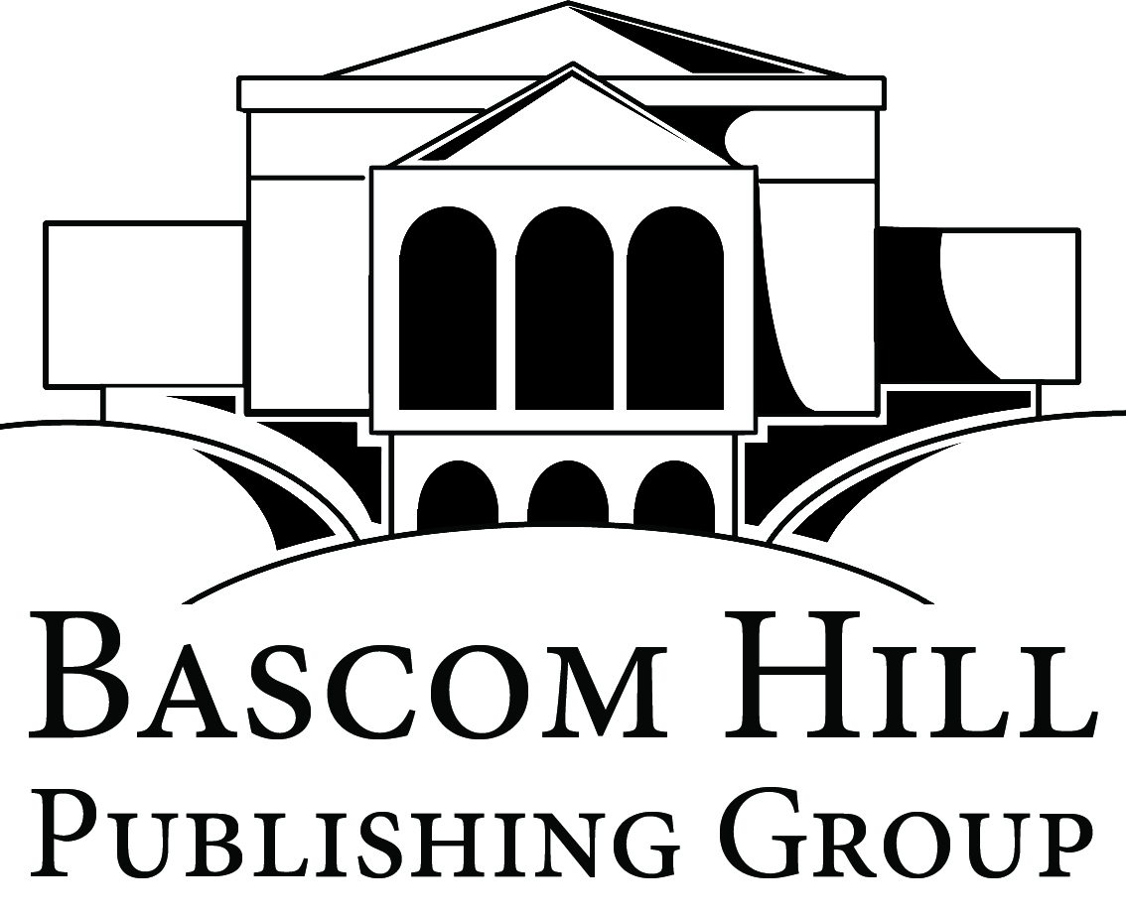

212 N 3rd Avenue · Suite 290 · Minneapolis · MN · 55401

Media Contact: Jessie King
Publicist
jessie@bascomhillpublishing.com
612-455-2293 x209

FOR IMMEDIATE RELEASE

9/11 Widow Pens Provocative New Book on Moral Certainty
MINNEAPOLIS, MN, May 5, 2010 –Bascom Hill Publishing Group has just released Nikki Stern’s provocative new book Because I Say So: The Dangerous Appeal of Moral Authority, a hybrid of memoir and cultural commentary about moral certainty in America. Stern’s vantage point is her experience as 9/11 widow and presumed moral authority recipient. She fastens a gimlet eye on not only the moral “sacredness” ascribed to victims, but also on our shared need to appoint various icons as representative of superior moral wisdom.
Open Salon reviewer Lorraine Berry, who praised the book’s arguments as complex and nuanced, noted that while she didn’t have the moral authority to order her readers to buy the book, “I will tell you that if I were you, it would be the next book I would read.”
Nikki Stern blogs regularly at www.1womansvu. Her writing has also appeared in the New York Times, Newsweek, and USA Today The former executive director of Families of September 11, she and the organization won an award from the global conflict transformation group Search for Common Ground for outreach efforts to members of the Muslim community after 9/11.
For information, please call or email publicist Jessie King, at 612-455-2293 x209, or visit www.nikkistern.com.
####

