Pop Surrealism Princess Camilla d’Errico debuts 3 Helmetgirls™ T-shirts at Hot Topic
Camilla d’Errico has debuted a new line of graphic t-shirts bearing her most famous character designs, Helmetgirls™ at Hot Topic across the USA. The striking designs are gorgeous full color and embellished with varnish. They are an affordable way for everyone to wear stylish, fun and edgy art from this rising art and design maven.
Vancouver, BC (PRWEB) May 7, 2010 – Camilla d’Errico, one of the leading ladies in the urban, pop art and comics scenes, has teamed up with the original pop and underground culture clothing store, Hot Topic, to launch 3 bold and colorful Helmetgirls™ designs on fitted t-shirts.
“My art should be accessible to everyone. I have fans ranging from young preteen girls to their moms.”
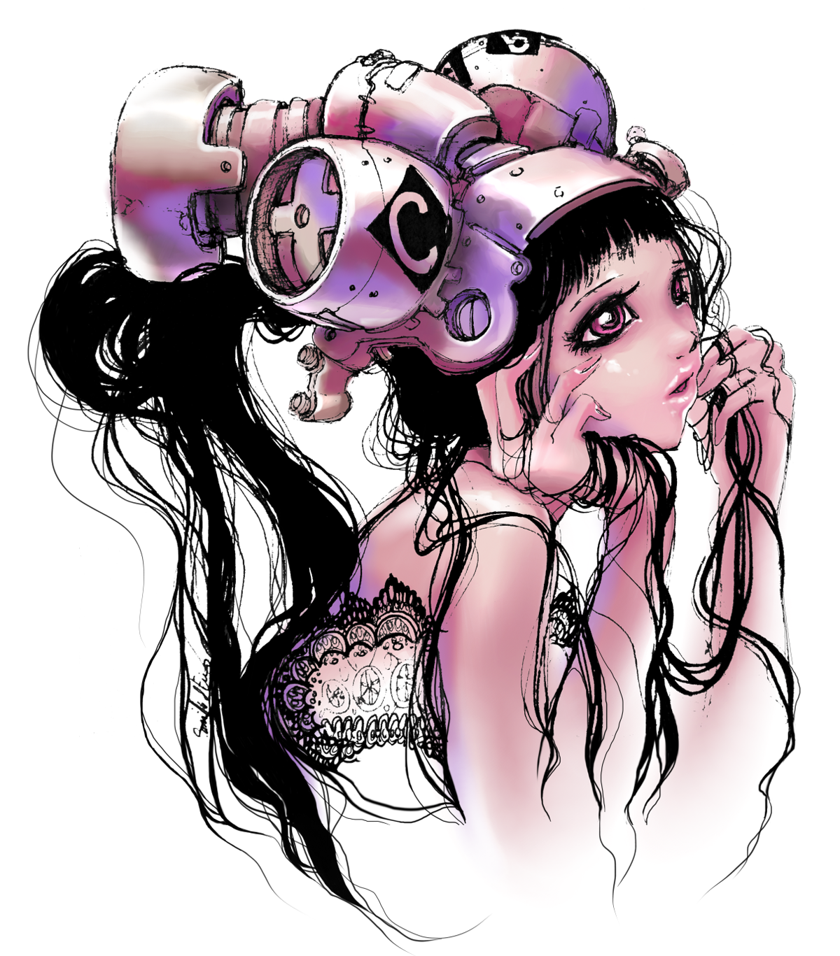
“I truly feel that my art should be available for everyone who enjoys it. I create art out of a passion to share it with people, and my first fans and customers were actually teen and tween girls. These shirts are for them, their big sisters and even their Moms!” says Camilla. “I get so much fan mail about my Helmetgirls™, so they were perfect candidates for the line. They are inspired by everything that shaped me: comics, anime and manga, and cartoons.”
Best known as just, “Camilla”, this outgoing artist, illustrator and character creator has a natural artistic versatility that allowed her to make waves in the fine art world, to create a name for herself in the comic and graphic novel industry, and to selectively disseminate her beautiful artwork commercially through merchandise, clothing and accessories.
“Camilla’s designs are gorgeous. Her manga influence is noticeable but not overpowering. There are people who instantly recognized the images as being Camilla’s, and others who immediately fell in love with them”, says Mike Mattox, CEO of licensee, All Pacific Apparel Ltd.
“Helmetgirls™ are my original characters so it has been fun to bring to them to life with bold colors in this line”, continues Camilla, “Good fit, beautiful prints with a touch of varnish, and high quality garment ensure that the final product best represents me and my art. We really focused on quality when designing and making these. I’m thrilled with the results.”
T-shirts are the new canvas for many artists, and the perfect vehicle for spreading their art. Wearable art is a term that has been coined, and many urban artists have been creating t-shirts showcasing their art. Camilla concludes, “Hot Topic’s soul is underground, cult, comic, music and pop culture, which made them the perfect retailer to launch Helmetgirls™ clothing.”
The three Helmetgirls™ designs are now in Hot Topic stores across the US, and online. With her fans alerted through various social media channels, these t-shirts are already being snapped up, quickly making the artist’s series a fan favorite.
About Camilla d’Errico
Camilla d'Errico is an urban contemporary painter, illustrator, character creator and comic artist residing in Vancouver, BC. With roots in comics, Camilla’s signature manga style is recognizable and seen on snowboards, magazine covers, toys, clothes, accessories and more. Her work has been published by Random House, Tokyopop, Simon Schuster, Image Comics Monsa Press, and Dark Horse. She has created BURN, Tanpopo and Helmetgirls™ and more recently has been working with entertainment companies on feature films and videogames. Camilla has distinguished herself through her ability to seamlessly weave manga and western comic art with surrealist elements, wrapping it all together with an extensive emotional palette. She has a unique style that bridges cultural and geographical boundaries, while remaining totally relevant to today’s varied audience. For more information about Camilla, visit www.camilladerrico.com or www.facebook.com/camilladerricoart, where currently more than 5000 fans converge. Media Contact: AdaPia d’Errico, d’Errico Studios Ltd., www.camilladerrico.com. adapiadm@gmail.com.

