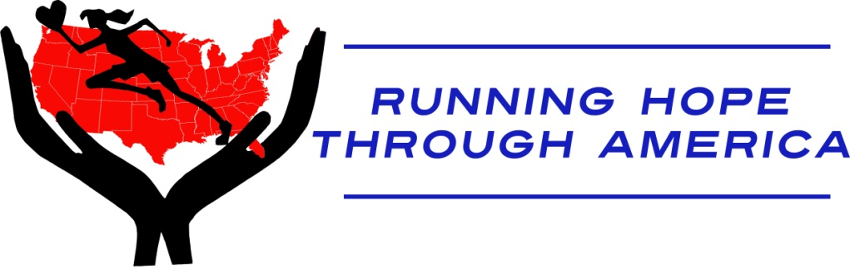

Background

Media Contacts:
Marianne DeMarco
Marianne@runhope.com
(917) 519-6730

Kristine Thompson
Kristine@storylinepublicrelations.com
(585) 944-5477

May 2010

Running 2,500 Miles of Hope Through America
- A conversation with Lisa Smith Batchen -

Because of the intense nature of the run and the length of time involved in it each day, Lisa Smith Batchen may not be available to stop for interviews. The following Qs and As with Lisa can be used in coverage.

Why are you running?
Running is what I know how to do. It’s the one thing I can do to raise awareness of the issues that orphans face around the world and right here in the U.S. If we each do one thing to help, be it donating $5, $50 or $500, we can change their lives.

Why orphans?
I have a personal connection: my husband and I have two adopted children. If we hadn’t adopted them, they’d be orphans.

It is unacceptable to me that there are 143,000 million orphans in this world. In our rich country alone, there are 500,000 children in foster care at any given moment. And, every year, about 25,000 age out of the system and face a daunting world on their own. In most states this is at age 18 and when the light switch turns to “off” – no more financial support, no more housing, no more health care, no more social worker to call at night.

Too often we think of orphans as being small, nameless babies or the hopeless seven year old child. Each one grows up and still needs love and support and each one can thrive if given the encouragement and support they deserve. Statistics show that if given this support, their outcomes change dramatically. I’ve met some of these young people and I’ve seen how love and support has affected them.

How do you define an orphan?
The Orphan Foundation of America’s (OFA’s) definition resonates with me: an orphan is anyone who has lost the love of a birth parent due to death, abuse, neglect or abandonment.

How can people get involved?
The best way people can help is to donate. The money will go right from my organization, the Dreamchaser Foundation, to each of these groups: AIDS Orphans Rising, The Caring House Project and the Orphan Foundation of America. I have a solid fundraising track record and have raised more than $4.5 million through my running. My goal is to raise $1 million for these deserving organizations. Visit www.runhope.com for more information.

How did you choose the beneficiaries of your run?
I chose AIDS Orphans Rising, The Caring House Project and The Orphan Foundation of because each plays a critical role in shaping and improving the lives of orphans in different parts of the world. Anyone who supports me on this run through dollars, prayers or by coming out and running or cheering me on, helps orphans everywhere.

How did you get started using running as a platform for service?
I began the Dreamchaser Foundation in 2008 as a way to improve the lives of women and children around the world. I want to empower people to achieve their athletic goals and dreams while at the same time raising awareness of the hunger, exploitation, illness and suffering of the children in our country and around the world. At Dreamchaser, we raise funds to specifically help children survive, succeed and improve the quality of their lives. We encourage athletes across all sports to use that passion to help others.

How did you meet sister Mary Beth?
We go back 20 years, having met when she was a track coach at Villa Walsh in New Jersey, an all girls Catholic college prep school. She still lives and teaches there and will return when the run is finished. She got the running bug then, needed a coach and the rest is history. I have used running as a way to raise money for AIDS Orphans Rising and I want to do more orphans around the world and in our own country.

Were you really invited to meet Pope John Paul II?
Yes. He was an inspiration to me and reaffirmed my passion for raising funds for and bringing attention to the plight of orphans everywhere.

Are you concerned you won’t finish?
No, I will finish. This is what I do.

How did you pick your routes?
We wanted short flat routes in each state so that I could sustain the momentum and so that others, regardless of their fitness level, could be part of the run. We worked with dedicated volunteers in each state who recommended routes that would work.

How did “50 miles in 50 states” get selected?
The number 50 has a variety of meanings me. Of course, there are 50 states and I will turn 50 in 2010.

Why is the run being done in 62 days?
Sixty-two miles in ultramarathon running is equivalent 100 kilometers, a race standard.

How do you train for something like this?
Much of the training takes place once the running has started. You get in good shape as you go along, but if you start out in your best shape, at your training peak, you'll be over-trained and injured by the end of the 2500 miles.

I do core training and yoga when I'm not running. When I train power-walking, I push my seven year old daughter in a stroller ahead of me and pull my four year old daughter behind me in a chariot attached to my waist. It's the working mom's workout.

What does your family think of this and how are staying connected to them?
The hardest part of this run is being away from my family for so long, but they have been so supportive, they understand how important this is to me. My seven year old told me on the phone the other day "Mommy, I miss you but keep running for all the orphans!" I have pictures both of my family on the walls of the RV and of course we talk every night on the phone, but it's very hard to be away from them.

How do you recover from each day’s run?
You can do everything possible to help recover after the run, but if you don't pay attention and take care of yourself *while* you're running there's nothing you can do afterward -- the damage will already be done. My crew knows what I need and when I need it. Sometimes they have to shove a sandwich in my face and say "Eat this!", but I pretty much know what I need during the run and I make sure I take care of myself.

That being said, there are specific things I do to aid recovery. First I always make sure I take a recovery drink-- drinks with a 2:1 ratio of carbohydrate to protein. I have to take an ice bath after the run every day which is horrible but necessary. It's wonderful to be able to get a massage, but it's just not possible to have one every day. When I sleep I wear Breg Polar Pads – they're plug-in ice wraps that circulate freezing water around my legs and feet. It's like an ice bath in your sleep, only not as brutal!

Is Sister Mary Beth really running?
Although she herself is an accomplished ultramarathoner, for this run, she will race-walk some of the way, walk other parts and she will just be there for me in every state as part of my crew, all of whom provide invaluable support. Her goal is to log 20 miles per day.

How did you form your crew?
The two Mikes – my brother and my good friend – have both crewed for me before so they know what I need. Sister Mary Beth has crewed for me many times, and she has run beside me in the past. She was with me when I ran 310 miles from Las Vegas to Death Valley to Mount Whitney, so I knew she had to be by my side for my hardest run yet. Marianne had never crewed before, but was a student of mine. I knew she could handle the logistics for the project and she was excited about helping me bring my dream to fruition.

Why did you start ultramarathon running?
When I was in high school I tried out for the cross-country team but the Coach told me I was too slow. In college a friend convinced me to run a local Turkey Trot, and I won. It was amazing – I felt so free when I ran. I eventually discovered that long-distances were my real strength, so I started doing marathons and Ironmans. When I did well with those distances, I wanted to go longer, and did my first ultra – the Badwater Ultra. I have run through the Sahara Desert and Death Valley and now I am pursuing the biggest, most rewarding challenge of my life.

###

