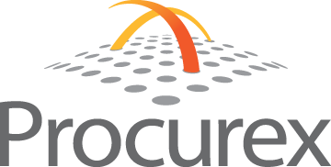
Press Release

FOR IMMEDIATE RELEASE
A Big Ten University Saves $675,000
Using Reverse Auction to Purchase Coal

Erie, PA – A Big Ten University saved $675,000 on its coal purchase through a competitive purchasing process powered by Procurex. The savings were realized using Procurex’s (www.ProcurexInc.com) proprietary reverse auction software which enabled this university to procure a coal contract from energy suppliers in a highly competitive process.

Within 45 minutes, this auction received 73 bids that were issued by seven different energy suppliers. This process was made possible by the ease of use of the Procurex reverse auction platform and the university’s forward thinking attitude to use a powerful technology solution to ensure competitiveness in their procurement process.

Using the Procurex platform, the process is streamlined and allows for continuous bidding until all of the suppliers provide their lowest bid. Before the auction begins, the bid documents are available to all suppliers online via a secured internet connection. This ensures that bidders have easy access to the most up-to-date specifications. Instead of submitting bids via phone, fax, email or paper, they simply register with Procurex and sign in to the secure site on the announced day and time of the auction to place their bids. Once a bid is placed, the suppliers can see where they rank, allowing them to alter their bids immediately if they choose. This course of action brings price compression and competitive pricing to the purchasing process.

“This success proves that Procurex has the flexibility and experienced staff on hand to service any organization that wants to engage in strategic e-procurement activities. We have services for energy procurement that includes electricity, gas and fossil fuels. We can handle all energy related procurement needs” said Bret Grady, CEO of Procurex.

Procurex™ offers powerful, on-demand solutions that help clients streamline their purchasing process to reduce costs and make better supplier selection decisions. Procurex offers a state-of-the art e-sourcing system, professional Purchasing expertise, and bid management services.

Visit http://www.ProcurexInc.com or email info@ProcurexInc.com for additional information.

Renaissance Center, 1001 State Street, Suite 1101, Erie, PA 16501, 866-412-7161

