See How One Company Used Propadoo.com for Reputation Repair

The Company
Jolly Wheels Car Rental is a private owner car rental company doing great business over the internet due to its lower prices. The unique business model is one where private owners to rent their own personal vehicles. Also, many car rental companies do not rent to people under the age of 25 or do so at exorbitant rates but Jolly Wheels has solutions for these individuals.

The Problem
Many customers prior to doing business with Jolly Wheels type the company name into Google, Yahoo, or Bing to find out more about them as they are not a well known brand and because the company asks for partial upfront payment. One of the search results in Google, Yahoo, and Bing was titled, “It Jolly Wheels a Scam?” and was located on Yahoo Answers. Even though the company isn’t a scam and the page does not claim that the company is, this was hurting sales. Jolly Wheels needed reputation repair.

The Solution – Reputation Repair
There are 3 major search engines to be concerned with, Google, Yahoo & Bing. The strategy is to use the Propadoo.com profile to create more search results that rank higher than the negative result and therefore push it off of page one. Secondly, if the negative result is too high to push off of page one then the next best thing to do is get the Propadoo profile to rank higher or at least rank right around the same spot as the negative result so that people can see the positive comments and have them out weigh the one negative comment. This is reputation repair.

In Google, the negative Yahoo Answers result was showing up in the #5 spot so the Propadoo profile showing up in the #7 spot provides a positive counter to the negative Yahoo result. In Yahoo, the negative Yahoo result showed up in the #10 spot on page 1. After using Propadoo and getting the profile ranked in Yahoo, the negative result got pushed off of page 1 and back to page 2. Right now Jolly Wheels Propadoo profile is sitting in the #3 spot in Yahoo. As for Bing, their Propadoo profile shows up in the #3 spot while the negative result has been pushed back to the second page as well.
Here are the screen shots associated with the above article showing the repaired reputation.

(Search Results screenshots on next page)
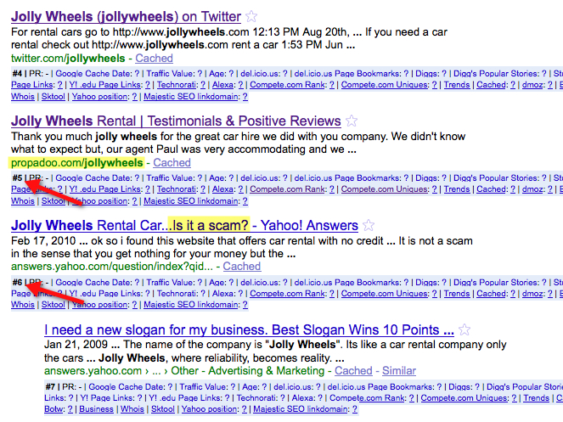

The Propadoo profile ranking here on page 1 actually pushed the negative search result off of page 1 and onto page 2. As of today (3/25/10) If you search now it shows up on page 2 of yahoo
http://search.yahoo.com/search?p=jolly+wheels&ei=UTF-8&fr=yfp-t-701&xargs=0&pstart=1&b=11&xa=wpzgBPvi99P3u85xzhhXgA--,1269639727

