**TRUSTNODE**

Trustnode’s online, interactive benefits education and enrollment platform is driven by The Potters and Friends™, a cast of programmable, animated cartoon characters linked to an insurance knowledgebase. The Trustnode platform enables insurance carriers and agents, benefits brokers, and employers to quickly and easily provide a personalized online experience that more effectively engages employees in the benefits enrollment process.



Programmable and Recognizable Characters

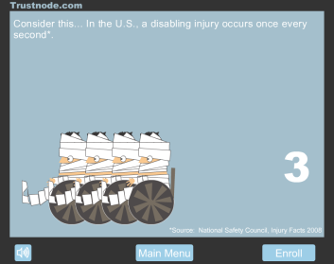

Personalized, Interactive Conversations and Story-telling

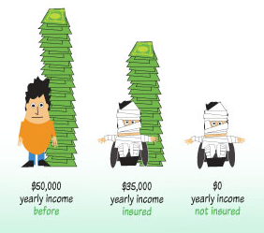

Data Visualization with Industry Specific Knowledgebase